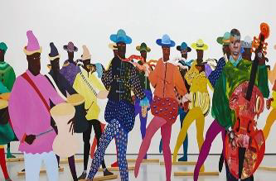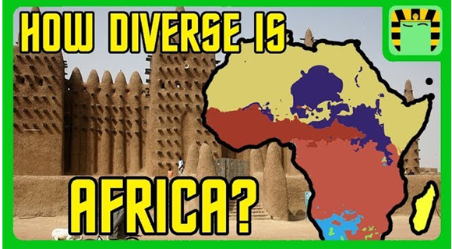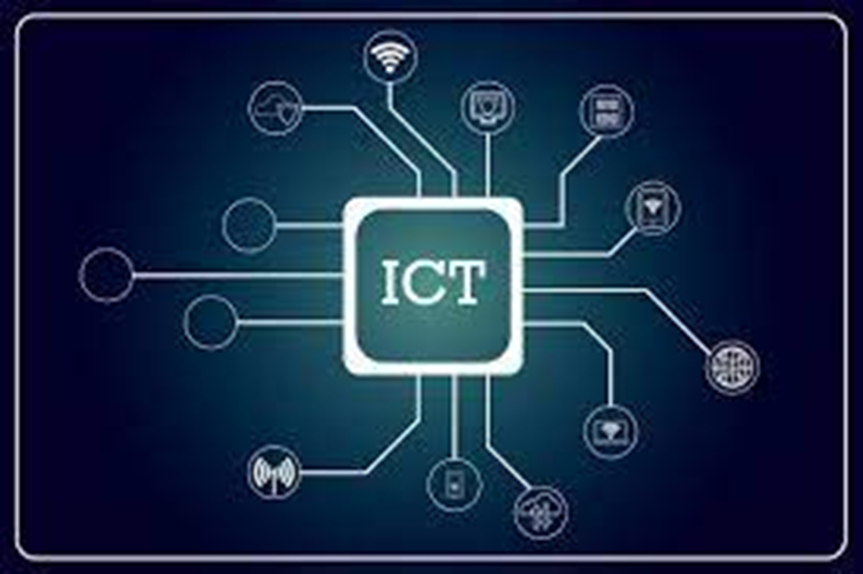 

As scientists we will:

be learning about Evolution and inheritance. We will be focusing on how things have changed and adapted over time, what we can learn from fossils, and inherited characteristics 

As artists we will: be exploring the work of the artist Lubaina Himid.

and her contributions

to the UK’s

Black Art

movement.

In ICT we will: be learning about flat file data.

Dear Parents and Year 5 and 6 children:

In Amethyst this half term we will be exploring the geography topic ‘How diverse is Africa?’

Our challenge questions are:

LC1: To know the physical features in Africa.

LC2: To know and locate mountain ranges in Africa.

LC3: To compare different biomes in Africa.

LC4: To compare life in Ghana and Nigeria.

LC5: To explore daily life in different areas of Africa

LC6: To research and present information about an area in Africa.

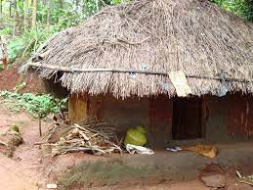 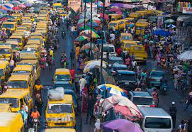

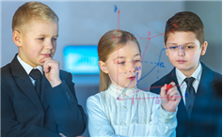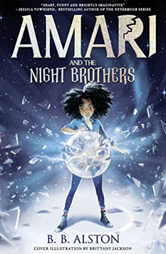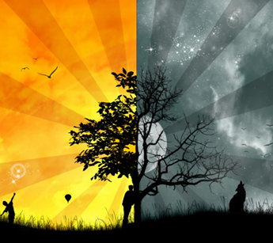

In PSHE we will: be learning about the working world, money and in app

purchases, as well as thinking

of our own money making ideas,

and the skills needed for our

future careers.

As mathematicians we will:

be learning about fractions, including equivalent fractions, adding and subtracting fraction, multiplying and dividing them, and fractions of amounts. We will then be moving onto decimals.

As authors we will:

Be reading the

book ‘Amari

and the Night

Brothers’.

As believers we will:

Be exploring the question ‘What do people

believe about

good and

evil?

How diverse is Africa?