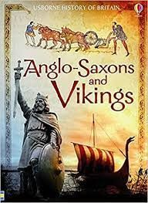 

Dear Parents and Year 5 and 6 children:

In Moonstone this half term we will be exploring the history topic ‘Who were the Anglo Saxons and Vikings?

Our challenge questions are:

LC1: To know when the Anglo-Saxons were in England and where they settled.

LC2: To know when the Vikings invaded and where they came from

LC3: To know how the Anglo Saxons attempted to bring about law and order

LC4: To know that the way the kingdoms were divided led to the creation of some of the country boundaries today.

LC5: To know that the Viking and Anglo-Saxons were often in conflict. LC6: To know why the Vikings frequently won battles with the Anglo Saxons.

In PSHE we will:

be learning about first aid, including what to do in an emergency, how to spot dangers, and

how to provide

basic first aid.

In ICT we will: be learning about vector drawing on publisher

As scientists we will:

be learning about animals including humans. We will be focusing on the growth and development of humans, including the changes that take place. 

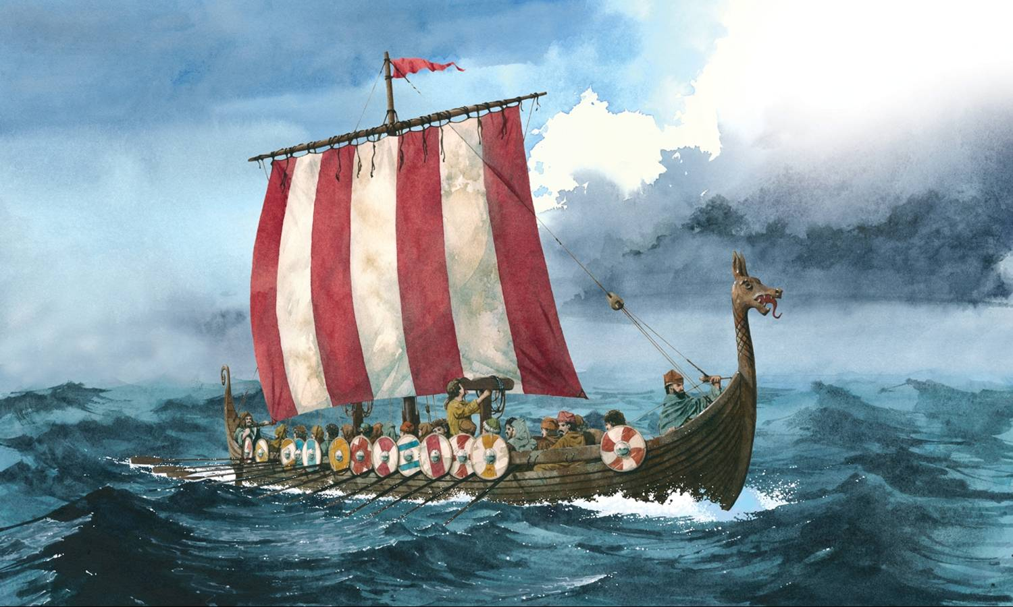

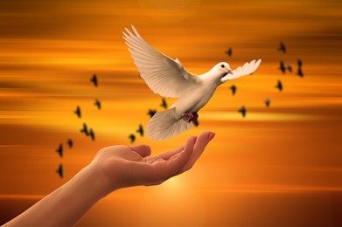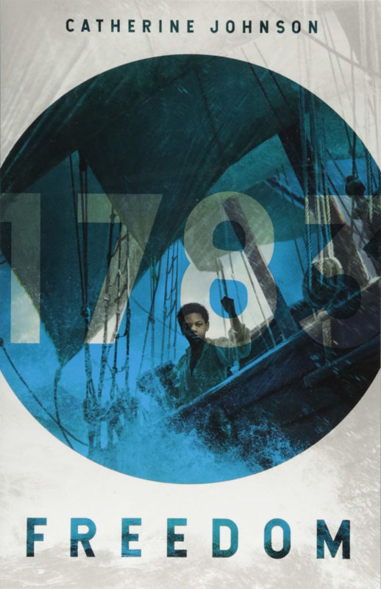

As mathematicians we will:

be finishing our work on long division and problem solving, before revisiting fractions.

Please encourage your child to continue timetable rockstars at home.

As writers we will:

be writing our biographies based on influential people. We will then be writing instructions linked to our PSHE learning on first aid.

As believers we will:

Be exploring the question ‘What do people believe about peace?’

Who were the Anglo-Saxons and Vikings??

As authors we will:

be reading the book ‘Freedom’. We

will also be

celebrating

World Book

day.

As musicians we will: be continuing our saxophone lessons!