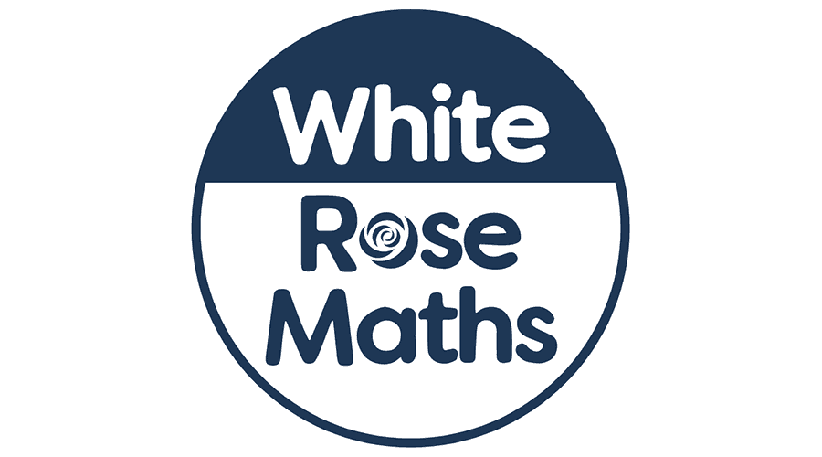

**As musicians we will:** be refining our listening and appraisal skills to understand music from other cultures.

**As artists we will:** be recreating collage work based on Henri Matisse.

**As Y1 mathematicians we will:** be learning about Place Value, but using bigger numbers, up to 50!

**As Y2 mathematicians we will:** be finishing our learning about Shape and will then be moving onto Money and Multiplication and Division.

**In R.E we will:** be looking at Creation Stories from a variety of religions.

**Dear Parents and Year 1 and 2 children,**

This term we will be exploring the geography topic ‘What would it be like to live in China?’

**Our learning challenges for this term are:**

* To know where China is in the world.
* Draw a map of China and locate the capital city, some main cities and oceans.
* To understand what life is like for people in China.
* To compare what life is like in different countries (China and the UK)
* To compare school life in China (Beijing) and The UK (my own school).
* To understand what Chinese culture is like.
* To understand the different types of farming in China, particularly rice.
* To locate a range of key features such as cities, oceans, rivers and mountains accurately, including Mount Everest, Yangtze river, Himalayas.

What would it be like to live in China?

**As athletes we will:** be learning the skills needed to play Rugby with Miss Steer.

**As readers we will:** be reading daily within our phonics lessons but we will also be sharing our class book together daily for 15 minutes**.**

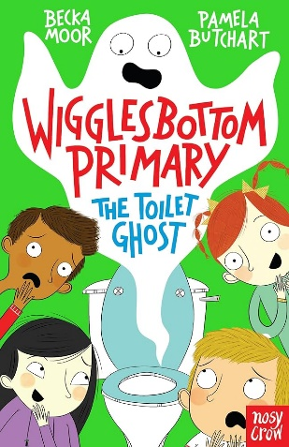

**In PSHE we will:** be learning all about our world, families, siblings and living things.

**In Computing we will:** be learning about pictograms and making our own.

**As scientists we will:** be learning about Everyday Materials.