Reading LTP Year 5 and 6 2024 - 2025
Poetry Thursday  Read a minimum of 2 poems from the poetry book of the term each week. | Texts  Guided reading and class books  Children’s classics (Pie Corbett reading spine)  Diversity  Humour and enjoyment  Contemporary children’s books (Present)  Topic linked books  Books by the same author  Poetry | Explicit Focus Points  Black – NC Objectives  Green – Reading Rope Strands  Language Comprehension  Background knowledge, Vocabulary, Language Structure, Verbal reasoning  Literacy Knowledge | Fluency Development  (6 Ps – identify specific focus)  Pitch, Power, Pace  Punctuation, Pause  Passion
Term 1  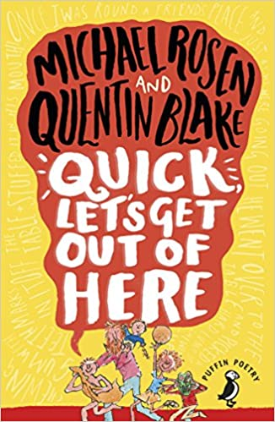  (Funny poems) | Guided reading:  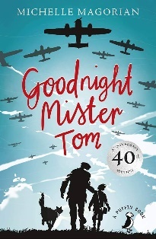  Goodnight Mr Tom  (Classic)  Class text:  Escape the Rooms  (Humour and enjoyment)  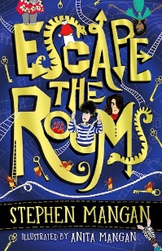 | VOCABULARY  - checking that the text makes sense to them, discussing their understanding and explaining the meaning of words in context  - discussing words and phrases that capture the reader’s interest and imagination  LITERACY KNOWLEDGE  - asking questions to improve their understanding of a text  - listening to and discussing a wide range of fiction, poetry, plays, non-fiction and reference books or textbooks.  VERBAL REASONING  - participate in discussions about books that are read to them and those they can read for themselves, building on their own and others’ ideas and challenging views courteously  - drawing inferences such as inferring characters' feelings, thoughts and motives from their actions, and justifying inferences with evidence  - identifying main ideas drawn from more than 1 paragraph and summarising these  - predicting what might happen from details stated and implied.  - -Be taught how to compare characters, settings, themes and other aspects of what they read.  BACKGROUND KNOWLEDGE  - Basic understanding of WW2, developed through topic lessons. | Pace: The speed and rhythm of what we read.  Punctuation: The adherence to and understanding of the marks an author has placed upon the page
Term 2  (Funny poems) | 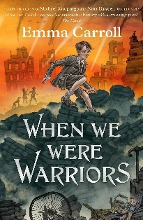  Guided reading:  When We Were Warriors  (Topic link)  Class book:  All the Things that could go Wrong  (Anti bullying)  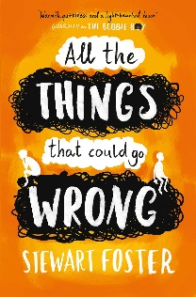 | VOCABULARY  - checking that the text makes sense to them, discussing their understanding and explaining the meaning of words in context  - using dictionaries to check the meaning of words they have read  VERBAL REASONING  - participate in discussions about books that are read to them and those they can read for themselves, building on their own and others’ ideas and challenging views courteously  - drawing inferences such as inferring characters' feelings, thoughts and motives from their actions, and justifying inferences with evidence  - identifying main ideas drawn from more than 1 paragraph and summarising these  - -Making comparisons within reading, within and across books  - explain and discuss their understanding of what they have read, including through formal presentations and debates, maintaining a focus on the topic and using notes where necessary  LITERACY KNOWLEDGE  - asking questions to improve their understanding of a text  - Identifying themes and conventions in a wide range of books (compare to previous book)  - listening to and discussing a wide range of fiction, poetry, plays, non-fiction and reference books or textbooks.  - discuss and evaluate how authors use language, including figurative language, considering the impact on the reader  LANGUAGE STRUCTURE  - identifying how language, structure and presentation contribute to meaning  - Reading books that are structured in different ways and reading for a range of purposes | Pitch: The musicality of the reading voice – including tone and intonation.  Passion: The emotion of the reading – including empathy and sympathy and the development of a reader’s love for the written word.
 | Texts  Anchor and Supplementary | Explicit Focus Points  Black – NC Objectives  Black and bold – ideas for teaching  Green – Reading Rope Strands  Language Comprehension  Background knowledge, Vocabulary, Language Structure, Verbal reasoning  Literacy Knowledge | Fluency Development  (6 Ps – identify specific focus)  Pitch, Power, Pace  Punctuation, Pause  Passion
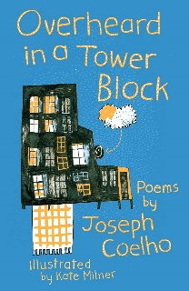  (Poems about bullying, exams, growing up and separated families) | Guided reading:  Amari and the Night Brothers  (Contemporary)  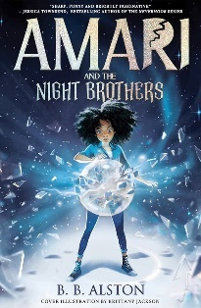  Class book:  Clockwork  (Pie Corbett – Classic)  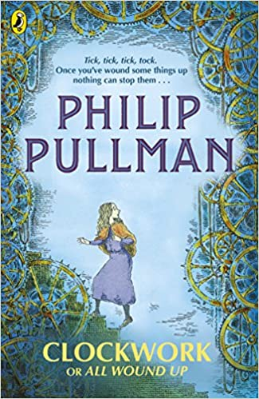 | VOCABULARY  - using dictionaries to check the meaning of words they have read  - discussing words and phrases that capture the reader’s interest and imagination  VERBAL REASONING  - drawing inferences such as inferring characters' feelings, thoughts and motives from their actions, and justifying inferences with evidence  - participate in discussion about both books that are read to them and those they can read for themselves, taking turns and listening to what others say.  identifying main ideas drawn from more than 1 paragraph and summarising these  - predicting what might happen from details stated and implied.  - -Be taught how to compare characters, settings, themes and other aspects of what they read.  - recommending books that they have read to their peers, giving reasons for their choices  - participate in discussions about books that are read to them and those they can read for themselves, building on their own and others’ ideas and challenging views courteously  LITERACY KNOWLEDGE  - asking questions to improve their understanding of a text  - increasing the familiarity with a wide range of books, including fairy stories, myths and legends, and retelling some of these orally.  LANGUAGE STRUCTURE  Reading books that are structured in different ways and reading for a range of purposes | Passion: The emotion of the reading – including empathy and sympathy and the development of a reader’s love for the written word.  Power: The strength given to the reading voice – including volume and stress.
(Poems about bullying, exams, growing up and separated families) | Guided reading:  Freedom  (Contemporary)  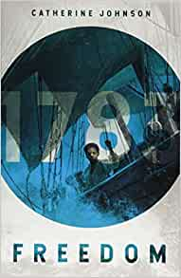  Class book:  Varjak Paw  (Classic – Pie Corbett)  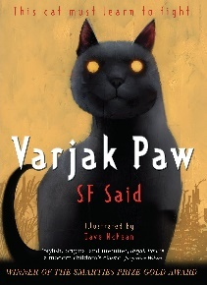 | VOCABULARY  - checking that the text makes sense to them, discussing their understanding and explaining the meaning of words in context  - discussing words and phrases that capture the reader’s interest and imagination  VERBAL REASONING  - drawing inferences such as inferring characters' feelings, thoughts and motives from their actions, and justifying inferences with evidence  - predicting what might happen from details stated and implied  - identifying main ideas drawn from more than 1 paragraph and summarising these  - participate in discussion about both books that are read to them and those they can read for themselves, taking turns and listening to what others say.  - participate in discussions about books that are read to them and those they can read for themselves, building on their own and others’ ideas and challenging views courteously  - explain and discuss their understanding of what they have read, including through formal presentations and debates, maintaining a focus on the topic and using notes where necessary  LITERACY KNOWLEDGE  - asking questions to improve their understanding of a text  - Identifying themes and conventions in a wide range of books  - increasing the familiarity with a wide range of books, including fairy stories, myths and legends, and retelling some of these orally.  LANGUAGE STRUCTURE  - identifying how language, structure and presentation contribute to meaning | Pause: The knowing of when not to read and for how long  Pitch: The musicality of the reading voice – including tone and intonation  Pace: The speed and rhythm of what we read.
 | Texts  Anchor and Supplementary | Explicit Focus Points  Black – NC Objectives  Black and bold – ideas for teaching  Green – Reading Rope Strands  Language Comprehension  Background knowledge, Vocabulary, Language Structure, Verbal reasoning  Literacy Knowledge | Fluency Development  (6 Ps – identify specific focus)  Pitch, Power, Pace  Punctuation, Pause  Passion
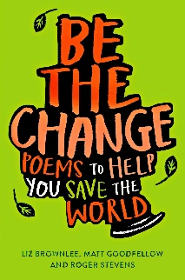  (Taking care of our world poems) | Guided reading:  The Explorer  Plus SATS prep and short texts  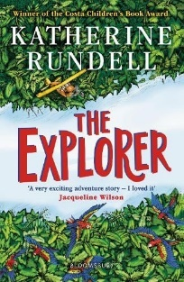  Class book:  Skellig  (Pie Corbett – Classic)  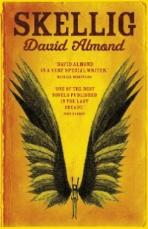 | VOCABULARY  - checking that the text makes sense to them, discussing their understanding and explaining the meaning of words in context  - discussing words and phrases that capture the reader’s interest and imagination  VERBAL REASONING  - drawing inferences such as inferring characters' feelings, thoughts and motives from their actions, and justifying inferences with evidence  - -Be taught how to compare characters, settings, themes and other aspects of what they read.  - -Making comparisons within reading, within and across books  - Ask questions to improve their understanding  - predicting what might happen from details stated and implied.  LITERACY KNOWLEDGE  - asking questions to improve their understanding of a text  - listening to and discussing a wide range of fiction, poetry, plays, non-fiction and reference books or textbooks.  - Identifying themes and conventions in a wide range of books  - increasing the familiarity with a wide range of books, including fairy stories, myths and legends, and retelling some of these orally.  - discuss and evaluate how authors use language, including figurative language, considering the impact on the reader  LANGUAGE STRUCTURE  - Reading books that are structured in different ways and reading for a range of purposes | Pause: The knowing of when not to read and for how long  Punctuation: The adherence to and understanding of the marks an author has placed upon the page.  Power: The strength given to the reading voice – including volume and stress.
(Taking care of our world poems) | Guided Reading:  The Explorer  Class book:  Tom’s Midnight Garden  (Pie Corbett – Classic)  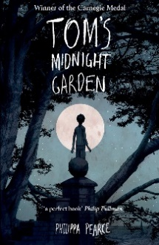 | VOCABULARY  - checking that the text makes sense to them, discussing their understanding and explaining the meaning of words in context  - discussing words and phrases that capture the reader’s interest and imagination  - using dictionaries to check the meaning of words they have read  VERBAL REASONING  - drawing inferences such as inferring characters' feelings, thoughts and motives from their actions, and justifying inferences with evidence  - predicting what might happen from details stated and implied  - participate in discussion about both books that are read to them and those they can read for themselves, taking turns and listening to what others say.  - identifying main ideas drawn from more than 1 paragraph and summarising these  - recommending books that they have read to their peers, giving reasons for their choices  - participate in discussions about books that are read to them and those they can read for themselves, building on their own and others’ ideas and challenging views courteously  - explain and discuss their understanding of what they have read, including through formal presentations and debates, maintaining a focus on the topic and using notes where necessary  LITERACY KNOWLEDGE  - asking questions to improve their understanding of a text  - increasing the familiarity with a wide range of books, including fairy stories, myths and legends, and retelling some of these orally. | Passion: The emotion of the reading – including empathy and sympathy and the development of a reader’s love for the written word.  Punctuation: The adherence to and understanding of the marks an author has placed upon the page.  Pace: The speed and rhythm of what we read.

