Reading LTP Year 3 and 4 2024 - 2025
Poetry Thursday  Read a minimum of 2 poems from the poetry book of the term each week. | Texts  Children’s classics (Pie Corbett)  Diversity  Humour and enjoyment  Contemporary children’s books (Present)  Topic linked books  Poetry | Explicit Focus Points  Black – NC Objectives  Black and bold – ideas for teaching  Green – Reading Rope Strands  Language Comprehension  Background knowledge, Vocabulary, Language Structure, Verbal reasoning  Literacy Knowledge | Fluency Development  (6 Ps – identify specific focus)  Pitch, Power, Pace  Punctuation, Pause  Passion
Term 1  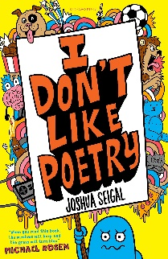  (Funny poems) | Guided reading  Amelia Fang and the Barbaric Ball  (Humour and enjoyment – children’s interest)  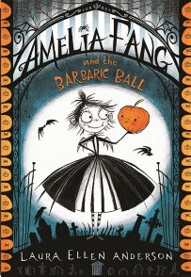  Class book:  The Last Bear  (Contemporary)  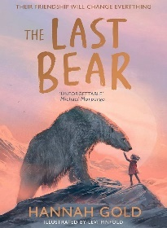 | VOCABULARY  - using dictionaries to check the meaning of words that they have read  - discussing words and phrases that capture the reader’s interest and imagination  VERBAL REASONING  - drawing inferences such as inferring characters’ feelings, thoughts and motives from their actions, and justifying inferences with evidence  - predicting what might happen from details stated and implied  - identifying main ideas drawn from more than 1 paragraph and summarising these  - participate in discussion about both books that are read to them and those they can read for themselves, taking turns and listening to what others say  - asking questions to improve their understanding of a text  LITERACY KNOWLEDGE  - checking that the text makes sense to them, discussing their understanding, and explaining the meaning of words in context  LANGUAGE STRUCTURE  - identifying how language, structure, and presentation contribute to meaning | Pace: The speed and rhythm of what we read.  Punctuation: The adherence to and understanding of the marks an author has placed upon the page.  Pause: The knowing of when not to read and for how long.
Term 2 | Harley Hitch and the Iron Forest  (Enjoyment)  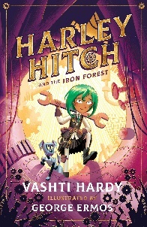  Class book:  The Mapmakers  (Contemporary)  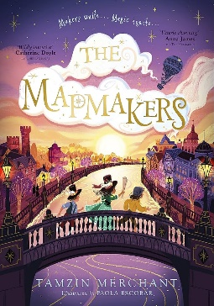 | VOCABULARY  - using dictionaries to check the meaning of words they have read  - discussing words and phrases that capture the reader’s interest and imagination  VERBAL REASONING  - drawing inferences such as inferring characters' feelings, thoughts and motives from their actions, and justifying inferences with evidence  - participate in discussion about both books that are read to them and those they can read for themselves, taking turns and listening to what others say.  LITERACY KNOWLEDGE  - asking questions to improve their understanding of a text  - increasing the familiarity with a wide range of books, including fairy stories, myths and legends, and retelling some of these orally. | Passion: The emotion of the reading – including empathy and sympathy and the development of a reader’s love for the written word.  Power: The strength given to the reading voice – including volume and stress.
 | Texts  Anchor and Supplementary | Explicit Focus Points  Black – NC Objectives  Black and bold – ideas for teaching  Green – Reading Rope Strands  Language Comprehension  Background knowledge, Vocabulary, Language Structure, Verbal reasoning  Literacy Knowledge | Fluency Development  (6 Ps – identify specific focus)  Pitch, Power, Pace  Punctuation, Pause  Passion
Term 3  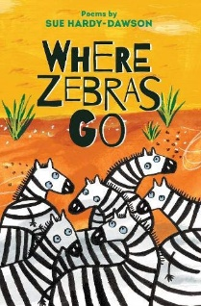  (Range of topics covered including protecting the environment and animals) | Guided reading:  Planet Omar  (Diversity - BAME)  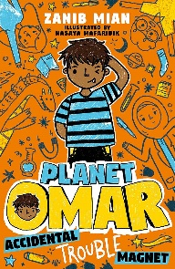  Class book:  The Boy at the Back of the Class  (Diversity)  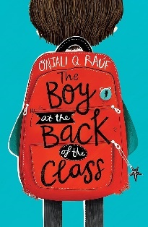 | Background knowledge  - what diversity is and how it might feel to be different  Vocabulary  - using dictionaries to check the meaning of words that they have read  Language Structure  - identifying how language, structure, and presentation contribute to meaning  Verbal reasoning  - discussing words and phrases that capture the reader’s interest and imagination  - participate in discussion about both books that are read to them and those they can read for themselves, taking turns and listening to what others say  - checking that the text makes sense to them, discussing their understanding, and explaining the meaning of words in context  - asking questions to improve their understanding of a text  - drawing inferences such as inferring characters’ feelings, thoughts and motives from their actions, and justifying inferences with evidence  - identifying main ideas drawn from more than 1 paragraph and summarising these  Literacy Knowledge  - listening to and discussing a wide range of fiction, poetry, plays, non-fiction and reference books or textbooks  - reading books that are structured in different ways and reading for a range of purposes  - identifying main ideas drawn from more than 1 paragraph and summarising these | Pace: The speed and rhythm of what we read.  Punctuation: The adherence to and understanding of the marks an author has placed upon the page.  Passion: The emotion of the reading – including empathy and sympathy and the development of a reader’s love for the written word.
Term 4 | Class book:  Nothing to see here hotel  (Humour and enjoyment)  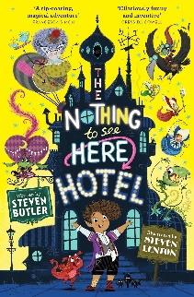  The Girl Who Stole an Elephant  (Diversity)  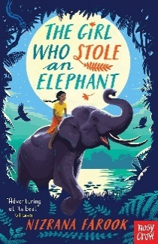 | Vocabulary  - using dictionaries to check the meaning of words that they have read  - discussing words and phrases that capture the reader’s interest and imagination  - checking that the text makes sense to them, discussing their understanding, and explaining the meaning of words in context  Verbal reasoning  - asking questions to improve their understanding of a text  - drawing inferences such as inferring characters’ feelings, thoughts and motives from their actions, and justifying inferences with evidence  - predicting what might happen from details stated and implied  - identifying main ideas drawn from more than 1 paragraph and summarising these  - participate in discussion about both books that are read to them and those they can read for themselves, taking turns and listening to what others say  Literacy Knowledge  - identifying themes and conventions in a wide range of books | Pitch: The musicality of the reading voice – including tone and intonation.  Power: The strength given to the reading voice – including volume and stress.  Pace: The speed and rhythm of what we read.  Passion: The emotion of the reading – including empathy and sympathy and the development of a reader’s love for the written word.
 | Texts  Anchor and Supplementary | Explicit Focus Points  Black – NC Objectives  Black and bold – ideas for teaching  Green – Reading Rope Strands  Language Comprehension  Background knowledge, Vocabulary, Language Structure, Verbal reasoning  Literacy Knowledge | Fluency Development  (6 Ps – identify specific focus)  Pitch, Power, Pace  Punctuation, Pause  Passion
Term 5  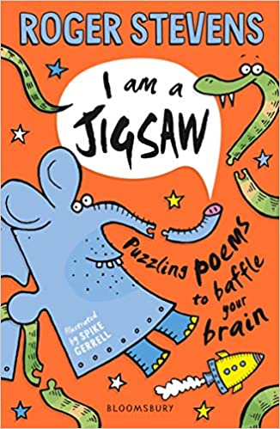  (Puzzles) | Charlott’es Web  (Classic – Pie Corbett’s reading spine)  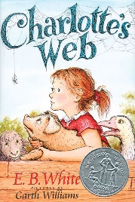  Class text:  The Great Chocoplot  (Humour and enjoyment)  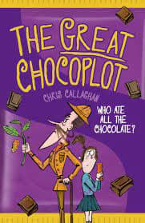 | Vocabulary  - using dictionaries to check the meaning of words that they have read  - discussing words and phrases that capture the reader’s interest and imagination  Language Structure  - identifying how language, structure, and presentation contribute to meaning  Verbal reasoning  - checking that the text makes sense to them, discussing their understanding, and explaining the meaning of words in context  - asking questions to improve their understanding of a text  - drawing inferences such as inferring characters’ feelings, thoughts and motives from their actions, and justifying inferences with evidence  - predicting what might happen from details stated and implied  - identifying main ideas drawn from more than 1 paragraph and summarising these  - participate in discussion about both books that are read to them and those they can read for themselves, taking turns and listening to what others say  - retrieve and record information from non-fiction  Literacy Knowledge  - listening to and discussing a wide range of fiction, poetry, plays, non-fiction and reference books or textbooks  - identifying themes and conventions in a wide range of books | Power: The strength given to the reading voice – including volume and stress.  Pace: The speed and rhythm of what we read.  Punctuation: The adherence to and understanding of the marks an author has placed upon the page.  Pause: The knowing of when not to read and for how long.
Term 6 | Guided reading:  The Lion, The Witch and the Wardrobe  (Classic – Pie Corbett)  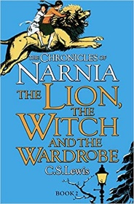  Class text:  The Griffin Gate  (Contemporary)  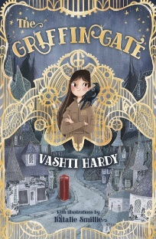 | VOCABULARY  - discussing words and phrases that capture the reader’s interest and imagination  - using dictionaries to check the meaning of words they have read  LITERACY KNOWLEDGE  - listening to and discussing a wide range of fiction, poetry, plays, non-fiction and reference books or textbooks.  - asking questions to improve their understanding of a text  - retrieve and record information from non-fiction  - Identifying themes and conventions in a wide range of books  VERBAL REASONING  - participate in discussions about books that are read to them and those they can read for themselves, building on their own and others’ ideas and challenging views courteously  - drawing inferences such as inferring characters' feelings, thoughts and motives from their actions, and justifying inferences with evidence  - identifying main ideas drawn from more than 1 paragraph and summarising these | Passion: The emotion of the reading – including empathy and sympathy and the development of a reader’s love for the written word.  Pitch: The musicality of the reading voice – including tone and intonation

