Year 2 LTP Reading 2024 - 2025
Texts  Anchor and Supplementary | Explicit Focus Points  Black – NC Objectives  Black and bold – ideas for teaching  Green – Reading Rope Strands  Language Comprehension Background knowledge, Vocabulary, Language Structure, Verbal reasoning Literacy Knowledge | Fluency Development  (6 Ps – identify specific focus)  Pitch, Power, Pace  Punctuation, Pause  Passion | Class book  Texts selected from a range, including:  - Pie Corbett reading spine  - Diversity  - Books for pleasure / humour
Term 1 | Read Write Inc Blue Group |  | 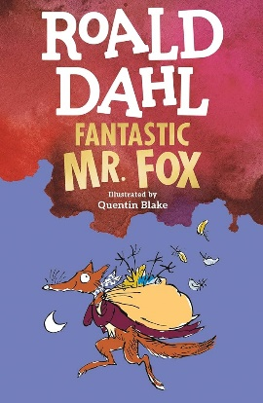  Fantastic Mr Fox
Term 2 | Read Write Inc Grey Group |  | Ellie and the Cat  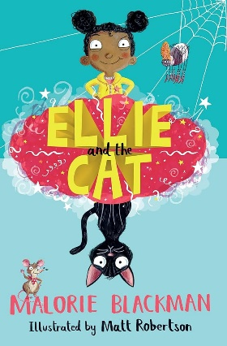
Term 3 | Reading fluency programme for 8 weeks – LEAD Equate. |  | 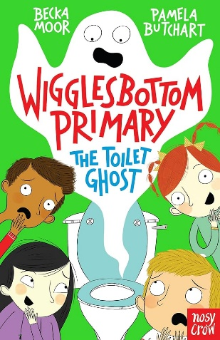  Wigglesbottom Primary: The Toilet Ghost
Term 4  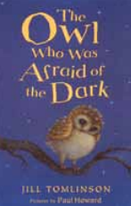  Children’s classics | Reading Strategies – Using Prior Knowledge/Previewing, Questioning, Making Inferences, Summarising.  Background knowledge  - drawing on what they already know or on background information and vocabulary provided by the teacher  Vocabulary  - discussing and clarifying the meanings of words, linking new meanings to known vocabulary  Verbal reasoning  - Basic recognition of simple themes across a range of texts  - Deduce and infer single points from specific parts of text and explain opinions  - Predicting what might happen on the basis of what has been read so far.  - Participate in discussion about books, poems and other works that are read to them and those that they can read for themselves, taking turns and listening to what others say.  Literacy Knowledge  - Being introduced to fiction / non-fiction books that are structured in different ways. | Punctuation: The adherence to and understanding of the marks an author has placed upon the page.  Pause: The knowing of when not to read and for how long.  Passion: Using emotion and expression when reading.  Power: The strength given to the reading voice – including volume and stress. | Genie and Teeny Make a Wish  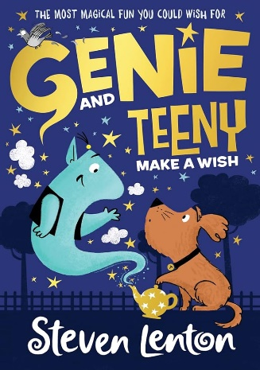
Term 5  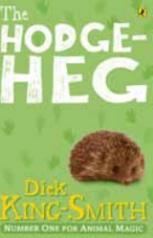  Children’s classics | Reading Strategies – Using Prior Knowledge/Previewing, Questioning, Making Inferences, Summarising.  VOCABULARY  - discussing and clarifying the meanings of words, linking new meanings to known vocabulary  VERBAL REASONING  - explain and discuss their understanding of books, poems and other material, both those that they listen to and those that they read for themselves  - participate in discussion about books, poems and other works that are read to them and those that they can read for themselves, taking turns and listening to what others say  - checking that the text makes sense to them as they read, and correcting inaccurate reading  - answering and asking questions  LITERACY KNOWLEDGE  - listening to, discussing and expressing views about a wide range of contemporary and classic poetry, stories and non-fiction at a level beyond that at which they can read independently | Punctuation: The adherence to and understanding of the marks an author has placed upon the page.  Pitch: The musicality of the reading voice – including tone and intonation.  Pace: The speed at which we read. | Cakes in Space  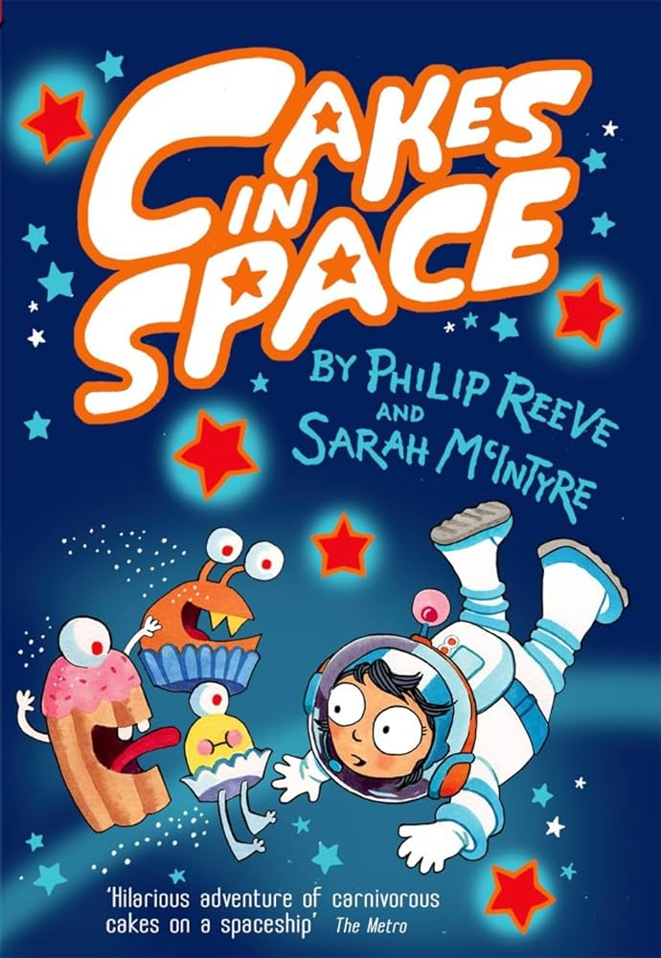
Term 6  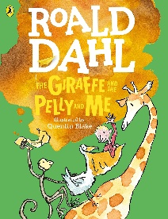  Children’s classics | Reading Strategies – Using Prior Knowledge/Previewing, Questioning, Making Inferences, Summarising.  Background knowledge  - drawing on what they already know or on background information and vocabulary provided by the teacher  Vocabulary  - discussing and clarifying the meanings of words, linking new meanings to known vocabulary  - recognising simple recurring literary language in stories and poetry (same author- different texts)  Verbal reasoning  - checking that the text makes sense to them as they read, and correcting inaccurate reading  - making inferences on the basis of what is being said and done  - answering and asking questions  - predicting what might happen on the basis of what has been read so far  Literacy Knowledge  - becoming increasingly familiar with and retelling a wider range of stories, fairy stories and traditional tales  - listening to, discussing and expressing views about a wide range of contemporary and classic poetry, stories and non-fiction at a level beyond that at which they can read independently | Pitch: The musicality of the reading voice – including tone and intonation.  Power: The strength given to the reading voice – including volume and stress.  Pace: The speed at which we read. | 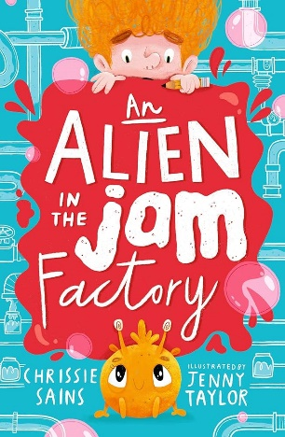  An Alien in a Jam Factory

