## Communication and Language (CL)

**PSED**

* Practice playing in our role-plays with other children, understanding that we play in ways which respect each other, and listen to each other’s ideas.
* Sharing my home life with my friends.
* Think about and discuss characters and events in stories, being kind, stealing, etc.
* Talk about feelings or how characters feel in a book they might be reading, encouraging a wide range of vocabulary e.g. scared, excited, happy, sad etc…
* We will discuss caring for animals and the environment.

**Literacy**

* Retell stories in the correct sequence using and creating story maps.
* Use phonic knowledge to read simple regular words.
* Recap on Set 1 sounds
* Write initial sounds for words or CVC (consonant, vowel, consonant) words
* Continue with oral blending for reading words

## Communication and Language (CL)

* Understand how to listen carefully and the importance of listening.
* Use talk to organise, sequence and clarify thinking, ideas, feelings, and events
* Articulate ideas and thoughts in well-formed sentences.
* Describe events in detail.
* Ask questions to find out more and check understanding.
* Learn new vocabulary.

## Mathematics (M)

* Subitising to 5
* 1 more and 1 less
* Children will continue to develop the understanding that all numbers are made up of smaller numbers and that this can include zero.
* Children will become more familiar with using balance scales and distinguish between the different quantities on either side. Use different kinds of scales so children do not think there is only one way to compare mass.
* Children build on their understanding of ‘full’ and ‘empty’ to further investigate different capacities and how they relate to each other.

Into The Woods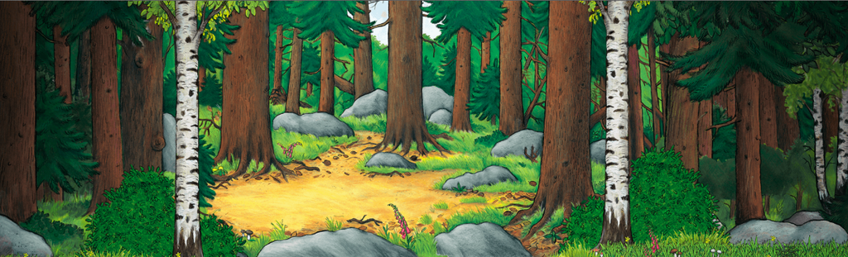

Spring 1

Topaz Class

## Understanding the World (UW)

* Explore the natural world around us.
* Investigate different objects we can find in the woods.
* Learn about animals and their habitats
* Create simple maps.
* Recognise different environments
* Understand the changing seasons in the world around us.

## Expressive Arts and Design (EAD)

* Study the work of Andy Goldsworthy and replicating his work or using his techniques.
* Painting and drawing through observations.
* Make masks/puppets to act out stories.
* Sing in a group and or on our own.
* Engage in music making and dance, performing in groups or solo.
* Build on previous learning and develop skills.

**Home Learning Challenges**

**Can you go for a walk in the woods**? What do you see? Hear? What objects can you find?

**Can you make a tree rubbing?** Or take a picture in all of the leaves?

**Can you find out about animals that live in the woods?**

**Can you draw a picture of them and tell Mrs Puttock some facts?**

**Can you make a woodland picture or collage?**

## Physical Development (PD)

* Develop fine motor skills- pencils, scissors, paintbrushes.
* Go on an imaginary woodland walk and treasure hunt using a range of equipment, travel around, under, over and through balancing and climbing equipment.
* Explore and use equipment to make large and small scale constructions- bridges, house
* Learn and play team games.
* Coach Jack will be continuing with us for P.E. lessons to help us develop our large and small movements and our skills.

