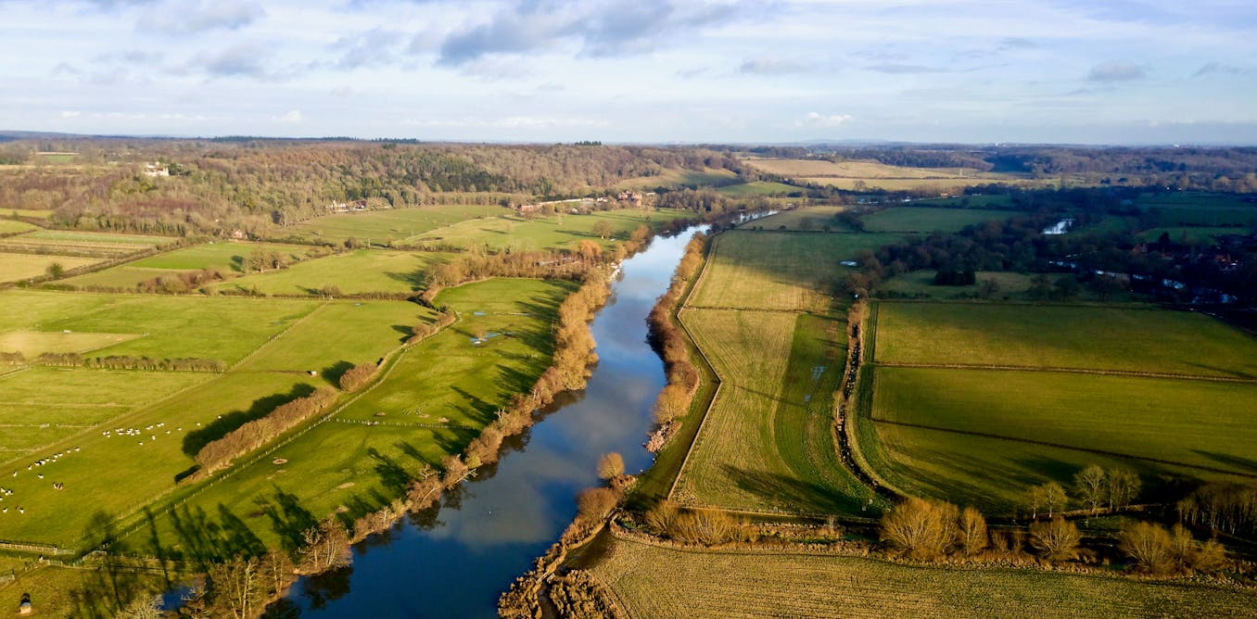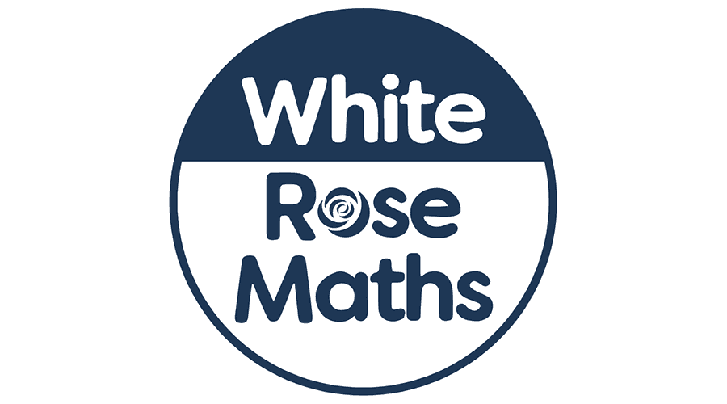

**As musicians we will:** continue our Friday afternoon sessions with Mr Roberts from the Lincolnshire Music Service.

**As artists we will:** explore the artist ‘Gustav Klimt’ through the use of oil pastels.

**As mathematicians we will:** be learning the time to the nearest 5 minutes and the nearest minute. We will explore am and pm, digital and analogue and durations including days, weeks and months. Later, we will be learning about decimals including tenths, hundredths, halves and quarters. We will be partitioning decimals, comparing and ordering them and rounding them to the nearest whole number. Please continue to encourage your child to practise their times tables on TT Rockstars.

Where does the river flow?

**Dear Parents and Year 3 and 4 children,**

This term we will be exploring the Geography topic ‘Where does the river flow?’

**Our learning challenges for this term are:**

|  |
| --- |
| To know, name and locate the main rivers of the UK. |
| To know how rivers are used in daily life around the world. |
| To know the main features of a river. |
| To know and explain the features of the water cycle. |
| To locate some of the longest rivers in the world on a map. |
| To know the route of a local river. |

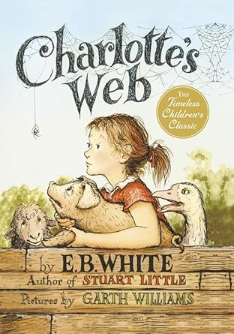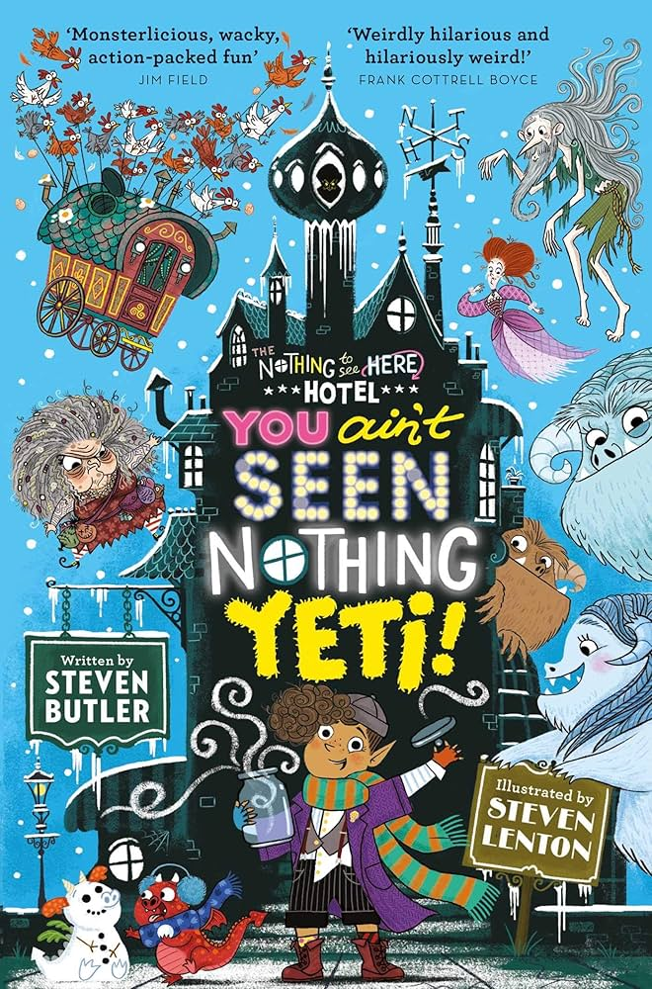

**As readers we will:** be reading the classic, ‘Charlotte’s Web’

during our daily guided

reading sessions.

As our class book, and

following on from last

term’s guided read, the

class have chosen to read

the next in Steven Butler’s

hilarious series, ‘You Ain’t

Seen Nothing Yeti.’

**In French we will:** be learning how to talk about our school with Mrs Parry.

**In Computing we will:** explore programming and repetition using shapes.

**In R.E we will:** explore what it means to belong in other world religions.

**As authors we will:** complete our information texts about the Anglo Saxons using our knowledge form last term’s learning. For the last few weeks of term we will read Valerie Bloom’s poem, ‘The River’ before writing our own versions of the poem, linked to our topic learning.

**As athletes we will:** be continuing our twice weekly sessions with coach Jack on a Monday and Wednesday. We will also be swimming each Thursday morning.

**As scientists we will:** continue our learning about rocks, soils and fossils. We will focus on how fossils are formed and link our learning to our rivers topic.

**In PSHE we will:** be learning all about online safety including image sharing, online bullying and making friends online.