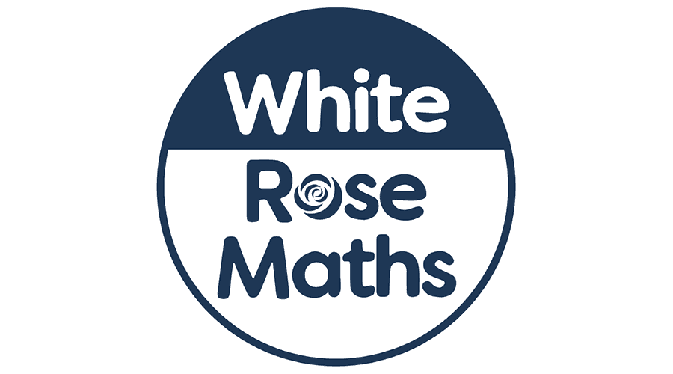

**As designers we will be:** designing and creating our very own pneumatic toy monsters!

**As musicians we will:** continue our Friday afternoon sessions with Mr Roberts from the Lincolnshire Music Service.

**As readers we will:** be reading ‘The Nothing to See Here Hotel’ during guided reading. As a class, we will read ‘The Girl Who Stole an Elephant’ each afternoon.

**Dear Parents and Year 3 and 4 children,**

This term we will be exploring the History topic ‘Who were The Saxons?’

**Our learning challenges for this term are:**

|  |
| --- |
| To know when and why the Saxons invaded Britain. |
| To know where and why they settled where they did. |
| To know what an Anglo-Saxon village was like and how they lived. |
| To use artefacts to predict what life was like |
| To know about Anglo Saxon Gods |
| To know who King Alfred was and know how he was remembered. (using sources of evidence) |

Who were The Saxons?

**As mathematicians we will:** begin the term by learning about perimeter and how to calculate the perimeter of different shapes. Later in the term we will begin our learning on fractions where we will learn how to compare and order fractions, find equivalents and also place fractions on a number line. Please continue to encourage your child to practise their

times tables on

TT Rockstars.

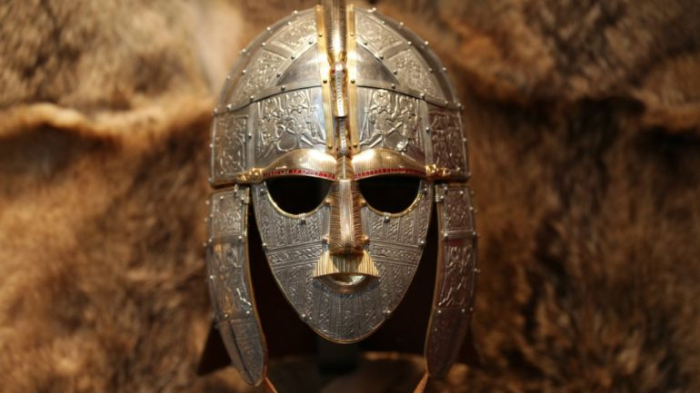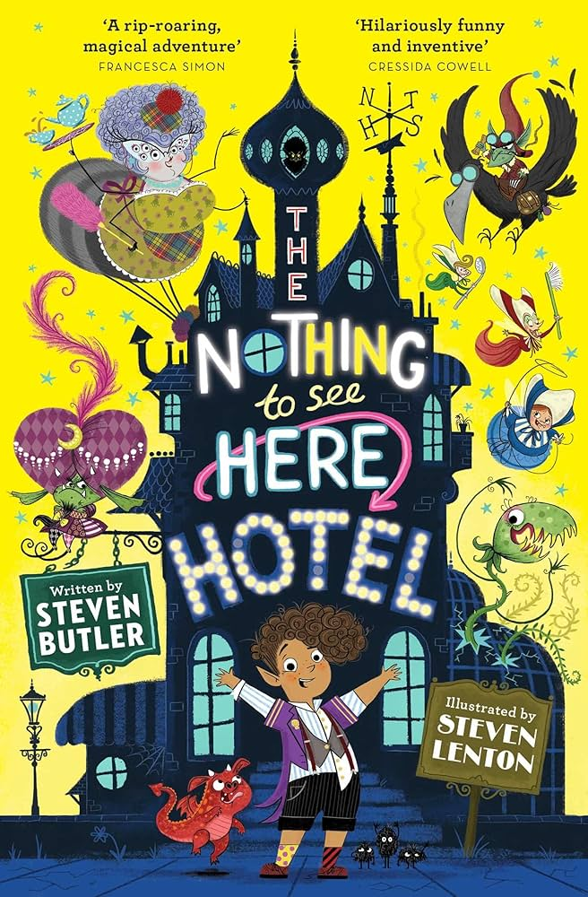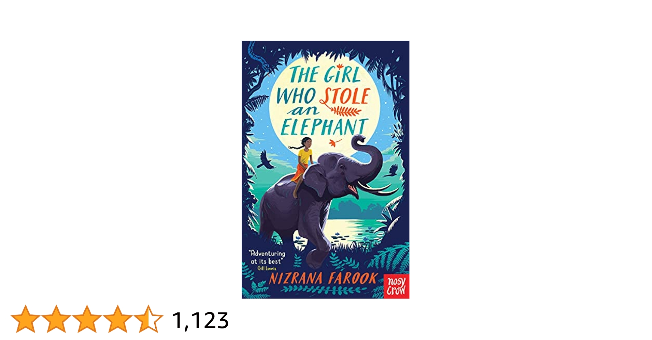

**As authors we will:** begin drafting our narrative adventure story before editing and redrafting. Later in the term we will be producing our own leaflets all about our school using non-fiction writing techniques.

**In R.E we will:** continue to explore how different ceremonies show people’s commitment to their worldview.

**In Computing we will:** be learning how to use email.

**As scientists we will:** be learning all about how rocks are formed and what the different types of rock are. We will also explore different soils and learn about how fossils are formed.

**In French we will:** be learning how to talk about our friends and family with Mrs Parry.

**In PSHE we will:** be learning what we need to do to keep healthy, including exploring the use of medicine, brushing our teeth and keeping clean.

**As athletes we will:** be continuing our twice weekly sessions with coach Jack on a Monday and Wednesday.