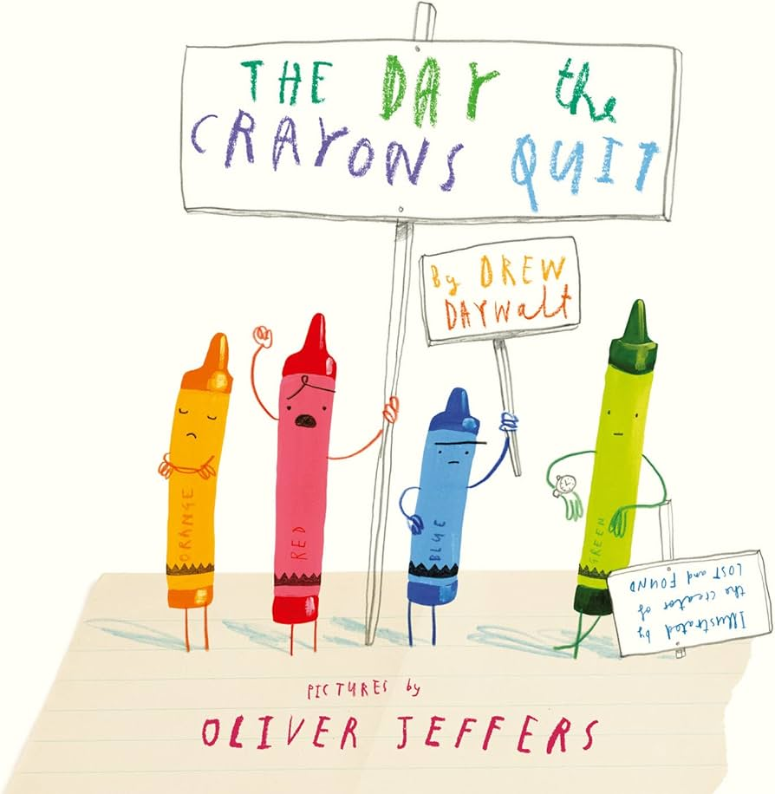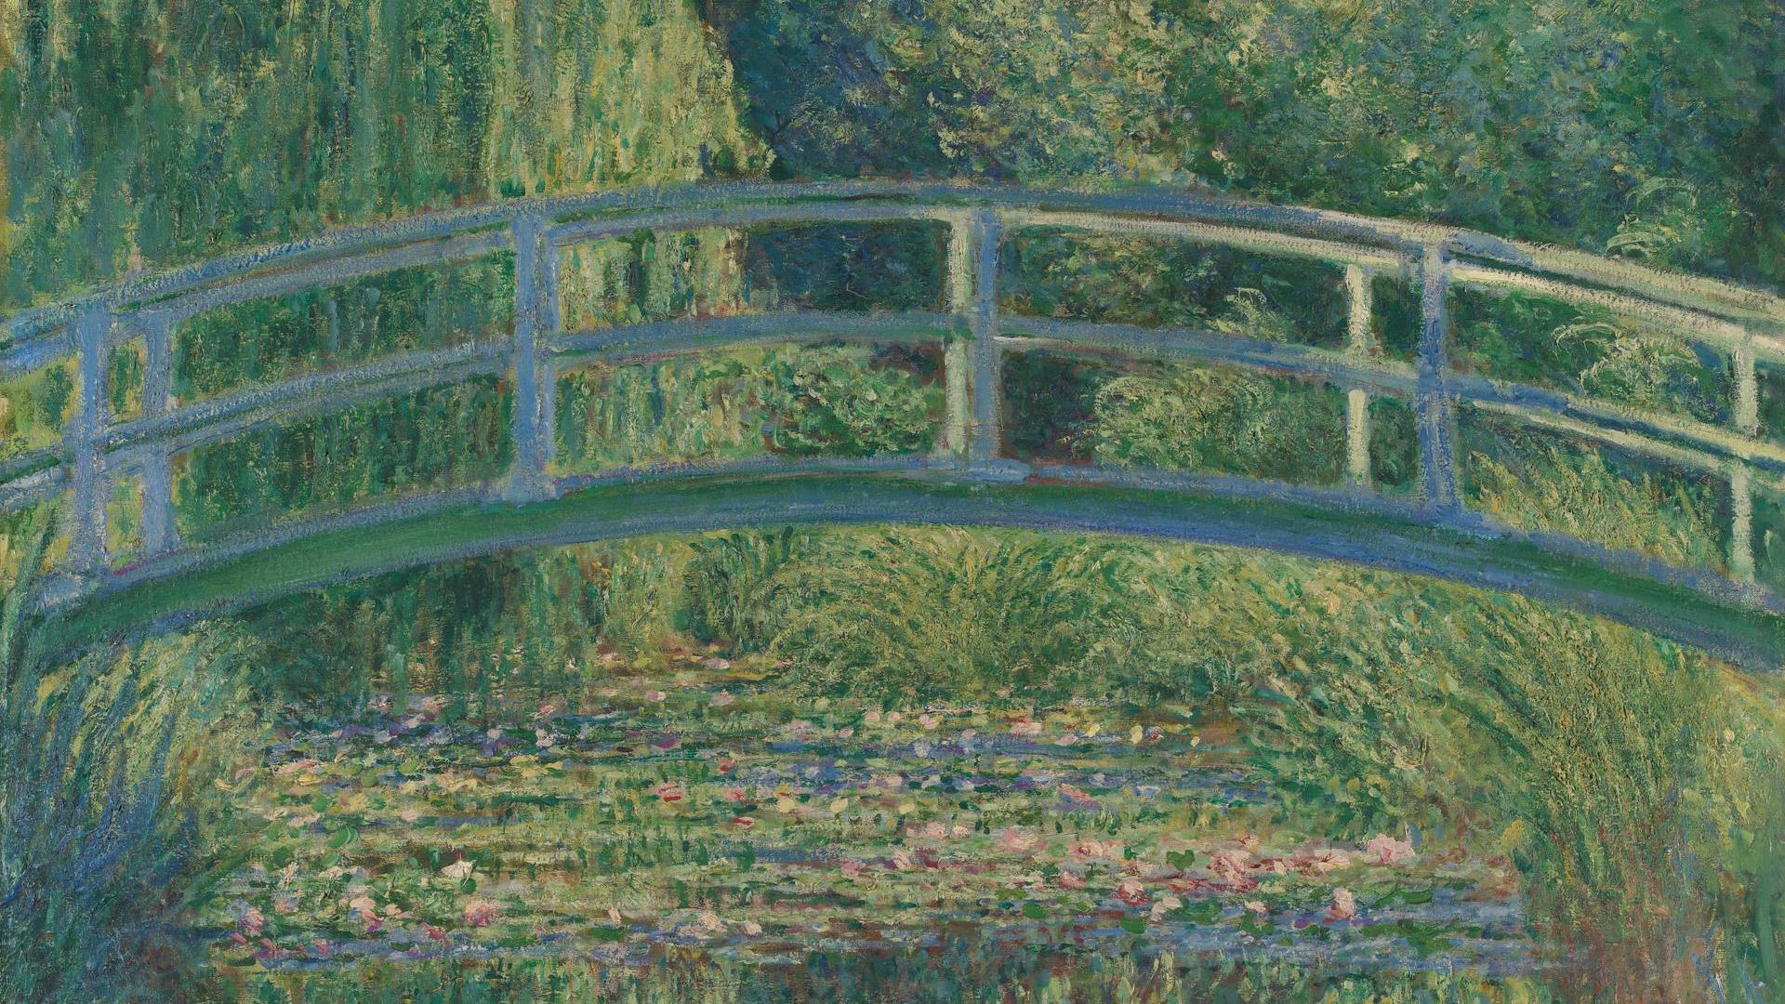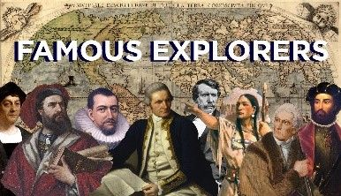 

**In Computing we will:** be learning to use animation through the programme Scratch.

**In R.E we will:** be learning about how people of different faiths use ceremonies to express their world view.

**Dear Parents and Year 3 and 4 children,**

This term we will be exploring the History topic ‘Who explored the world?

**Our learning challenges for this term are:**

**LO: To know what makes a person significant**

**LO: To know some of the challenges faced by explorers.**

**LO: To know about Neil Armstrong**

**LO: To know about Amelia Earhart.**

**LO: To know about Christopher Columbus.**

**LO: To know about Amy Johnson.**

**LO: To know about Ernest Shackleton.**

**As mathematicians we will:** continue our learning on multiplication and division. We will be looking at factor pairs, scaling and multiplying a 3-digit number by a 1-digit number both with and without remainders. Continue practising your times tables on TT Rockstars!

**As authors we will:** be reading ‘The Day the Crayons Quit’ by Oliver Jeffers before

writing our own persuasive letters.

Later in the term, we will look at diary

writing and write our own entry as an

explorer.

**Who explored the world?**

**As artists we will be:**

Recreating a Claude Monet piece whilst developing

our watercolour

techniques.

**As musicians we will:** be continuing our whole class music tuition every Friday with Mr Roberts.

**As readers we will:** be reading The Extraordinary life of Amelia Earhart as our class book and Planet Omar during guided reading.



**As scientists we will:** be investigating forces and magnets. We will explore different types of surfaces such as rough or smooth and learn about friction. We will also learn about magnets and magnetic materials.

**In PSHE we will:** be learning about responsibility and how that looks for different people of different ages. We will also look at the difference between borrowing and stealing.

**In MFL we will**: be learning how to talk about food and express likes and dislikes.

**As athletes we will:** be learning tennis and cricket during PE sessions every Monday and Wednesday with Coach Jack. Wrap up warm!