Welbourn Church of England Primary School
‘Believe, Excite, Succeed, Together’
Topaz class. Reception.
Topic: Is a castle a safe place to live? |  | Subject: History
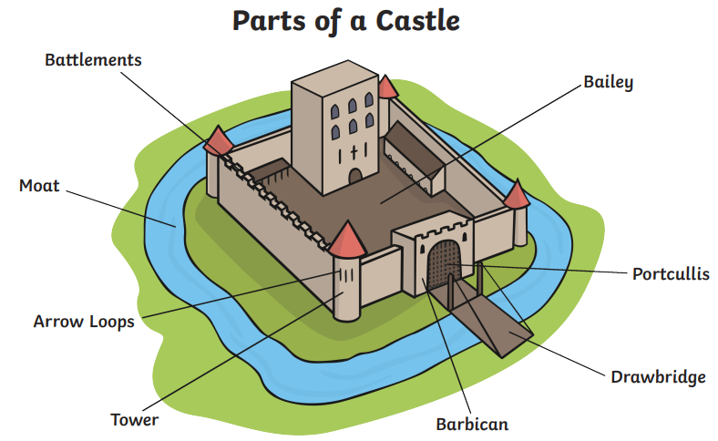
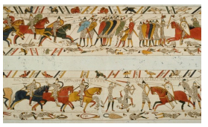

Key Vocabulary
Castle | A large building, typically of the medieval period, fortified against attack with thick walls, battlements, towers, and in many cases a moat.
King | Male ruler of a country. Can be husband to Queen.
Queen | Female ruler of a country. Can be wife to a King.
Knight
Past
Attack
Defend

