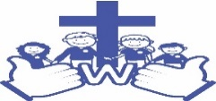

Welbourn Primary School
‘Believe, Excite, Succeed, Together’
Topaz Choose from the selection of projects to complete…
Home baking  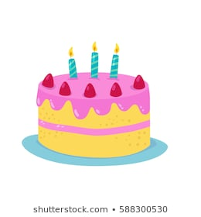  Could you write a list of what’s included in your baking and draw a picture of your finished item? | Expressive Arts  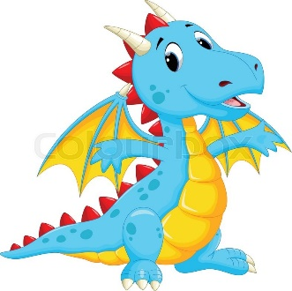  Paint or draw a king, princess, knight or dragon | Shape, Space and Measures  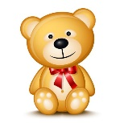  Use a favourite toy as a measure to compare things to. Can you sort into 2 groups- longer than/shorter than my teddy. | RE  Linking in with our RE this term, make thank you cards for special people that you know.
Reading  Can you draw and write about a character from your favourite story? | 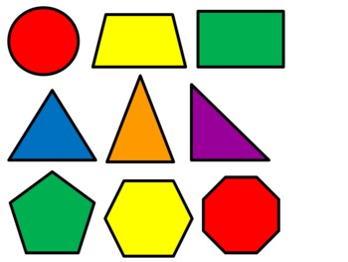  Draw a castle picture using 2D shapes. | 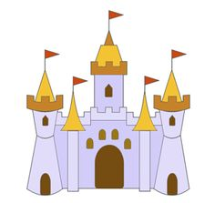  Make a model of a castle. | 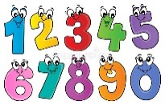  Practice writing your numbers to 10 and beyond. What number can you count up to?

