Welbourn Primary School
‘Believe, Excite, Succeed, Together’
Choose from the selection of projects to complete…
Produce a power point or create a poster about healthy living, diet and exercise.  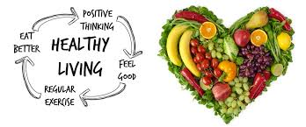 | Create a painting or sketch of a Viking warrior using the work of Arturas Slapsys.  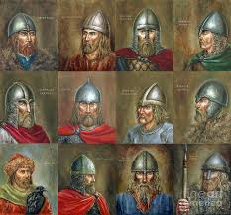 | Carry out research on the Viking settlements in Lincolnshire and present it in a fact file.  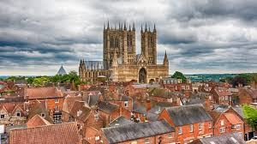 | Bake a cake or cook a main course; take photos and write instructions.  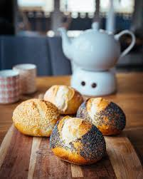
Make a mini book of poems or stories with pictures.  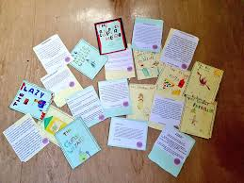 | Create a knowledge organiser of the human body and how it works  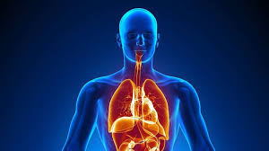 | Make a model of a Viking longboat or longhouse.  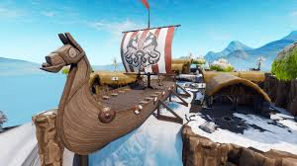 | Create a mini book of different fractions, decimals and percentages.  