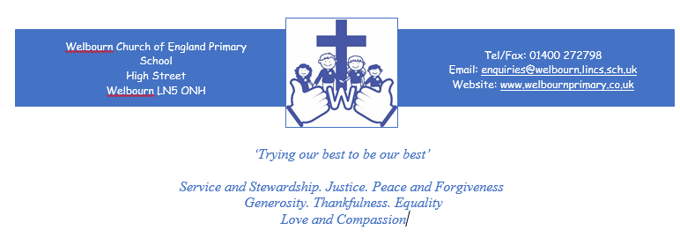

Welbourn Church Of England Primary School

Positive behaviour Policy

November 2018

Date Ratified by Governors: | November 2018
Review Date: | November 2021
Signed by Chair of Governors:
Name of Chair: | A Jackson

Introduction
At Welbourn C of E Primary School, it is our privilege to nurture and inspire each other to be considerate, hard-working and creative; reaching our potential in a loving school community.
We do this by:
- Providing a stimulating and enriching curriculum, tailored to meet the needs of all learners
- Continuously setting high expectations required to strive for personal excellence.
- Providing nurture and security, reflected in a caring Christian ethos.
- Affording creative opportunity, enabling children to flourish in art, music and drama.
- Encouraging teamwork and respect; governors, staff and children working together in our school and wider community.
- Valuing each individual, ensuring that each child’s unique qualities are developed and they receive the education they deserve.
- Unlocking the potential in each individual and developing academic skills needed for lifelong learning, including ingenuity, problem-solving and curiosity.
- Fostering a positive atmosphere in developing essential emotional skills, including aspiration, perseverance, and independence.
At the heart of all we do, we strive to make our children’s experiences of primary school enriching, engaging, successful, happy and fun.
Principles
Our vision for this school is that children leave with secure academic achievements and the personal attributes required to embrace future learning and opportunities. Excellent behaviour is fundamental to our ability to achieve this. We expect the school to encourage, support and expect excellent standards of behaviour from all of our children, and for this to be modelled by our staff, parents, governors and visitors. Good behaviour is essential for the safety of everyone in our school. Our children and staff have the right to feel safe at all times.
Our school has an important role to play in assisting pupils to grow up with a respect for the needs of others and an appreciation of the importance of high standards of behaviour in a civilised society. We aim to support pupils to develop self-discipline and self-respect together with the basic virtues of honesty, fairness and good manners. We believe that school should provide a safe and secure learning environment free from the threat of bullying. Violent and aggressive behaviour, swearing, sexist and racist attitudes and remarks and all forms of harassment including bullying, are unacceptable. Such behaviour will not be tolerated and will be dealt with seriously (see Anti-Bullying Policy).
We expect that the school behaviour policy should be applied consistently and fairly.
We recognise that everyone must take responsibility for their own actions and the effects these have on themselves and others. We will encourage people to make the right choices thinking about the values that we have within this school. Where pupils, staff, governors, parents or visitors exhibit behaviour that is not acceptable, we expect them to be challenged on this and face appropriate action to ensure the safety and learning of others. Where people exhibit particularly good behaviour, we expect this to be recognised and rewarded.
Our children, parents, governors and staff are part of our school, and reflections of it. As such, we expect the school to deal with behaviour outside school that reflects on the school as an organisation or individuals within the school using the same behaviour policy that applies for behaviour in school.
This behaviour policy will take into account our legal duties under the Education Act 2002, the Equality Act 2010, the Education and Inspections Act 2010, and guidance from the Department for Education relating to behaviour and discipline within schools. Governors must be satisfied that sanctions and rewards set out in this behaviour policy are lawful.
Staff Responsibilities
- Have clear rules and routines for behaviour in classrooms, and take responsibility for promoting good and courteous behaviour both in classrooms and around the school, in accordance with the Teacher Standards and school’s behaviour policy
- Have high expectations of behaviour, and establish a framework for discipline with a range of strategies, using praise, sanctions and rewards consistently and fairly, manage classes effectively, using approaches which are appropriate to pupils’ needs in order to involve and motivate them
- Maintain good relationships with all pupils, exercise appropriate authority, and act decisively when necessary.
- To treat all children fairly and with respect
- To help ALL children to develop and exceed expectations
- To provide a challenging, interesting and relevant curriculum and a consistently high level of teaching
- To create a safe environment both physically and emotionally
- To be a good role model at all times
- To form and maintain positive relationships with parents and children
- To recognise and value the strengths of ALL children
- To offer a framework for teaching the personal, social and emotional skills and abilities that underpin the school’s behaviour policy.

Parents’ Responsibilities
- To make children aware of appropriate behaviour;
- To encourage independence and self-discipline;
- To show an interest in all their child does in school;
- To support the school in implementing this policy; and
- To be aware of the school rules.

Children’s Responsibilities
- To always do their best, have high expectations of self and others and aspire to be an ambassador for the school
- To have ownership of their own learning, aspiring to be an independent learner
- To treat others, their belongings and the environment with respect
- To show consideration and empathy for others regardless of background culture or faith
- To consider the effects of their actions on others

Our rewards system is a proactive way of encouraging pupils to focus on learning, achievement and progress and to set very high standards for their behaviour.
Practice
The 5Rs
- Rights
- Rules
- Routines
- Respect
- Responsibility
These are shared with all children and displayed in every class at the start of each year as
part of the ‘New Beginnings and Belongings’ theme week. They are used to establish each
classes ‘Class Charter early in the academic year. A vital part of these are our Golden Rules
which have been devised by the children in school:
- Treat everything and everyone with respect.
- ·Always be kind and polite to each other.
- ·Keep your hands and feet to yourself.
- ·Walk sensibly and calmly around school.
- ·Listen carefully and do as you are asked the first time.
- ·Be happy and always try to do your best.
These are on display in each classroom and around the school. They are used by all staff,
including lunchtime staff.
The 2Cs
- Choices
- Consequences
These work alongside the 5Rs highlighting to our children that for every choice they make,
there is a consequence for their actions. When the 5Rs are introduced, the 2Cs will be
discussed to enable children to recognise their role. Children who may display
inappropriate behaviour in our school are not referred to as ‘naughty’ but are considered to
have made the ‘wrong choice’ and therefore there must be an appropriate consequence.
Positivity around children making ‘good choices’ ensures children understand that when we
do as we are asked, we naturally receive the positive consequence.
Consequences /Sanctions
Each class creates and signs their own class charter/ set of rules which is based on what they feel is important for ensuring their class is a safe and happy place to learn and play. The school also sets clear rules for behaviour. These are communicated via the Golden Rules which are discussed with each class and displayed clearly around the school. The consequences in the form of steps are also discussed and displayed in each class and around the school environment.
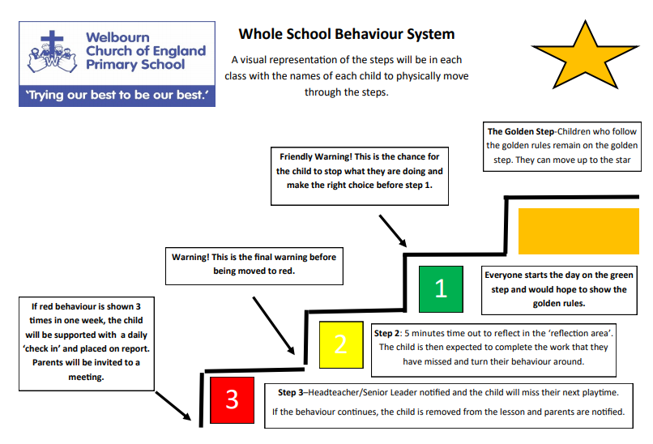
The Golden Step

Good to be Green
This is a clear visual system, which empowers our children to consistently learn and behave in a respectful manner. Children are recognised for good behaviour but are also provided with several opportunities to reflect and change their behaviour if the need arises.

The Golden Step- Children who follow the golden rules remain on the golden step reinforce
to pupils that remaining on the Golden Step ensures they are eligible for all
of the positive elements of school that are offered each day.
- The Golden Star-The children who display that they have consistently displayed
positive behaviour and/or undertake an act deemed to need to be rewarded more
highly than a team point can have their name moved up to the Golden Star. They will receive a Gold star sticker. Children will collect Gold Star wards to receive a greater achievement as decided by the School Council each year.
- When children are on red behaviour or step 3, the incident will be logged on CPOMS and parents will be notified. If a child is already on red and continue to show the same behaviour, the child may be removed from lesson.
- Lunchtime supervisors can move children down the steps and provide sanctions of
5, 10, 15 minutes in the outside reflection area and their class teacher informed at
the end of the lunchtime period.
- Letters will be sent home to parents to invite them to a meeting if their child displays red behaviour 3 times or more in one week. A discussion will take place on how to best support the child further to enable them to make positive behaviour choices. This may include being put on report or having additional intervention or support.

If no further progress is made, other options will be considered. This will include a meeting between all parties to consider the next best step. It is likely that the Special Educational Needs Co-ordinator (SENCO) will be involved in drawing up an Individual Behaviour Support Plan agreed by child, parents and teacher. This outlines the specific targets/areas being worked on and may result in a PSP (Pastoral support plan) being made. Other external agencies may also be involved and an application may be made to BOSS (Behaviour outreach support service). In extreme cases, a child may be excluded from school. In such cases, the latest guidelines from the Local Authority (LA) will always be strictly adhered to (see Exclusion Policy).
Rewarding Positive Behaviour
It is important that different age groups have appropriate rewards and that they are
awarded consistently. Each class teacher decides upon these rewards for their new class in
September, taking into account what has happened in previous years. Examples of these
are:-
Individual rewards
- Verbal praise
- Stickers
- Postcards of Praise
- Special Mentions in Collective Worship
- Name moved to the Gold Star (Gold sticker awarded)

Class Rewards
These are used to reinforce behaviours that we are teaching the children from the time they start school. Points may be earned in a variety of ways –collecting pebbles in a jar to enable them to have a class treat, star of the day to sit on a cushion/ comfy chair the next day etc
Team points
Children are grouped vertically across all Classes into 4 teams. Team points are awarded for
working towards our school values and for following our Golden Rules, displaying effort and
positive attitudes.
The school values are;
- Service and Stewardship
- Justice
- Peace and Forgiveness
- Generosity
- Thankfulness
- Equality
- Love and Compassion
Team points are shared weekly in a Friday’s worship. These are collected over a term with the winning team receiving an award at the end of each small term. (Decided by the School Council).
Lunchtime Rewards and Sanctions
Lunch time supervisors have the same system of Golden Rules and Behaviour Steps
Sanctions as the rest of the school. Lunchtime supervisors can move children down
the steps and provide sanctions of 5, 10, 15 minutes in the outside reflection area
and their class teacher informed at the end of the lunch session.
Lunchtime supervisors will reward good behaviour with:
- Verbal praise
- Stickers
- Special jobs
- Talking to the teacher
- Certificates

Behaviour, consequences and sanctions
Colours of behaviour steps
Continuously showing outstanding attitude and exceptional green behaviour, in line with the school values may result in being moved up onto the gold star.
Children who follow the golden rules remain on the golden step
Everyone starts each day on green / after being on red/ yellow children can return to green after their consequence
- Listening  - Respecting equipment  - Extending work independently  - Helping  - Working hard  - Respectful  - Kind to others  - Lining up on time  - Politeness  - Demonstrating our church school values | This behaviour should be reinforced with positive praise by adults in the classroom; being explicit about behaviours.
- Not following class management rules e.g. tidying up, refusal in the first instance, telling tales unnecessarily  - Not sharing  - Ignoring adults reasonable requests  - Talking at an inappropriate time  - Disrespectful to others e.g spoiling their game or work  - Lying if truth is immediate  - Shouting out  - Inappropriate noises  - Damaging property  - Making fun/taunting/teasing  - Sitting unsafely  - Running in corridors  - Not trying your best | They will need some ‘time to reflect’ in a quiet place in the classroom.  Children can turn their behaviour around to green behaviour, and return to green on the chart.  Children should be encouraged to speak to an adult (TBC) at break time to discuss ways to cope with their behaviour, in order to avoid further yellow or red behaviour.  If the child is on yellow on the chart, and this behaviour continues, they may move to red.
- Bullying  - Physical violence e.g. spitting, kicking, punching or scratching  - Fighting  - Swearing  - Spitting  - Defiance  - Rudeness to other children  - Rudeness to adults  - Leaving the classroom without permission  - Deliberate damage to school or personal property and resources  - Proven stealing  - Witnessed racist incidents  - Persistent lying | A child is moved to red immediately when a child demonstrates any red behaviour as shown.  The child’s name will be recorded in a behaviour record on CPOMS.  Children MUST attend ‘time to reflect’ at lunchtime if placed on red behavour and work with an adult on feelings and behaviour.
If a child is demonstrating red behaviour and distrupting whole class learning, then they will be given a warning that they will be removed from the lesson. Or you need to remove the class if safety is compromised.
Here is a list of adults who will support with this, in this order:
- Send the ‘adult help card’ to the nearest adult
- Claire Cottam (SENDco)
- Tracy Boulter (Headteacher)
As much as we can we want to ensure that the relationship isn’t broken with the CT, we want them to stay in class.
If a child is placed on Step 3 (red behaviour) 3 times in one week or they have had to be removed from a lesson, they must then begin ‘Check-in/check out’ sessions with an adult for the rest of the term. The child will ‘check in’ at the start of the morning session and ‘check-out’ at the end of each day. Parents will be notified of this.
If there is no change in behaviour following ‘Check-in/check-out’, parents will be asked to attend a meeting with the class teacher to discuss.
If the behaviour continues then the class teacher meet with parents to discuss extra support. Claire Cottam may be invited here. (Boss ladder of intervention)
If they are at risk of exclusion or continue these behaviours after all of the above then they and parents will meet with Mrs Cottam and or the Headteacher. (Mrs Boulter)

The practice of managing pupil behaviour on a day to day basis is underpinned by the Golden Step. The scheme provides:
- a consistent and fair approach to behaviour management;
- clear and visible systems to recognise good behaviour and sanctions for inappropriate
behaviour;
- a structure that allows children to take ownership of their behaviour.

The scheme works on the principles that:
- each day is a new day; each session is a new session
- each class has a clearly visible behaviour chart and each day all children begin on green to demonstrate the expectation that each day will be a positive one.

Children know that there are consequences when making inappropriate behaviour choices
Racist Incidents
We reject and oppose racist behaviour. Any child found behaving in a racist manner will be moved to step 3 (red behaviour) and will be sanctioned accordingly, they will be educated and supported to ensure that the incident will not be repeated and parents will be contacted. Time will be given to support the victims who will be treated sensitively. The school keeps a record of all racist incidents in line with government requirements. The governing body are informed of racist incidents.
Bullying
Bullying is unacceptable. Bullying is the wilful, conscious desire to hurt, threaten, intimidate or frighten another pupil. Any incidents of bullying will be immediately dealt with. Please see our Anti-Bullying Policy for our description of what bullying is and our procedures for dealing with it. The Head Teacher will regularly report on the ethos of the school and any bullying incidents to the governing body.
Positive Handling
All members of staff are aware of the regulations regarding the use of force by teachers, as set out in DfES Circular 10/98, relating to section 550A of the Education Act 1996: The Use of Force to Control or Restrain Pupils. Staff only intervene physically to restrain children or to prevent injury to a child, or if a child is in danger of hurting him/herself. The actions that we take are in line with government guidelines on the restraint of children.
All staff have had ‘Team Teach’ training which forms an integral aspect of our positive behaviour management within school. The Positive Handling policy outlines procedures in detail.
Fixed-term and Permanent Exclusions
We do not wish to exclude any child from school, but sometimes this may be necessary. The school has therefore adopted the standard national list of reasons for exclusion, and the standard DfES guidance.
Only the Head Teacher (or the acting Head Teacher) has the power to exclude a child from school. The Head Teacher may exclude a child for one or more fixed periods, for up to 45 days in any one school year. In extreme and exceptional circumstances, the Head Teacher may exclude a child permanently. It is also possible for the Head Teacher to convert a fixed-term exclusion into a permanent exclusion, if the circumstances warrant this.
If the Head Teacher excludes a child, he/she informs the parents immediately, giving reasons for the exclusion. At the same time, the Head Teacher makes it clear to the parents that they can, if they wish, appeal against the decision to the Board of Governors. The school informs the parents how to make any such appeal.
The Head Teacher informs the LA and the Board of Governors body about any exclusion (through his report to Governors and through completion of forms to the LA). The Head Teacher will immediately inform Governors of any permanent exclusion.
The Board of Governors itself cannot either exclude a child or extend the exclusion period made by the Head Teacher.
The Board of Governors has a committee which is made up of between three and five members. This committee considers any exclusion appeals on behalf of the Governors.
When a committee panel meets to consider an exclusion, they consider the circumstances in which the child was excluded, consider any representation by parents and the LA (if made), and consider whether the child should be reinstated.
If the Governors’ appeals panel decides that a child should be reinstated, the Head Teacher must comply with this ruling.
Pupils with Special Educational Needs and Disabilities (SEND)
School Action | The child’s teacher may need to meet with parents to discuss inappropriate behaviour. Targets and a review date may be set. The teacher together with the involvement of senior staff will monitor the child’s behaviour.
 | If after a series of reviews there has been no improvement in the child’s behaviour, they are referred to the SENCo. She will meet with the child’s teacher and parents and gather evidence of behaviours displayed by the child. Targets will be set and Outside Agencies may be involved to provide advice and support.
External Action | If there is little or no improvement, the Lincolnshire Ladder of Behavioural Intervention will be followed. This process will begin to explore any underlying reasons why the child is presenting with behaviour difficulties and may lead onto regular Pastoral Support Programme (PSP) meetings in liaison with the Education Out of Schools Team in order to put an action plan in place so that behaviour can be improved.

Monitoring and Review
The Head Teacher monitors the effectiveness of this policy on a regular basis. They also report to the Board of Governors on the effectiveness of the policy and, if necessary, makes recommendations for further improvements.
The Head Teacher keeps a record of any child who is excluded for a fixed-term, or who is permanently excluded.
It is the responsibility of the Board of Governors to monitor the rate of exclusions, and to ensure that the school policy is administered fairly and consistently.
The Board of Governors reviews this policy every two years or earlier if it is felt appropriate.

