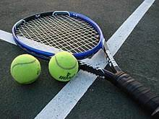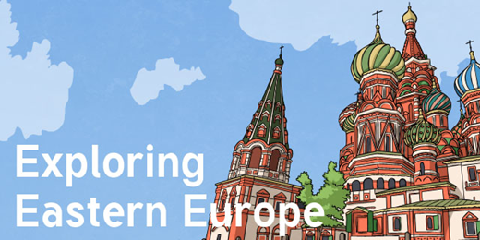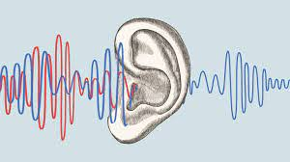

Dear Parents and Year 5/6

In Amethyst this half term we will be exploring the geography topic:

‘How does Eastern Europe compare to where we live?’

We will be learning about the physical and human geography of countries in Eastern Europe, including the climate and landscapes. We will be researching one country and producing an itinerary as though we are travelling there.

We will also be learning about the impact of the Chernobyl nuclear disaster, and the countries that were affected by it.

As scientists we will: be exploring the topic ‘Sound'

We will be learning about how sounds are made and how they travel to the ear, and finding patterns between the volume of a sound and the strength of the vibrations that produced it.

In art we will:

be exploring the work of Lubaina Himid

and learning why she is famous.

As athletes we will:

be developing our skills in tennis and

gymnastics

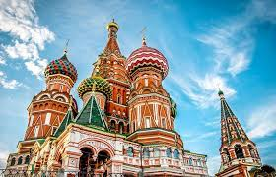

In RE we will:

be continuing to explore the question ‘Creation and Science: Conflicting or Complementary?

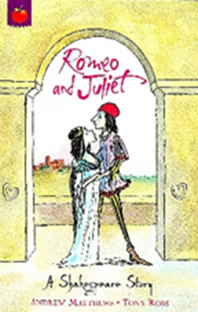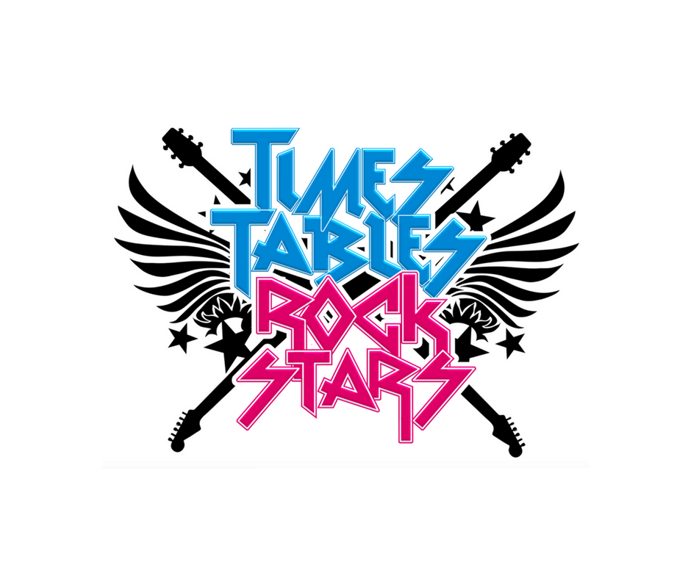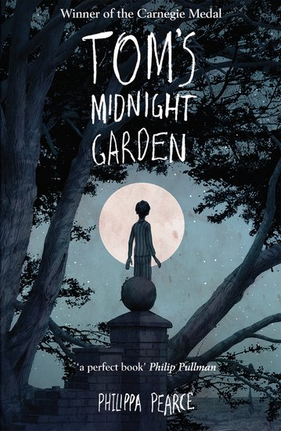the impact of the Chernobyl nuclear disaster

In IT we will:

be learning about variables in games using scratch.

As musicians we will:

be learning a range of instruments through the music service.

In PSHE we will:

be learning about puberty, conception and appropriate touch.

As mathematicians we will:

be learning how to do long multiplication.

We will also

continue with

Times tables

Rock stars!

As writers we will:

be looking at different sentence structures, before writing a narrative

and discursive text

based on Romeo

and Juliet.

As readers we will:

be reading ‘Romeo

and Juliet’

Our Class

book will

be ‘Toms Midnight Garden'

.

‘How does Eastern Europe compare to where we live?’