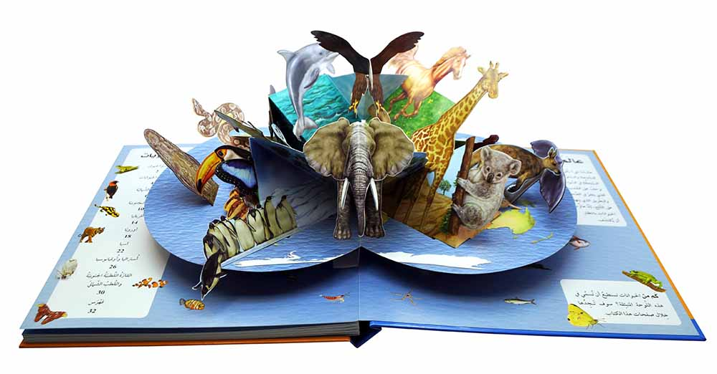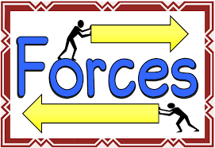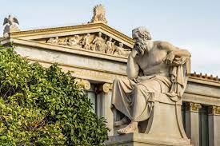 

As global citizens we will: be exploring the topic of pilgrimage,

and what this

involves in

different religions.

As designers we will: be continuing to design and create our 3d pop up books!

Dear Parents and Year 5 and 6

In Amethyst this half term we will be exploring the history topic ‘Who were the Ancient Greeks?.

Our challenge questions are:

LC1: To know about the Ancient Greek Empire

LC2: To know how the political system worked in Ancient Greece

LC3: To know about the Ancient Greek Olympics

LC4: To know about the Battle of Marathon

LC5: To know about Greek Gods and Godesses

LC6: To know about the Trojan War.

As scientists we will: be studying the topic of ‘Forces’ We will be exploring gravity, air resistance, water resistance,

friction and the use of different

levers and mechanisms.

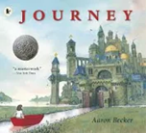

As writers we will:

be writing a newspaper report based on the true story of the 3 little pigs, a setting description, and

developing our spag knowledge through ‘Active English’

Who were the Ancient Greeks?

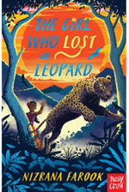

In PE, we will be starting swimming lessons every Thursday morning. Please remember your kit! 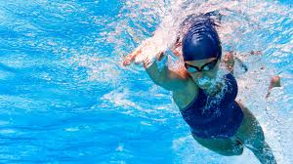

As readers we will:

be developing our comprehension skills

reading ‘The girl who

lost a leopard’. We

will also be reading

short SATs style texts.

In PSHE, we will be:

learning about how to live a healthy lifestyle, and the issues associated with smoking and alcohol.

As mathematicians we will be learning about fractions, decimals and percentages, then area and perimeter.

Y6 will also be learning about algebra, and having revision sessions in preparation for SATS.