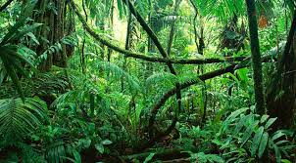 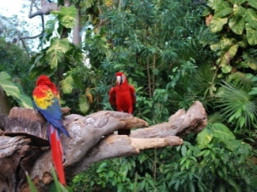 Welbourn Primary School home learning 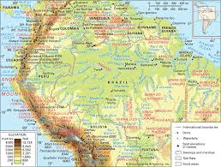 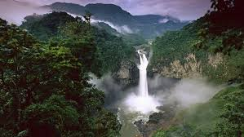
‘Believe, Excite, Succeed, Together’
Summer Term 2 Week 7 The Amazing Amazon!
During the course of the week, we would like you to complete the following learning. We understand that this is a very difficult time for us all and that some children will struggle to engage with learning at times. This learning is for your child to complete at your own pace, if you wish to do more, you can access learning on our school website, on your class page via the padlets.
Moonstone Class Week 7 Summer Term 2
9.00 – 9.30 P.E daily P.E lessons:
Joe wicks: https://www.youtube.com/playlist?list=PLyCLoPd4VxBvQafyve889qVcPxYEjdSTl
or dance moves with JumpStart Johnny https://www.youtube.com/channel/UC8PDFwCV0HHcl08-1SzdiBw
or Strictly Come Dancing’s Oti Mabuse https://www.youtube.com/channel/UC58aowNEXHHnflR_5YTtP4g
or Cosmic Kids Yoga https://www.cosmickids.com
Why not have a go at some home learning P.E Challenges 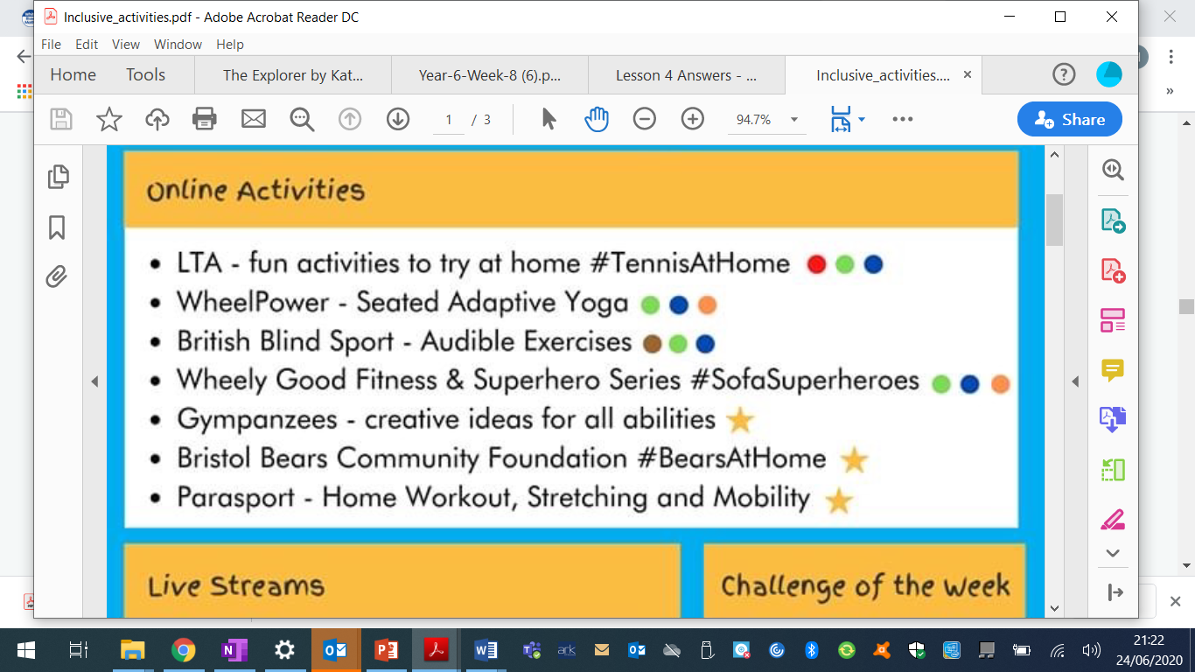 See our class padlet for details.
Maths:  Daily maths lessons can be found at: https://whiterosemaths.com/homelearning/year-5/ Week 12  https://whiterosemaths.com/homelearning/year-6/ Week 12 Worksheets attached  Please use your maths text books and then if you require any further work use the whiterose maths sheets.  Keep up with TT Rockstars – see if you are able to improve your Rockstar status!  Challenge: Have a go at some of the maths challenges from Third Space Learning or using Iseemaths.  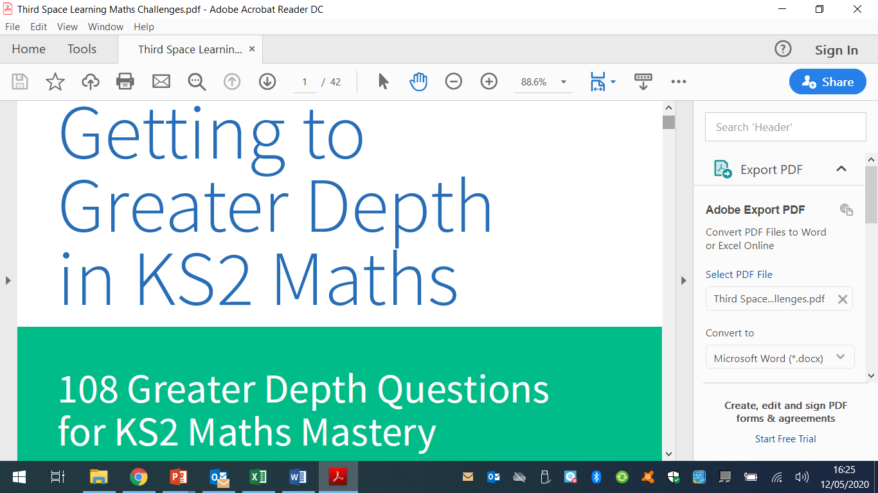  For those wanting extra maths challenges have a go at these https://www.firstmaths.com/mental-maths/fun-lockdown-maths-lessons/year-6-maths/free-year-6-maths-challenges-ks2-fun-teaching-resources/  There are some more maths puzzles and problems using the pdf file which you can find on our class padlet.  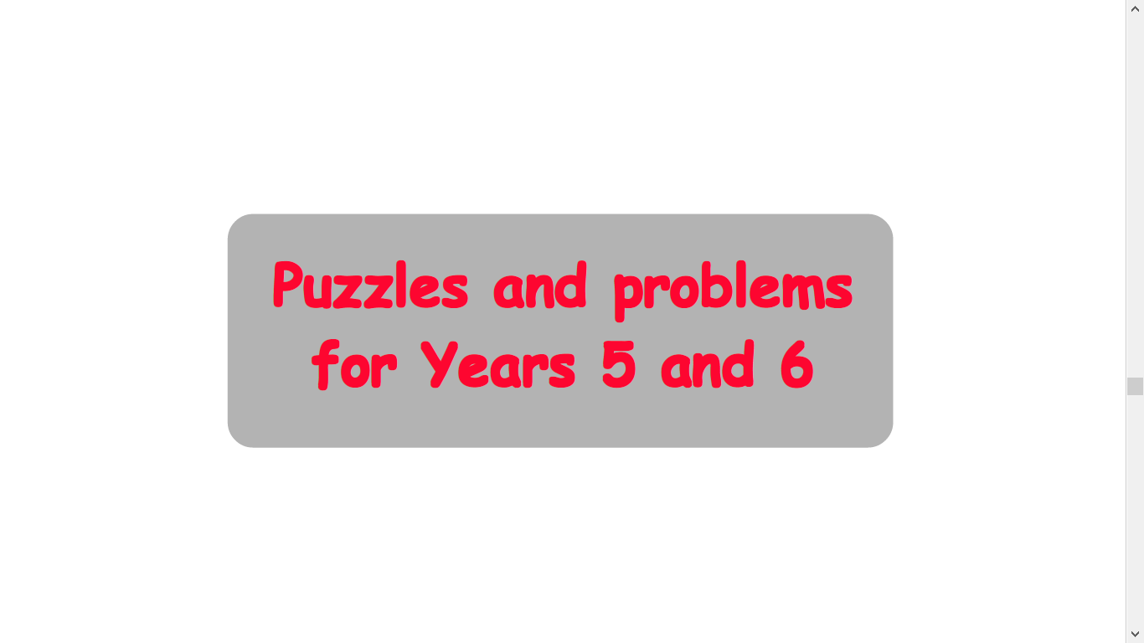 | Reading:  Task 1 – Read Chapter ‘The Raft’ – The ebook can be found under files, class resources on Moonstone Mircrosoft Teams page.  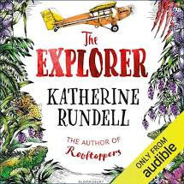  Task 2 – Look up any vocabulary you are unsure of and find out the meaning.  Task 3 – Complete the reading comprehension on our class padlet |  |  | Writing:  Task 1 – This week you will be looking at setting description. Follow the link and watch the lesson on Oak National Academy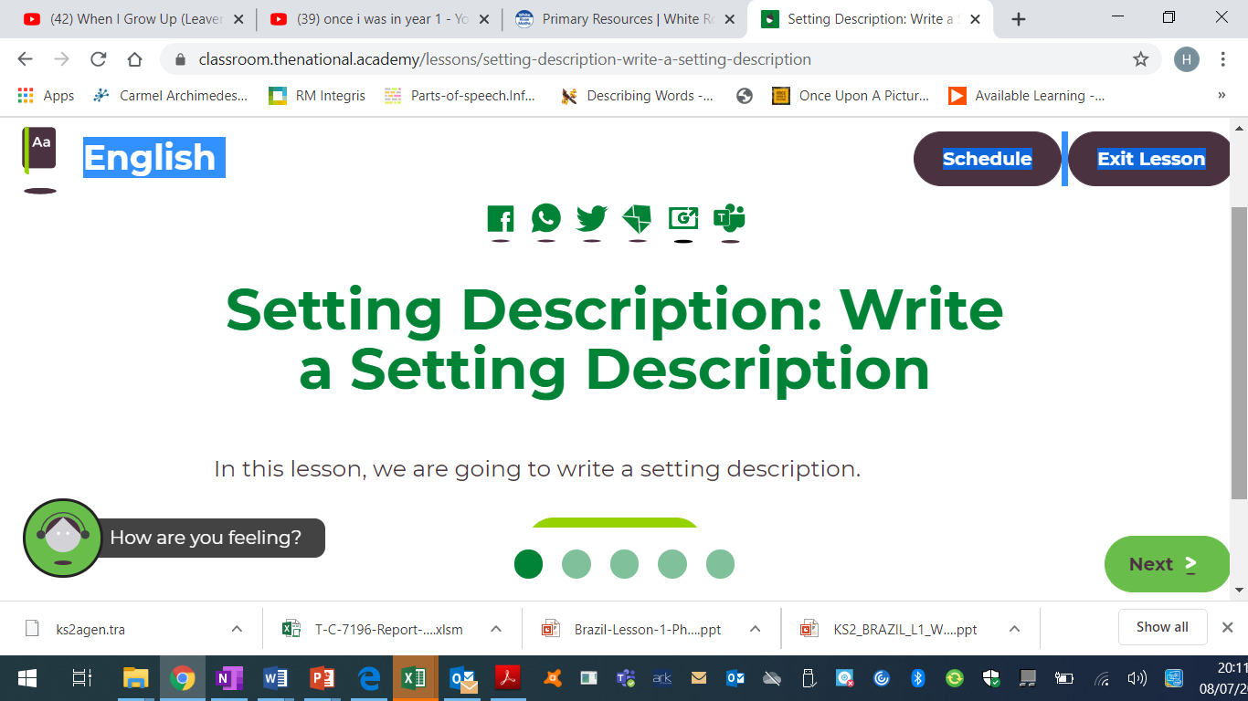  https://classroom.thenational.academy/lessons/setting-description-write-a-setting-description  Task 2 – Using the skills you have learned in the lesson above, I would like Iyou to write your very own story about the rainforest. This could be about the animals (similar to the jungle book) about survival, adventure anything that you would enjoy writing about. It can be a short story or a longer one, the choice is yours.
Spellings to learn this week – This week you have a spelling assessment please download the sheets on our class padlet under English
Topic – Amazon Rainforest  Geography  Task 1 – This week you will be looking at different plants in the rainforest. I would like you to watch these videos before you begin 1) https://www.youtube.com/watch?v=H9MV5CgPgIQ  2) https://www.youtube.com/watch?v=C1Ib0-BlBKU  Task 2 - I would like you to then complete the following worksheet  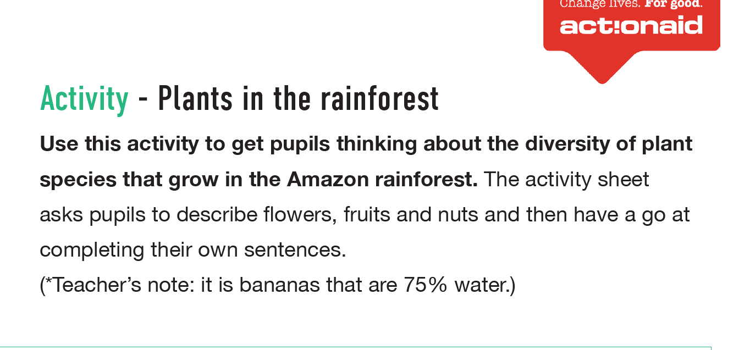  Task 3 – Look through the following slides then complete the worksheet  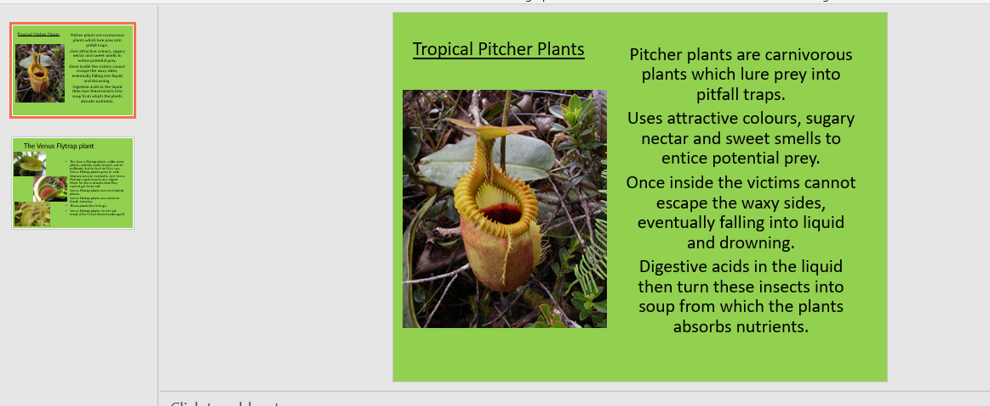  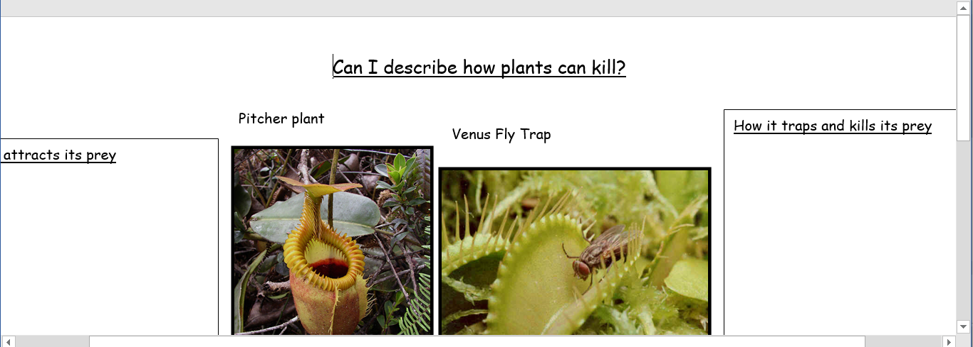 |  | Art / D.T  Task – I would like you to draw yourself as either a caricature with a leavers message to the Year 6’s. I will then photocopy them to make a leavers book to give to them.  For help have a look at this video link https://www.youtube.com/watch?v=qxKe6klFiE0  Task 2 – With the year we have had I thought this would be a really nice activity to complete. If you don’t receive a printed pack, you can find this on our class padlet.  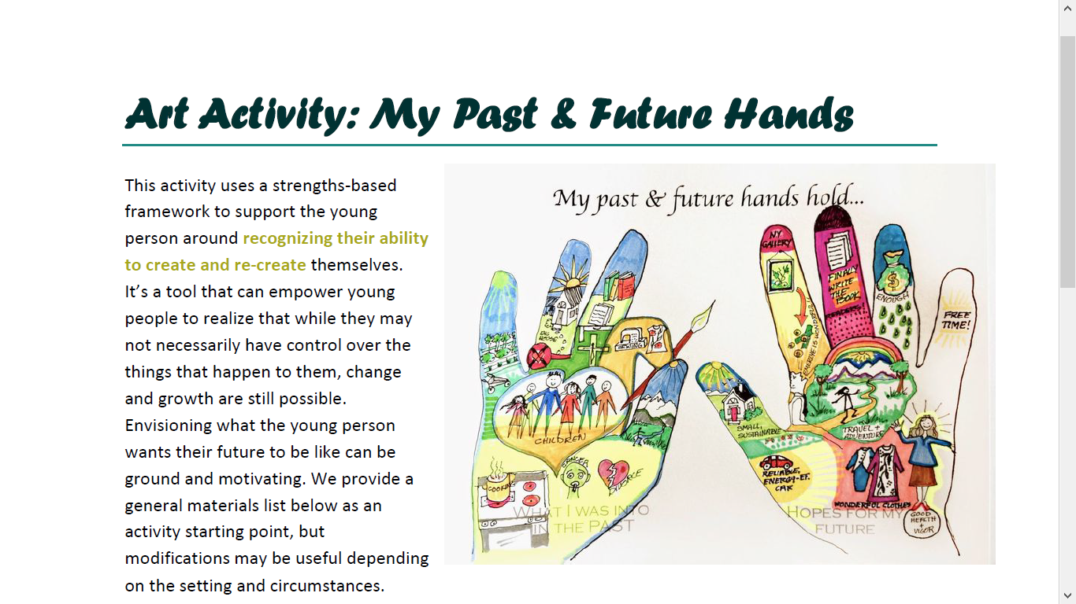 | Music  Task Get creative with music and complete this session  https://www.bbc.co.uk/bitesize/articles/z44x6v4  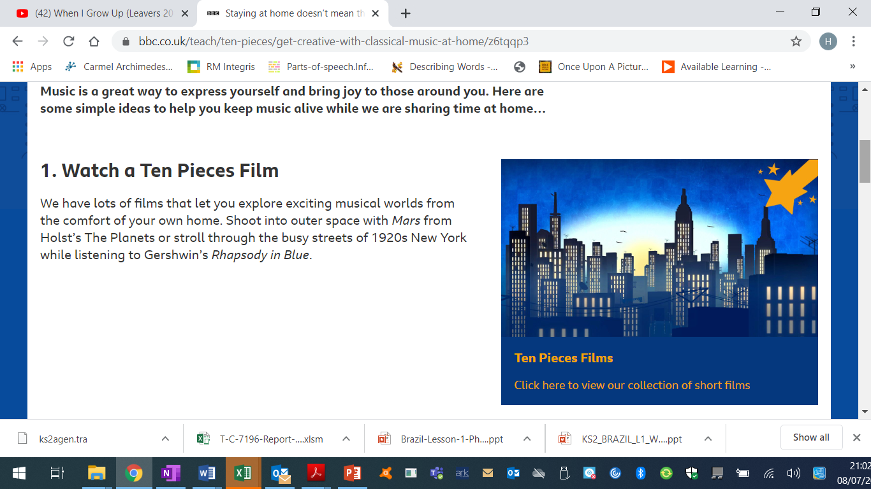  You will be looking at classical music. If you would like to create a piece of art as a follow up task, see the BBC bitesize page just below the video. |  | Science – Animals including humans – Growth of Babies  Task 2 – Complete the worksheets looking at the growth of babies and children  Task 3 - Complete the following worksheet on analysing growth of babies | I.T.  Task 1 – Have a go at creating your very own alien language to move objects.  https://projects.raspberrypi.org/en/projects/alien-language  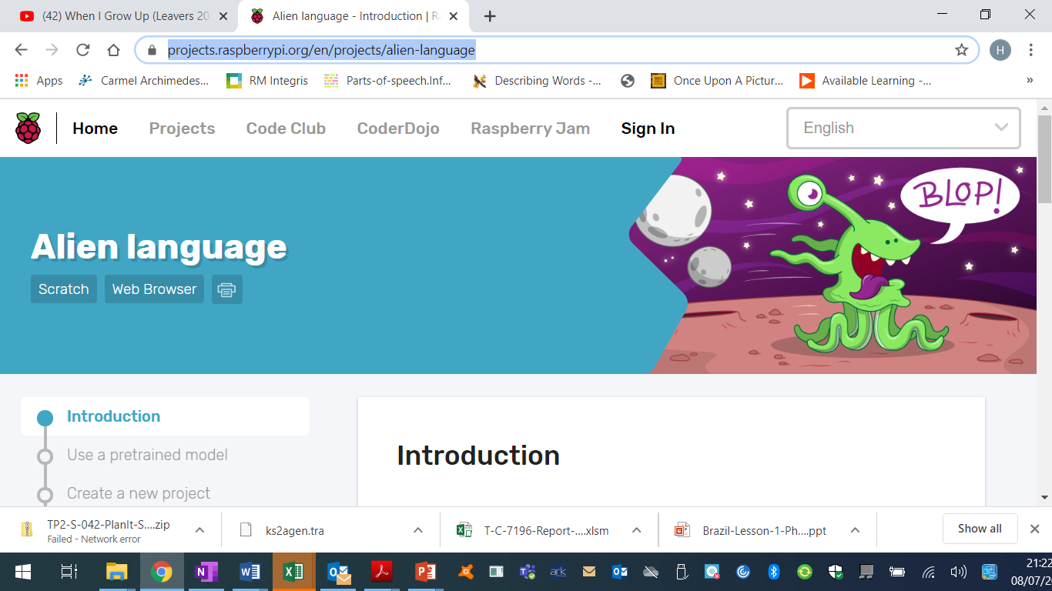  Task 2 – Have a go at making your very own game!  https://projects.raspberrypi.org/en/projects/cd-beginner-unity-sushi  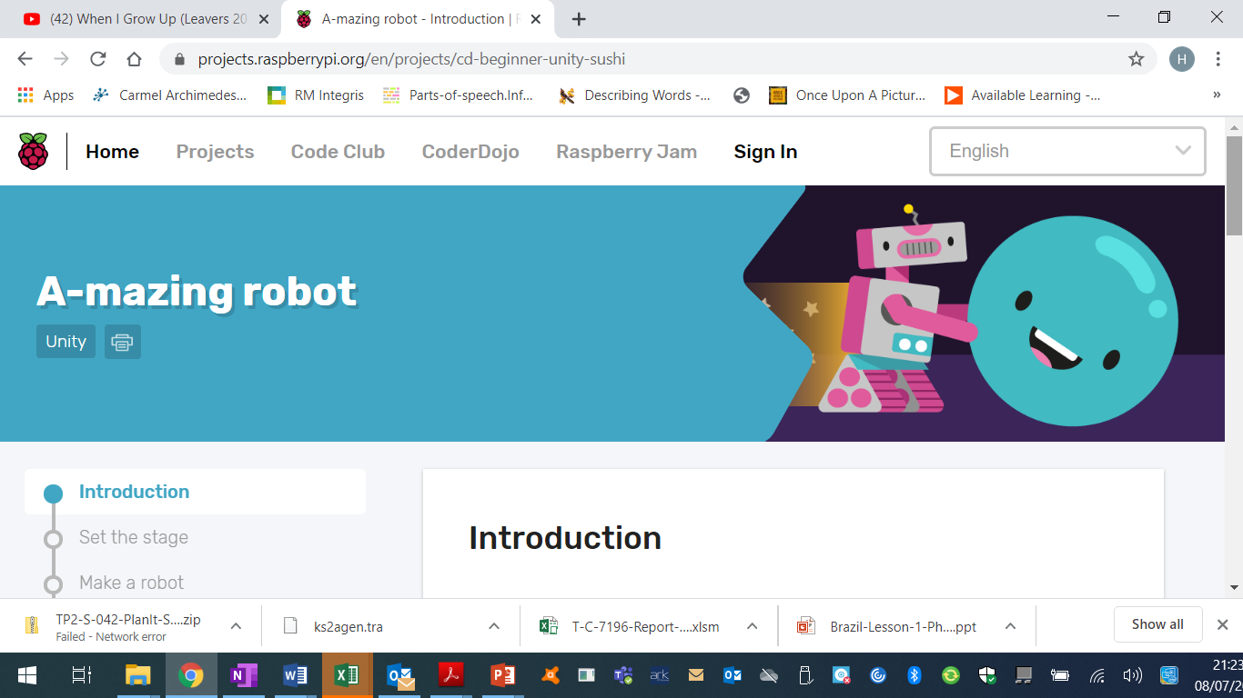
PSHE – This week I would like you to think of how far you have come and look back on what you have achieved. Here is a booklet to complete.  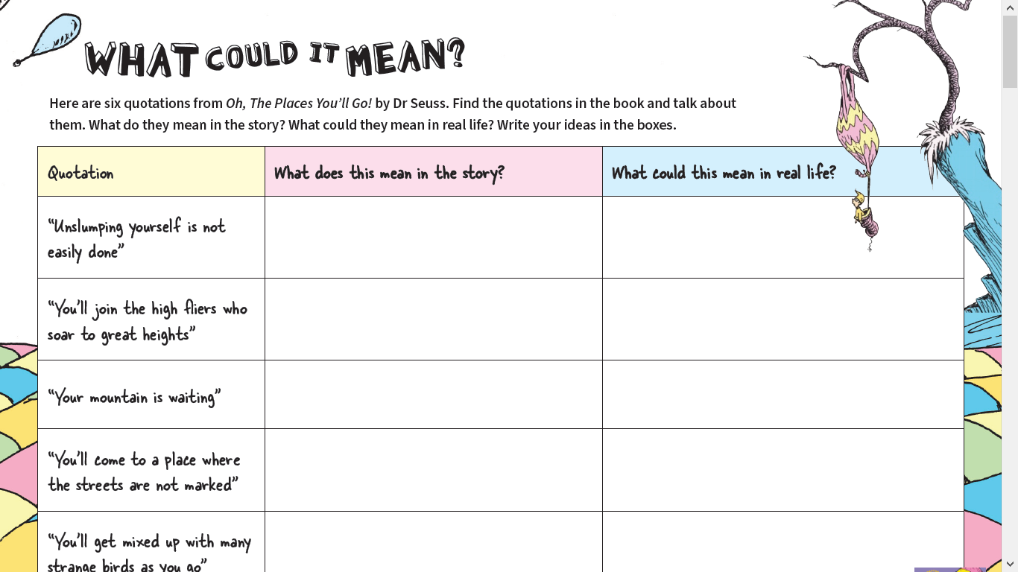 |  |  | French: You can access French learning here: https://www.duolingo.com, it is free to join,  you can take a small test first to see how much you know before moving on.  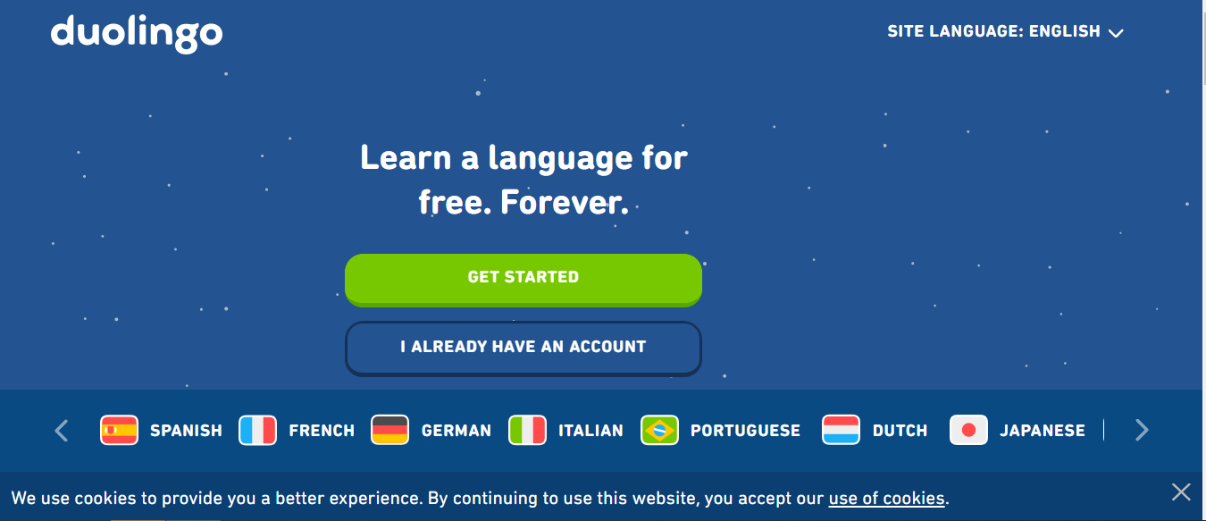  Have a go at this French lesson on BBC Bitesize https://www.bbc.co.uk/teach/school-radio/french-ks2-radio-labo-9-ecole/zv7k382  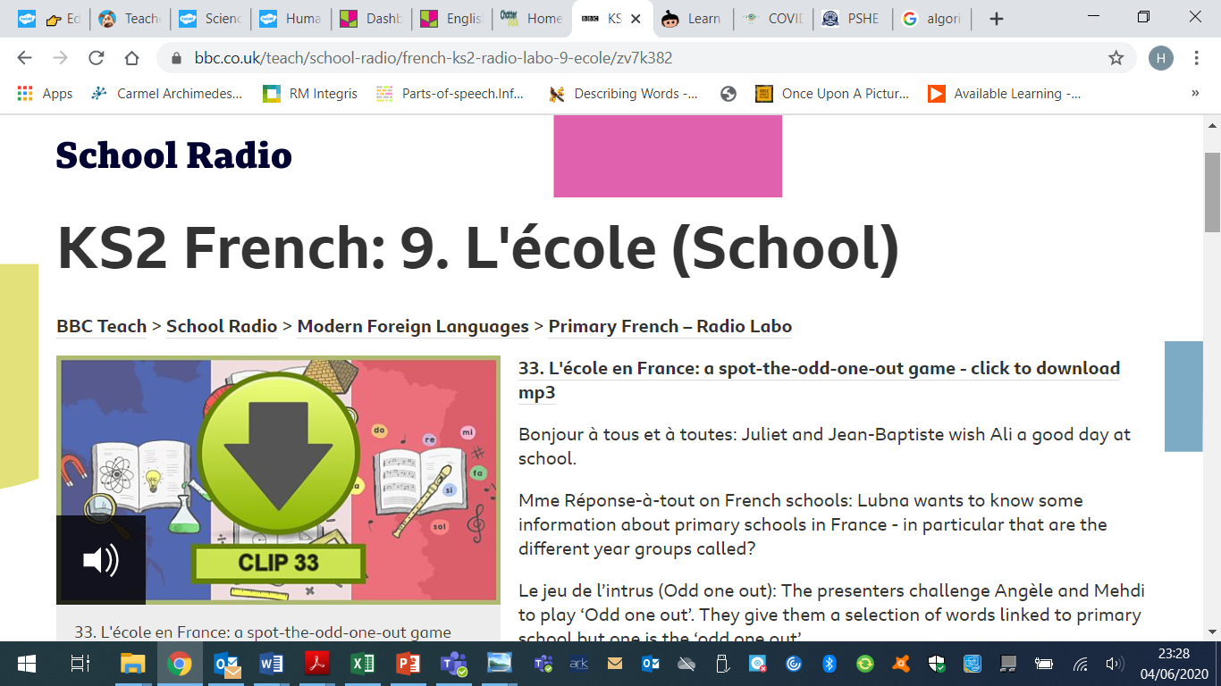  If you fancy something different, try some  French games here: https://www.frenchgamesnet  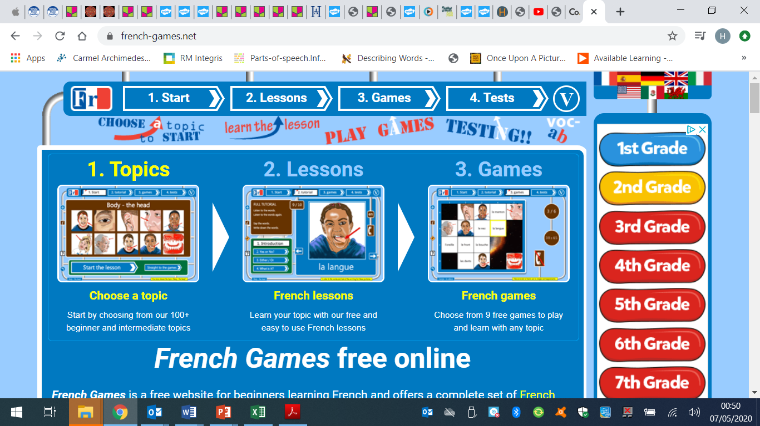

Week 3 - Moonstone Timetable for Microsoft Teams

09:00 Each Monday I will post assignments due for that week which the children will be notified of when they sign in.

14:00 Available for messaging each day

On a Friday we will have a live video with the whole class – Please message any ideas for this week.

This week the assignments due in are:
Art – Wednesday 3:30pm
Science – Friday 3:30pm
Please feel free to message me if you would like any help or support with anything

