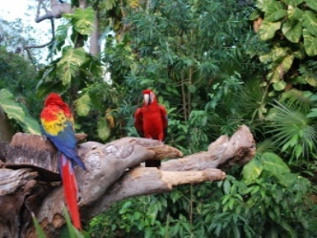 Welbourn Primary School home learning 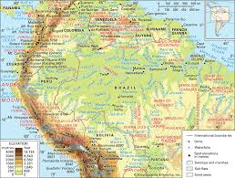
‘Believe, Excite, Succeed, Together’
Summer Term 2 Week 3 The Amazing Amazon!
During the course of the week, we would like you to complete the following learning. We understand that this is a very difficult time for us all and that some children will struggle to engage with learning at times. This learning is for your child to complete at your own pace, if you wish to do more, you can access learning on our school website, on your class page via the padlets.
Moonstone Class Week 2 Summer Term 3
9.00 – 9.30 P.E daily P.E lessons:
Joe wicks: https://www.youtube.com/playlist?list=PLyCLoPd4VxBvQafyve889qVcPxYEjdSTl
or dance moves with JumpStart Johnny https://www.youtube.com/channel/UC8PDFwCV0HHcl08-1SzdiBw
or Strictly Come Dancing’s Oti Mabuse https://www.youtube.com/channel/UC58aowNEXHHnflR_5YTtP4g
or Cosmic Kids Yoga https://www.cosmickids.com

Maths:  Daily maths lessons can be found at: https://whiterosemaths.com/homelearning/year-5/ Week 7  https://whiterosemaths.com/homelearning/year-6/ Week 7 Worksheets attached  Please use your maths text books and then if you require any further work use the whiterose maths sheets.  Keep up with TT Rockstars – see if you are able to improve your Rockstar status!  Challenge: Have a go at some of the maths challenges from Third Space Learning or using Iseemaths.  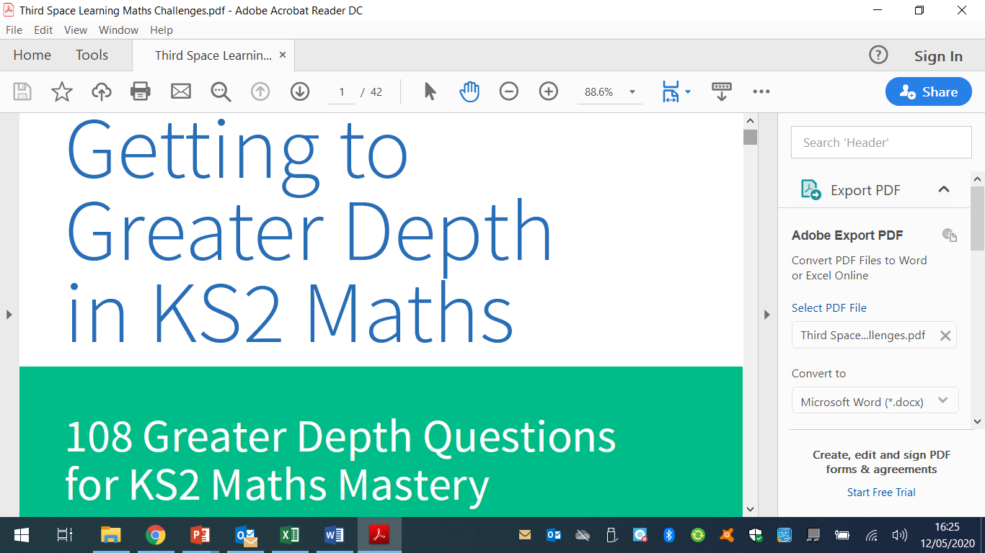 | Reading:  Task 1 – Read Chapter 3 The Den – The Explorer (ebook on padlet)  Task 2 – Look up any vocabulary you are unsure of and find out the meaning.  Task 3 – Complete the reading comprehension on padlet |  |  | Writing:  Task 1 – Watch Pandora https://vimeo.com/193963379  Watch the video clip again, this time you need to listen to the description of the creatures of Panora. (All resources are on our class padlet, or were printed in week 1 if you have your home learning packs printed)  Task 2 – Using resource 3B fill in the blank spaces with suitable words. Can you infer what type of language this might be?  Task 3 –Now look at resource 3A. Look at the cohesive devices they have used i.e. repetitions, adverbials, conjunctions,  substitution of nouns, use of pronouns etc and make a list of all the different ones that have been used. What can you notice? How does this help the reader? 3a uses the idea of talking about hexapods in general then narrows down to discuss the selected creature. Now have a go at improving the paragraph you did last week adding further details and using cohesive devices.
Spellings to learn this week, synonyms and antonyms: ecstatic, jovial, exultant, elated, delighted, despondent, forlorn, dejected, woeful, dismal
Topic – Amazon Rainforest  Geography  Task 1 – Learn why the rainforest is in trouble. You can access the video on the link below. You need to scroll down the page a little to get to it.  https://www.nationalgeographic.org/media/amazon-deforestation-and-climate-change/  Task 2 - Once you have watched the video look at the pdf attached if you have your home learning pack printed or on our class padlet. |  | Art / D.T  Task 1 -Have a look at this link https://www.edenproject.com/visit/whats-on/spirit-of-the-rainforest-art-project  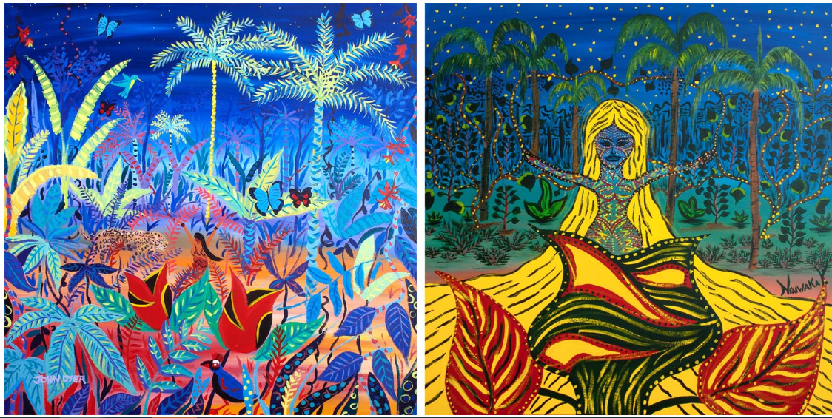  Task 2 – The rainforest artwork above depicts the water spirit of the Amazon. Now have a go at creating your own, using similar techniques to those used in the link.  Task 3 – Can you draw or paint and label the layers of the rainforest, in as much detail as you can. Explaining what each of the layers purpose is. | Music  https://www.bbc.co.uk/bitesize/articles/zkx3bdm  Have a look at the link above and carry out Activities 1,2 and 3  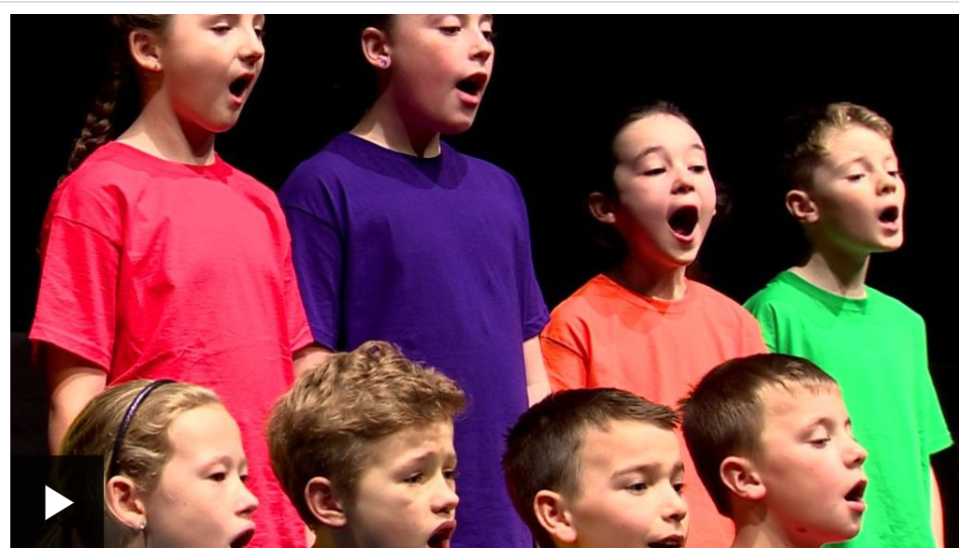  https://www.incredibox.com  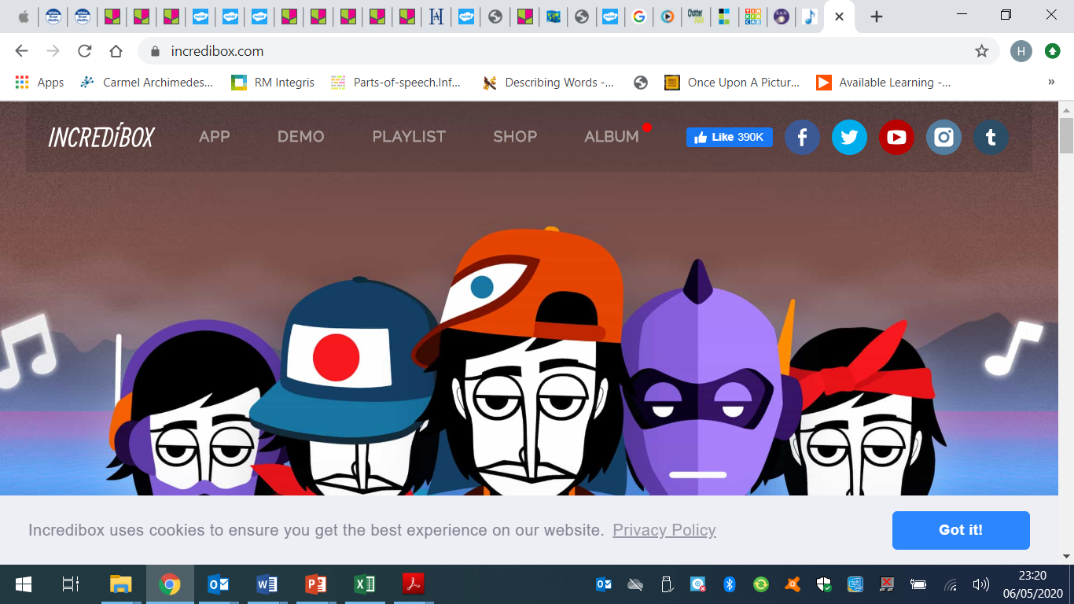 |  | Science – Animals including humans - Puberty  Task 1 - Look through the following power point.  Task 2 – Complete the worksheet attached. You can either do this on your own or go through it with your parents. | I.T.  Task – Look at the pdf on Anti Virus (on our class padlet or attached if you have your home learning packs printed).  Read through the pdf and then answer the questions at the bottom.
PSHE –  Look at the pdf attached if you have your homelearning printed, or on our class padlet.  It is sometimes hard to look at ourselves with eyes of gratitude rather than judgement. This tool is meant to help with self-esteem by reminding us that when we add gratitude to what we are seeing, we are always beautiful and we always have much to be grateful for.  Fill in the mirror and put it up in your home to remind you of your self-worth.  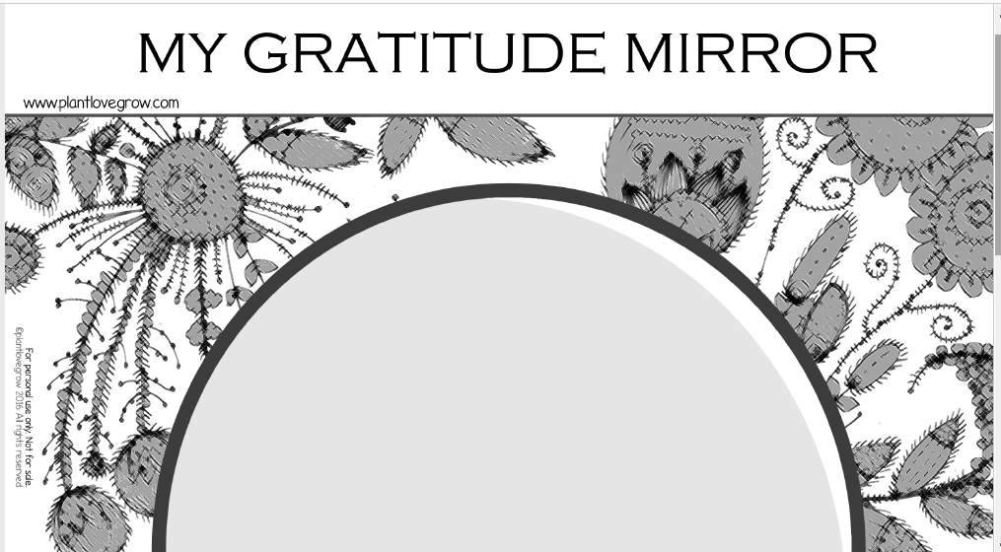 |  |  | French: You can access French learning here: https://www.duolingo.com, it is free to join,  you can take a small test first to see how much you know before moving on.  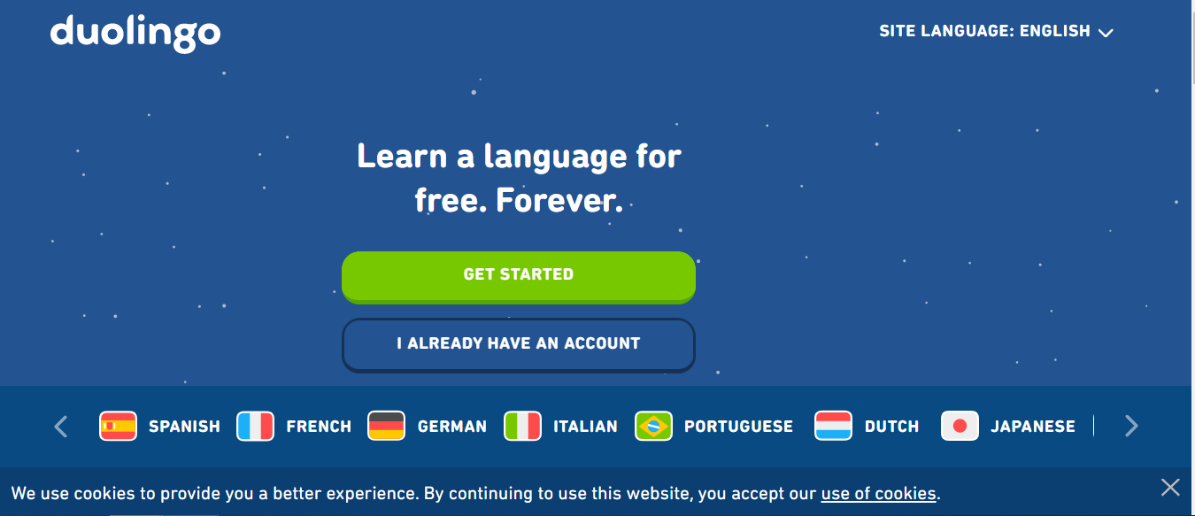  Have a go at this French lesson on BBC Bitesize https://www.bbc.co.uk/teach/school-radio/french-ks2-radio-labo-9-ecole/zv7k382  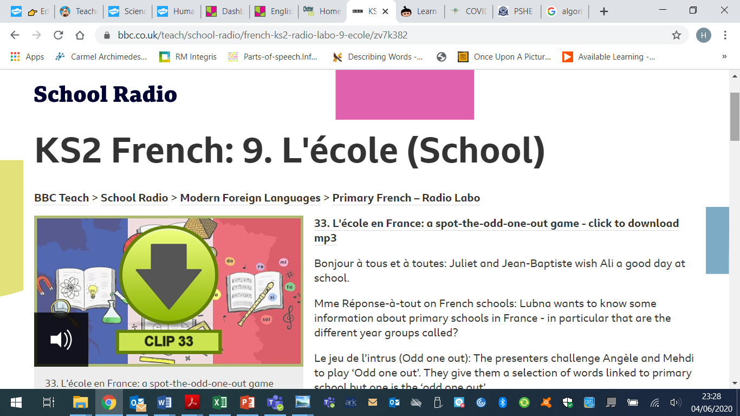  If you fancy something different, try some  French games here: https://www.frenchgamesnet  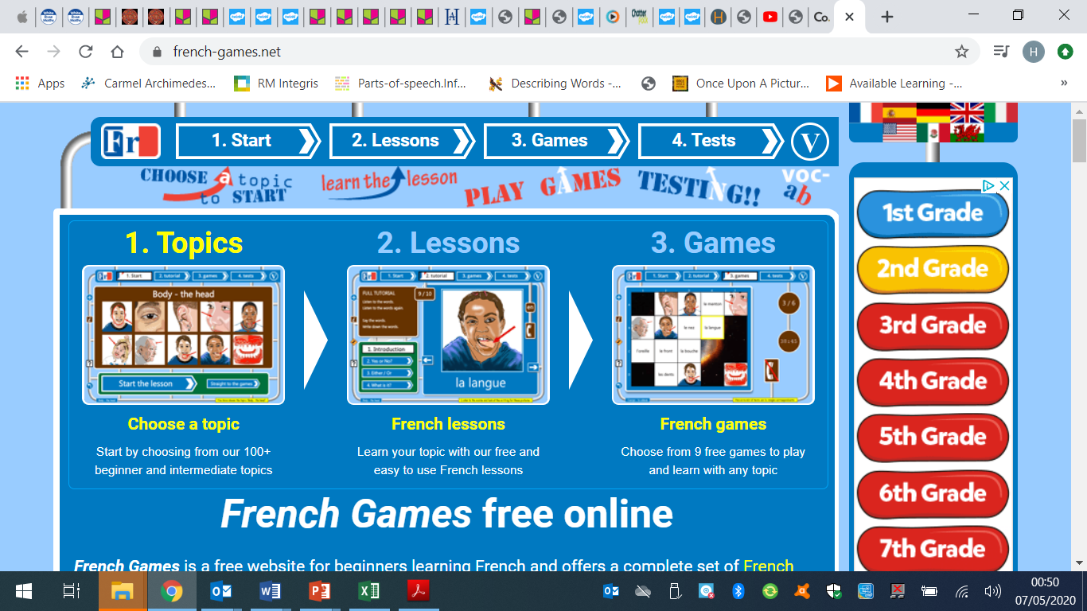

Week 3 - Moonstone Timetable for Microsoft Teams

09:00 Each morning a task will be set for pupils to complete. Each Monday I will post assignments due for that week which the children will be notified of when they sign in.

14:00 Available for messaging each day

On a Friday we will have a live video with the whole class – Please message any ideas for this week.

This week the assignments due in will be art work due in Wednesday
Science work due in Thursday

