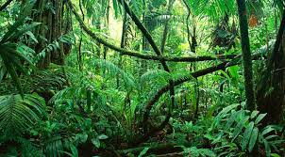 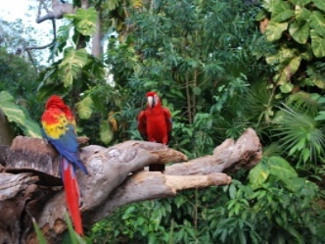 Welbourn Primary School home learning 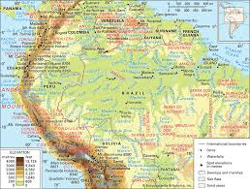 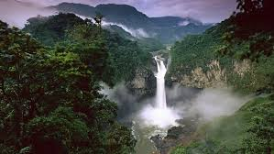
‘Believe, Excite, Succeed, Together’
Summer Term 2 Week 2 The Amazing Amazon!
During the course of the week, we would like you to complete the following learning. We understand that this is a very difficult time for us all and that some children will struggle to engage with learning at times. This learning is for your child to complete at your own pace, if you wish to do more, you can access learning on our school website, on your class page via the padlets.
Moonstone Class Week 2 Summer Term 2
9.00 – 9.30 P.E daily P.E lessons:
Joe wicks: https://www.youtube.com/playlist?list=PLyCLoPd4VxBvQafyve889qVcPxYEjdSTl
or dance moves with JumpStart Johnny https://www.youtube.com/channel/UC8PDFwCV0HHcl08-1SzdiBw
or Strictly Come Dancing’s Oti Mabuse https://www.youtube.com/channel/UC58aowNEXHHnflR_5YTtP4g
or Cosmic Kids Yoga https://www.cosmickids.com

Maths:  Daily maths lessons can be found at: https://whiterosemaths.com/homelearning/year-5/ Week 6  https://whiterosemaths.com/homelearning/year-6/ Week 6 Worksheets attached  Keep up with TT Rockstars – see if you are able to improve your Rockstar status!  Challenge: Have a go at some of the maths challenges from Third Space Learning. It does say year 6, but Year 5’s will be able to access too. I have attached them for you.  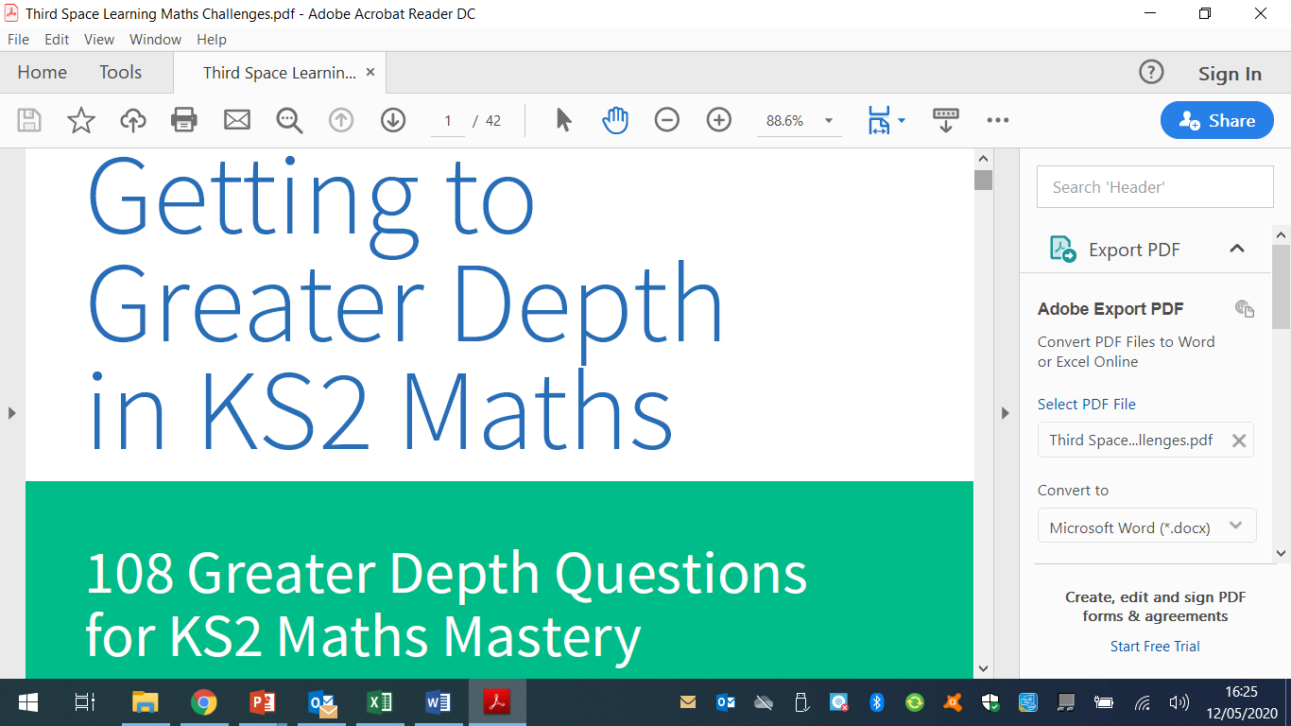 | Reading:  Task 1 – Read Chapter 2 The Green Dark– The Explorer (ebook on padlet)  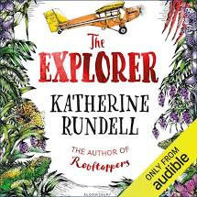  Task 2 – Look up any vocabulary you are unsure of and find out the meaning.  Task 3 – Complete the reading comprehension on padlet |  |  | Writing:  Task 1 – Watch Pandora https://vimeo.com/193963379  Watch the video clip again but this time from play from 1minute to 2m 10s. Then listen to it again but this time writing down any vocabulary linked to the anatomy of the creatures of Pandora. Use resource sheet 2a to write these down on.  Task 2 - Use an image found by searching for alien insects or alien creatures. Using the vocabulary on source 2a, jot down some ideas on the description of the creature. Look at the use of expansion, prepositional phrases and  adverbs.  Task 3 – Using Resource 2c for inspiration, I would like you to come up with your own alien hexapod using different features of  different insects to combine your hexapod. I would like you to draw and label your own insect using the skills in tasks 1 and 2.
Spellings to learn this week, synonyms and antonyms: Immense, vast, gigantic, gargantuan, mammoth, miniature, miniscule, insignificant, microscopic, petite
Topic – Amazon Rainforest  Geography  Task 1 – Who are the indigenous people of the Amazon rainforest? Have a look at the following links  www.youtube.com/watch?v=sLErPqqCC54  www.survivalinternational.org/awa  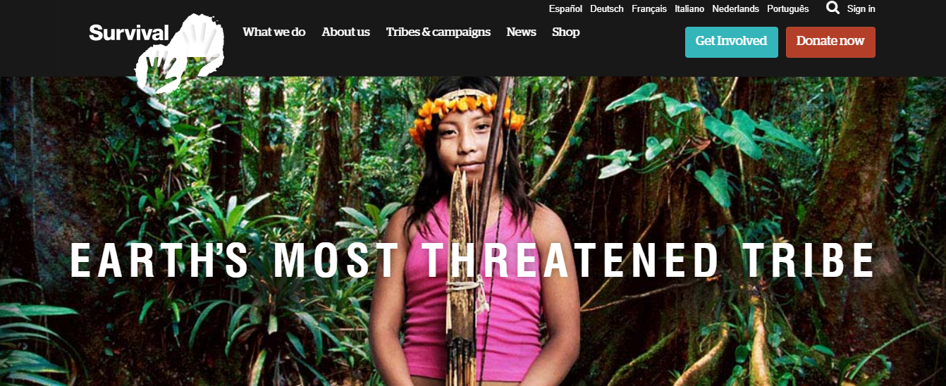  Task 2 - The videos you watched were of the Awa tribe who are an uncontacted tribe located in the Amazon rainforest in Brazil.  Brazil is home to the highest number of uncontacted tribes in the world. Uncontacted means that the tribes have no contact with the outside, modern world.  There are thought to be over 77 isolated groups living in the Amazon. I would like you to answer the following questions.  - What do you think the lives of these people is like?  - How do you think they felt when they saw the plane filming them?  - What is meant by the term indigenous people?  - What does the term, uncontacted tribe mean?  Task 3 – I would like you to do carry out some research on the Awa tribe, what their lives are like, their contact with the outside world, cattle ranching, farming, logging, disease and road building on the lives of the Awa tribe (and also the lives of those undertaking these activities) You can present this in any way you choose and can add photos, pictures and videos. |  | Art / D.T  Task 1 -Have a look at the Henri Rousseau art power point.  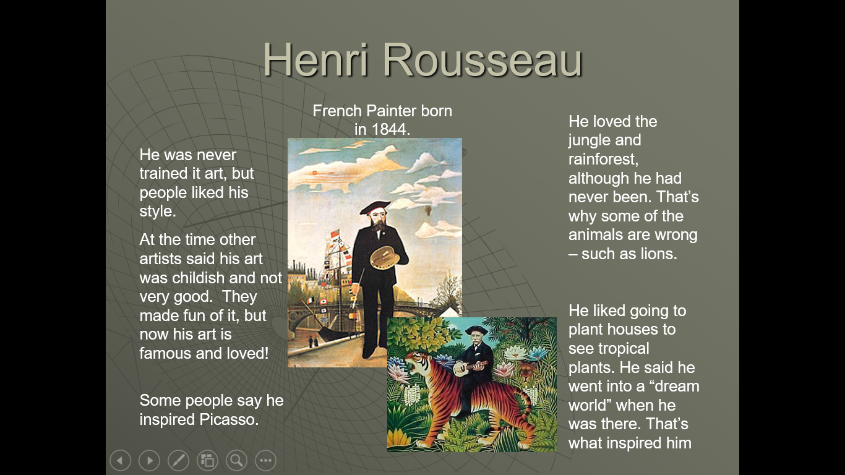  Task 2 -  Look through the Henri Rousseau art photos and answer the questions.  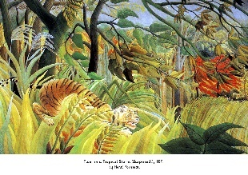  Task 3 – Choose a picture of the rainforest by Henri Rousseau and try to recreate it. This can be done by drawing or painting. You can either use one that it on the power point or the word document or research any others you can find. | Music  Have a look at these short video clips. If you have a musical instrument try and compose a piece of music. If you don’t use something you have at home (it can be more than one item) and see what you can come up with.  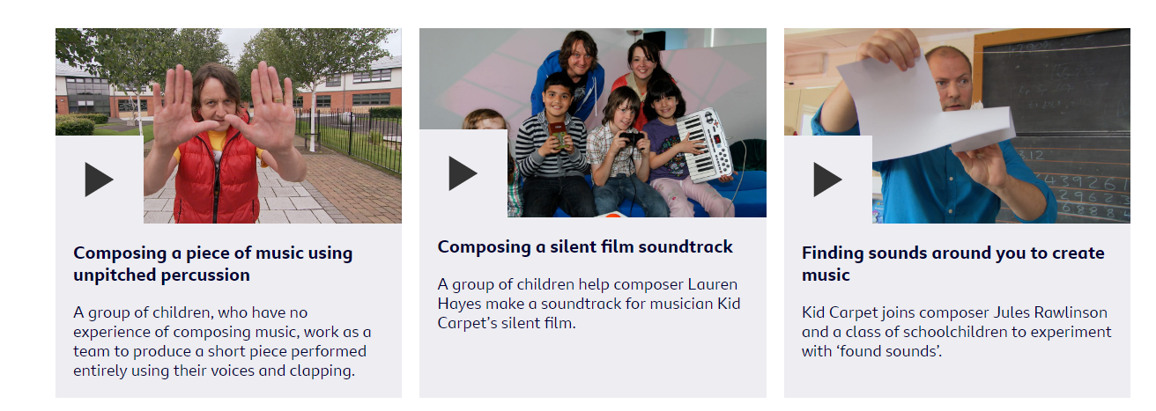  https://www.incredibox.com  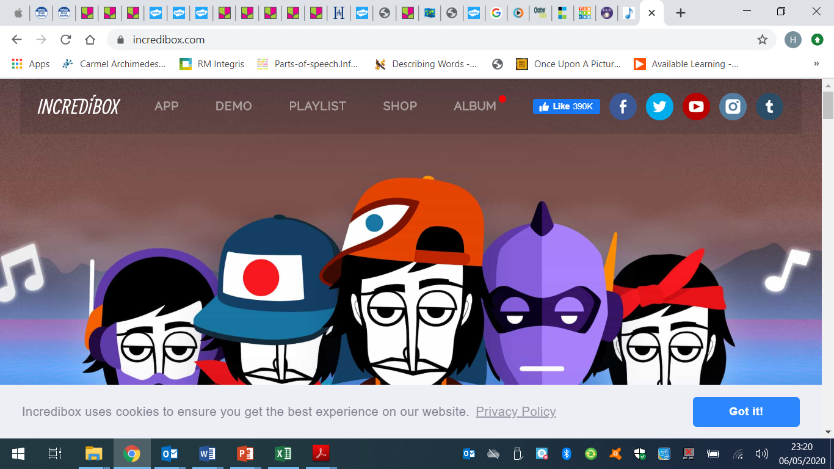 |  | Science – Animals including humans  As we have now come to the end of our science block, I would like you to complete the end of block assessment. It says Year 6 but we have covered this for year 5 and year 6.  Do not look at the answers until you have completed your assessment! | I.T.  What is an algorithm?  Have a look at this link to learn all about what algorithms are and what they are used for  https://www.bbc.co.uk/bitesize/topics/zs7s4wx/articles/zqrq7ty  Task 2 – Have a go at creating your own algorithms using scratch. You will need to sign up if you haven’t used it before, but it’s free of charge to use.  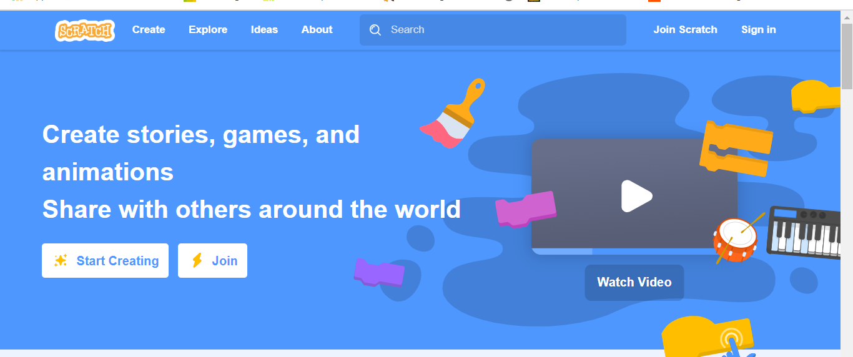
PSHE – Go through the linking by thinking pdf. This is on our class padlet or In your home learning packs if you have them printed. |  |  | French: You can access French learning here: https://www.duolingo.com, it is free to join,  you can take a small test first to see how much you know before moving on.  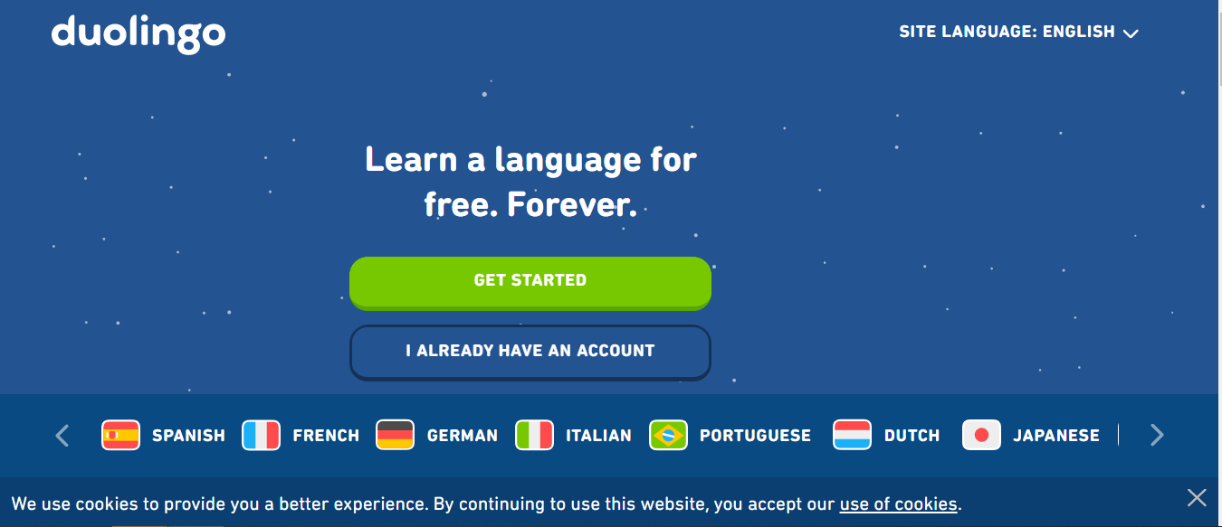  Have a go at this French lesson on BBC Bitesize https://www.bbc.co.uk/teach/school-radio/french-ks2-radio-labo-9-ecole/zv7k382  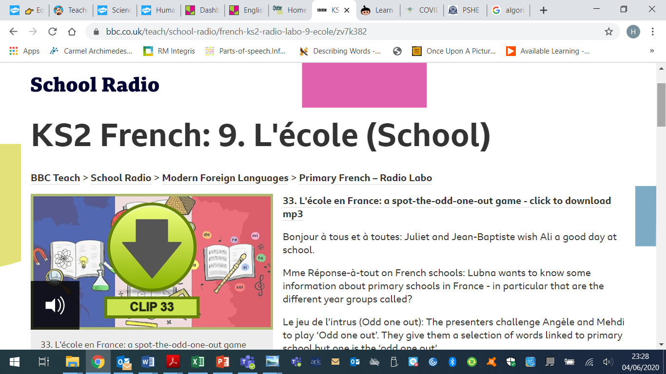  If you fancy something different, try some  French games here: https://www.frenchgamesnet  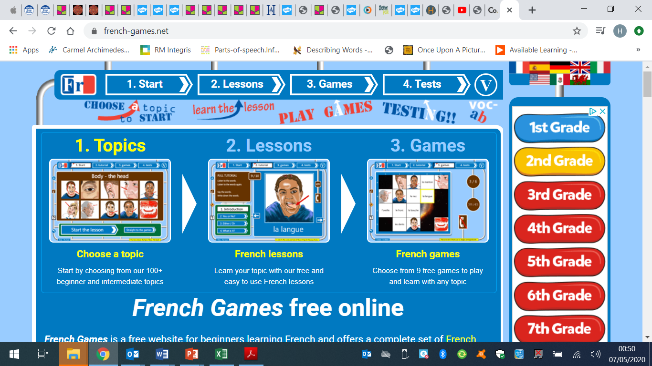

Week 2 - Moonstone Timetable for Microsoft Teams

09:00 Each morning a task will be set for pupils to complete. Each Monday I will post assignments due for that week which the children will be notified of when they sign in.

14:00 Available for messaging each day (if not in school)

On a Friday we will have a live video with the whole class – Please message any ideas for this week.

This week the assignments due in will be the Topic work due in Wednesday
A piece of maths work due in Thursday

