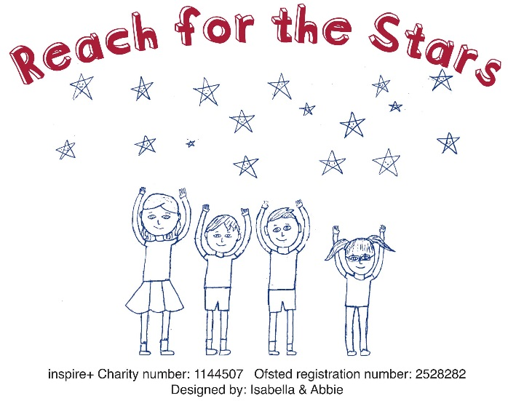

Child/Children’s Name/s.

School Year (Sept 2019) :

 | Mon | Tues | Weds | Thurs | Fri
Breakfast – 5pm
Breakfast – 6pm
Breakfast only
Afterschool – 5pm
Afterschool – 6pm

Term 1: Weds 4th September – Fri 6th Sept 2019

Term 1: Mon 9th – Fri 13th Sept 2019

 | Mon | Tues | Weds | Thurs | Fri
Breakfast – 5pm
Breakfast – 6pm
Breakfast only
Afterschool – 5pm
Afterschool – 6pm

Term 1: Mon 16th – Fri 20th Sept 2019

 | Mon | Tues | Weds | Thurs | Fri
Breakfast – 5pm
Breakfast – 6pm
Breakfast only
Afterschool – 5pm
Afterschool – 6pm

Term 1: Mon 23rd– Fri 27th Sept 2019
 | Mon | Tues | Weds | Thurs | Fri
Breakfast – 5pm
Breakfast – 6pm
Breakfast only
Afterschool – 5pm
Afterschool – 6pm

Term 1: Mon 30th Sept– Fri 4th Oct 2019

 | Mon | Tues | Weds | Thurs | Fri
Breakfast – 5pm
Breakfast – 6pm
Breakfast only
Afterschool – 5pm
Afterschool – 6pm

Term 1: Mon 7th– Fri 11th Oct 2019
 | Mon | Tues | Weds | Thurs | Fri
Breakfast – 5pm
Breakfast – 6pm
Breakfast only
Afterschool – 5pm
Afterschool – 6pm

Term 1: Mon 14th – Fri 18th Oct 2019

 | Mon | Tues | Weds | Thurs | Fri
Breakfast – 5pm
Breakfast – 6pm
Breakfast only
Afterschool – 5pm
Afterschool – 6pm

Holiday Club: Monday 21st Oct – Monday 28th October

 | Mon 21st | Tues 22nd | Weds 23rd | Thurs 24th | Fri 25th | Mon 28th
Holiday Club

See parent guide for prices

  - The provision will be registered with Ofsted, therefore we will be able to accept childcare vouchers and tax free childcare payments. Please tell us if you wish to use either childcare vouchers or tax free allowance for childcare provisions. If you use childcare vouchers, please tell us which company/scheme you are signed up to.

  - The holiday club will be open for children outside of Uffington School to attend. Do you know of any other families or friends who would be interested in attending the provision? If yes, how many children?

  - Any questions or observations please list:

Parents Name:
Contact Number:
Email address:

