Welbourn Church of England Primary School
‘Believe, Excite, Succeed, Together’
Emerald Class
Topic: Is a castle a safe place to live? |  | Subject: History
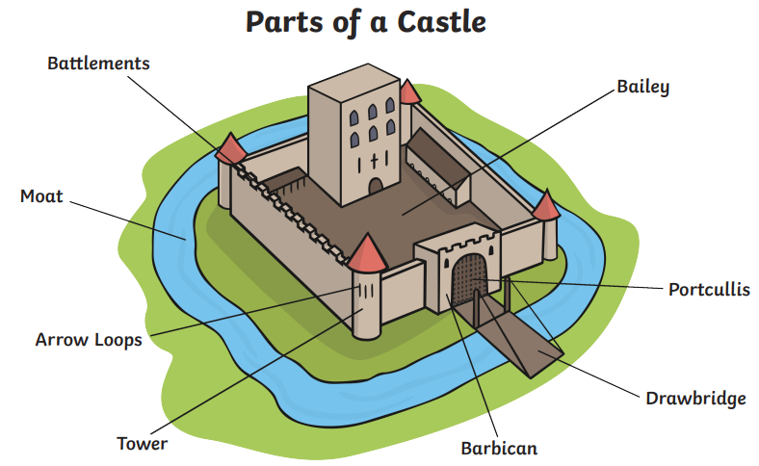
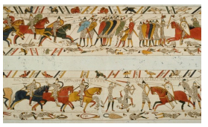

The Bayeux Tapestry

Important person
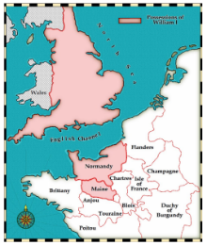
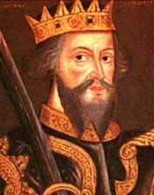
William the conqueror - Became King in 1066 after defeating Harold of Wessex at the Battle of Hastings. Came from Normandy.
Key knowledge
The Lord and the Lady would run the castle and be of a high important rank, often being close to the King and Queen.
The cook would make all the meals for those living in the castle.
The Musician would entertain the Lord and Lady and their guests during big feasts.
Key Vocabulary
Castle | A large building, typically of the medieval period, fortified against attack with thick walls, battlements, towers, and in many cases a moat.
Medieval | Period of time 11th century until 16th century.
King | Male ruler of a country. Can be husband to Queen.
Queen | Female ruler of a country. Can be wife to a King.
Lord and lady | Important people of high rank who run and own the castles. Lords are men and Ladies are women.
Battlements | The top of the castle wall with raised sections and lowered sections to allow people to fire arrows at their opponents in battle.
Portcullis | A strong iron gate that can be raised to allow the drawbridge to be lowered.
Drawbridge | A bridge that can be lowered or raised to enter and exit a castle.
Moat | A deep ditch that surrounds a castle. It can be filled with or without water.
Turrets | A small tower built on the castle, at the corner or on top of a larger tower.
Keep | Fortified tower built within castles for defence.
Bailey | The outer wall of a castle.
Taxes | Money given to the government to help rule the country.

