Welbourn Primary School
‘Believe, Excite, Succeed, Together’
Emerald class. Choose from the selection of projects to complete…
Use a computer to type up information about castles. (A ppt or word document) | Paint a picture using your knowledge of primary, secondary and neutral colours. | Create a poster or fact file about animals found in the rainforest using your knowledge from last term. | Weigh ingredients and bake fairy cakes. Write a set of instructions for someone else to make them.
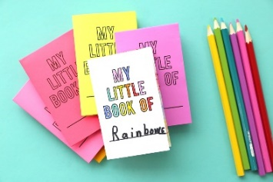  Make a mini book of fairy tales including pictures and writing. | 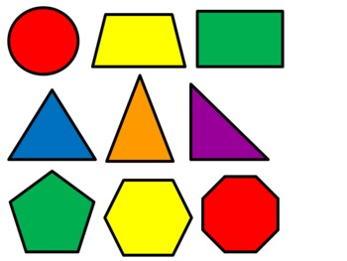  Draw a castle picture using 2D shapes. | 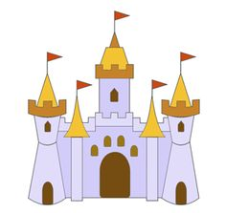  Make a model of a castle. | 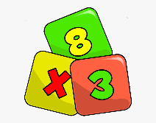  Make a mini book of times tables for 2x, 5x, 10x and for a challenge 3x.

