This term in **PE** Emerald will continue to work with Mr Green on a Monday to develop their jumping skills. The children will also be developing their movement skills through gymnastics sessions with a particular focus on animal movements.

In **Art** this term the children will be building up to recreating Henri Rousseau’s ‘Tiger in a Tropical Storm’. They will develop their skills in sketching, watercolours and shading.

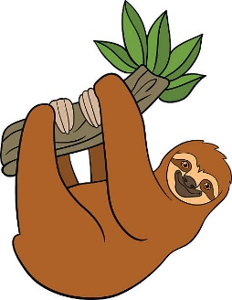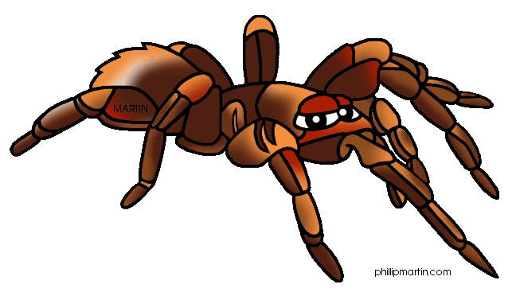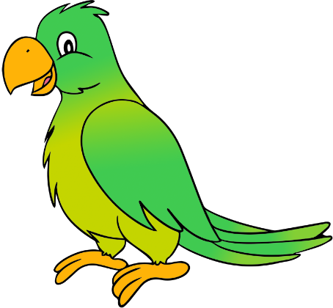

Our school trip this term is to Woodside Wildlife Park!

The children will be using musical instruments to represent animals and will learn a traditional African call and response song in **Music**.

In **Maths** the children will be talking about months of the year, days of the week and learning to tell the time to o’clock, half past the hour and to five minute intervals. The children will also recap addition and subtraction and place value.

In **Science** this term the children will be naming and classifying different animals (mammals, birds, fish and reptiles). They will also learn about carnivores, omnivores and herbivores before learning how to care for animals and pets.

In **Computing** the children will learn ways to gather and present data on a computer by creating a chart and pictogram.

We will be exploring Muslim beliefs in **RE** and learning the ways in which Muslims celebrate birth.

Our **Read Write Inc** phonics will continue daily and children will be grouped according to their ability. They will bring books home to share with you.

Emerald

What is making the jungle rumble?

In **Geography** the children will be locating jungles around the world, identifying the features of a rainforest and its climate and comparing British woodland to a tropical jungle.