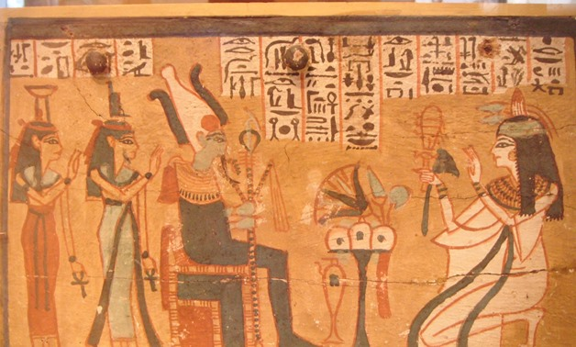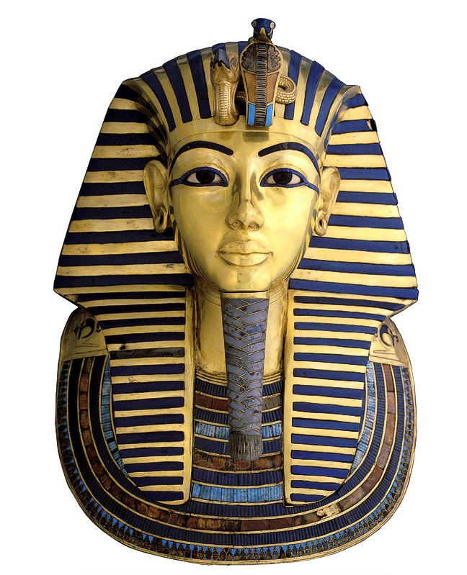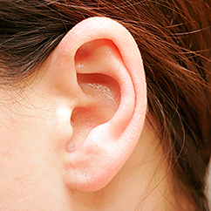 

Dear Parents and Year 3 and 4 children:

In Amethyst this half term we will be exploring the history topic ‘Ancient Egyptians’.

Our challenge questions are:

LC1: Can I use physical artefacts to ask questions about the past?

LC2: Can I explain the importance of the Nile to the Ancient Egyptians?

LC3: Can I explore the reasons the pyramids were built?

LC4: Can I investigate the mummification process?

LC5: Can I investigate the discovery of Tutankhamun’s tomb?

LC6: Can I research and share my findings of an Egyptian God?

LC7: Can I create and decode hieroglyphic messages?

As artists we will:

be creating a range of Egyptian

artwork including hieroglyphics

and Tutankhamun masks with

different materials such as clay

and Papier Mache.

As scientists we will:

begin focusing on the topic ‘Sound’. We will be learning how our ear works and

investigating

how

soundwaves

are made.

Wow Days:

We will be using our historical enquiry skills to explore a range of Egyptian artefacts and sources. We will also be visiting ‘The Collection’ to take part in

an Egyptian

day.

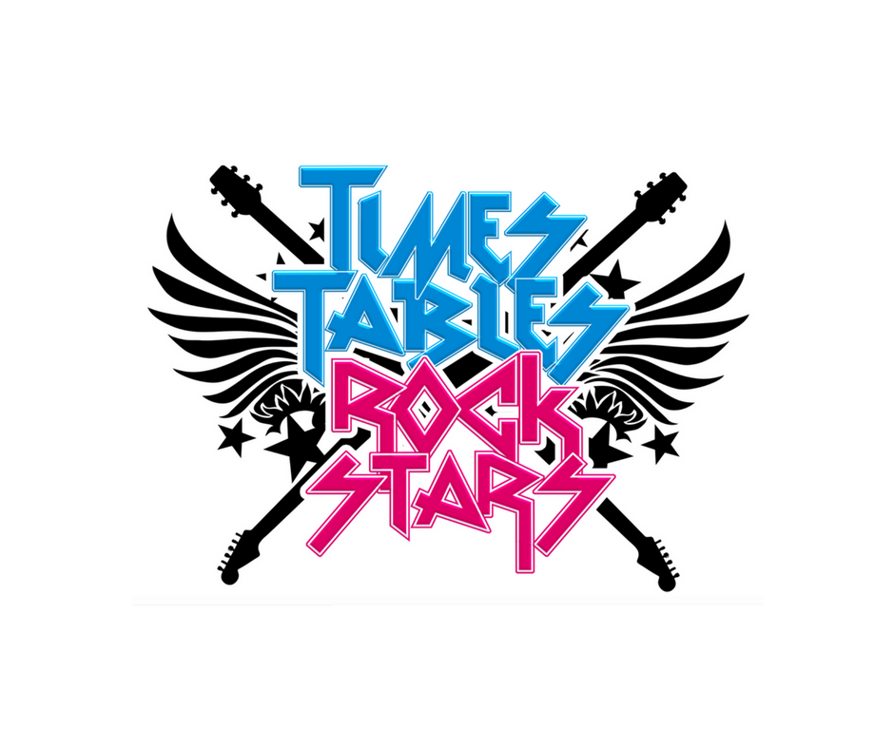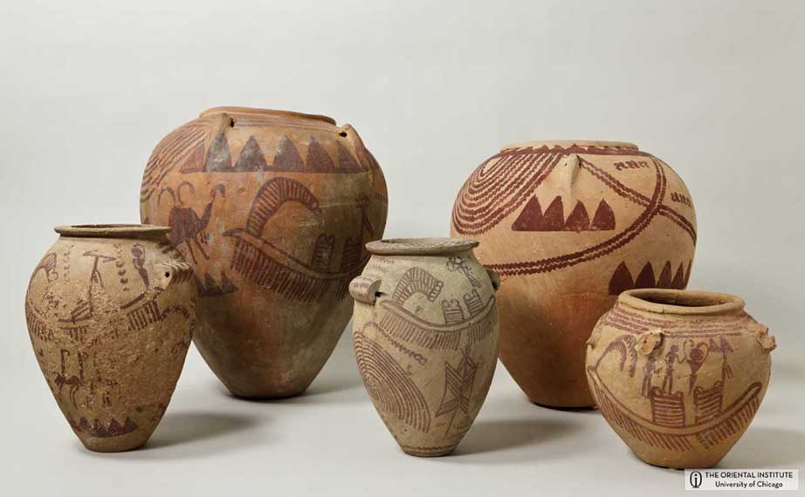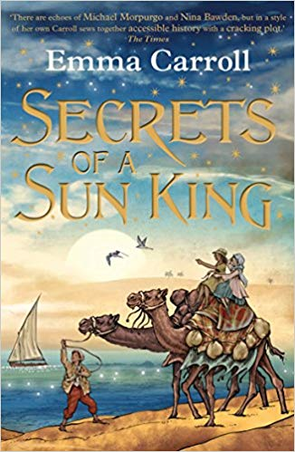

As authors we will:

be researching the diary entries of Howard Carter. We will then create our own diary entries and letters. We will also be looking at stories from other cultures.

As Readers we will:

be reading a new book linked to our topic ‘Secrets of a Sun King’. We will also be

starting new

books in our

guided reading

groups.

As Musicians we will:

be looking at the music from different festivals, and focusing on the Chinese New

Year.

As mathematicians we will:

be focusing on measurement, statistics, addition and subtraction.

We will also continue

with Times tables Rock stars!

What was life like for the Ancient Egyptians?