# Image result for magnets

As mathematicians we will:

be continuing to improve our mental maths. We will also be developing our addition and subtraction skills, including problem solving and reasoning. We will be sorting, classifying and making 2D and 3D shapes, and finally interpreting data in statistics.

We will also continue

with Times tables Rock

stars! Well done to the children for such an improvement with this!

As authors we will:

Be using film clips as a stimulus to write our own stories set in imaginary worlds. We will also be writing shape poetry.

As programmers we will: be exploring networks, learning how devices communicate and creating a video and map to present our findings.

Dear Parents and Year 3 and 4 children:

In Amethyst this half term we will be exploring the science topic ‘Forces, forces everywhere’.

Our challenge questions are:

LC1: Can I explain how air pressure can control movement?

LC2: Can I identify what forces there are around us?

LC3: Can I experiment how objects move on different surfaces?

LC4: Can I explain how magnets work?

LC5: Can I classify magnetic and non-magnetic objects?

LC6: Can I conduct an experiment to compare the strength of different magnets?

LC7: Can I design an experiment to explore what resources may affect magnetism?

LC8: Can I research how magnets are used within the world?

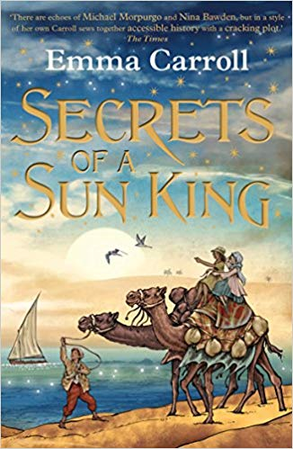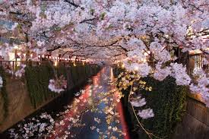

As artists we will: be studying a range of different artists’ work, such as Edward Hopper, Brueghel and Paula Rego, and analysing shape, texture, pattern and tone.

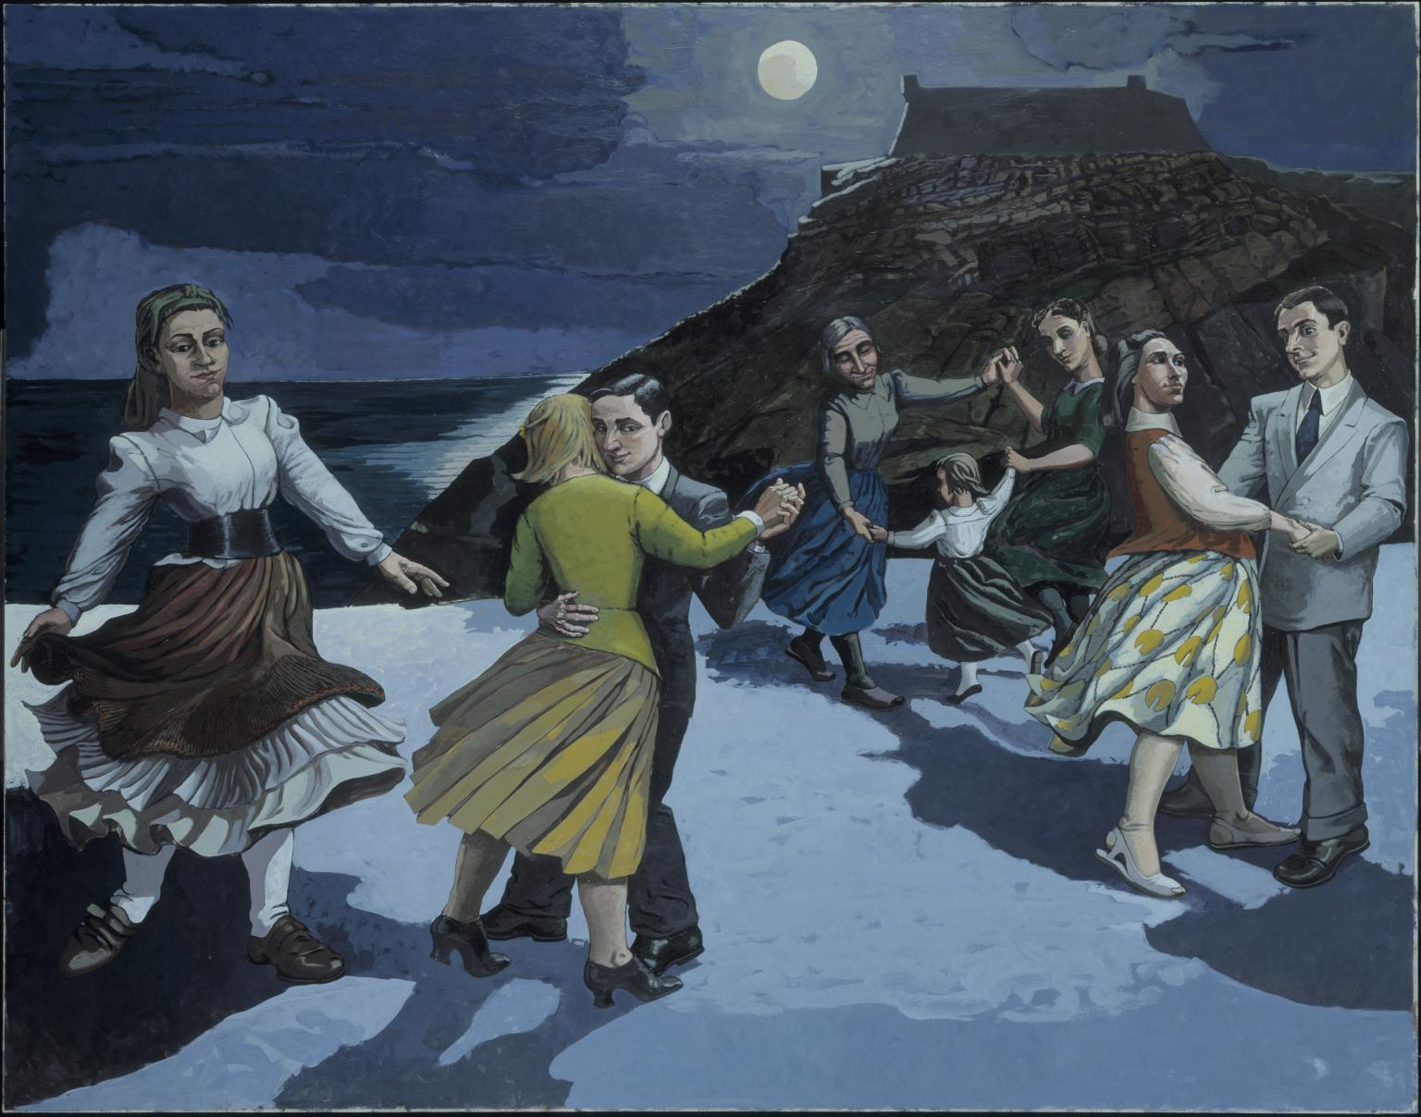 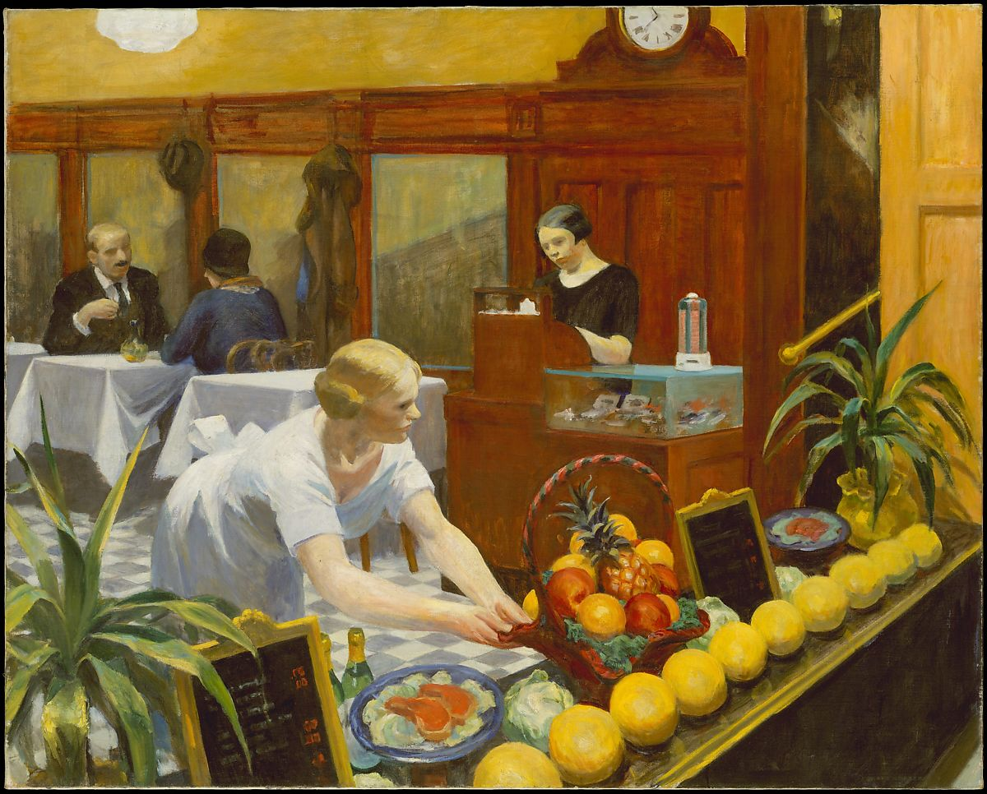

As Readers we will:

be continuing to read our book ‘Secrets of a Sun King’ in our

new library!

As Musicians we will: be exploring Hanami (cherry blossom festival). We will be creating a Haiku, adding percussion and performing to

each other.

Forces, forces everywhere!