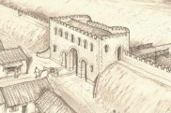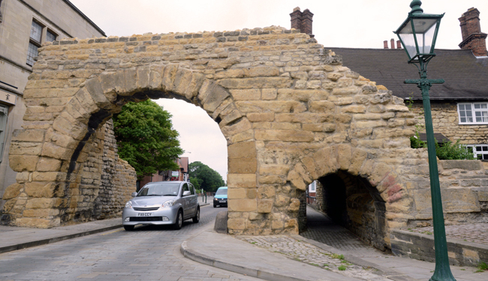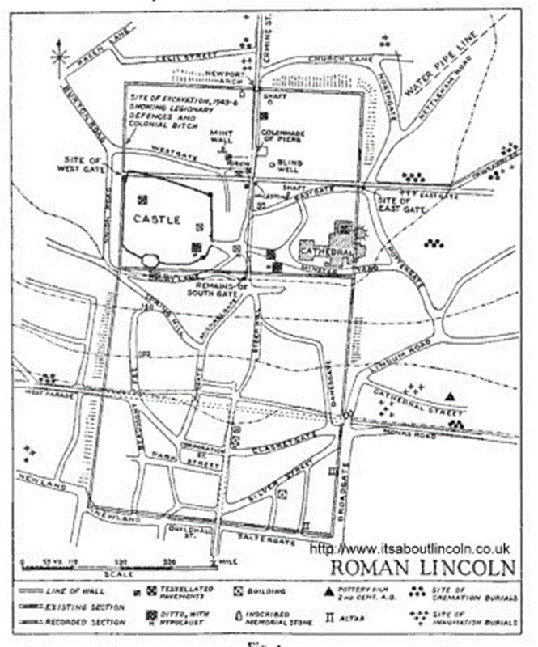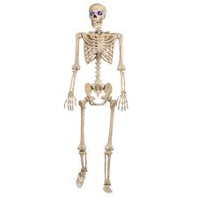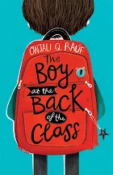

As mathematicians we will:

be focusing on statistics, multiplication and division, fractions and properties of shape. We are also making maths active by completing ‘supermovers’ everyday.

We will be starting times tables tests next week.

As musicians we will: be exploring the rainforest by building up our own rhythms using percussion

As artists we will: be exploring texture and pattern, making and using our own textured stamps for printing; drawing a ‘flip’ pattern and recreating a famous and ancient geometric pattern.

Dear Parents and Year 3 and 4 children:

Welcome back. This half term we will continue to learn about the Romans, specifically Roman Lincoln.

Our challenge questions are:

LC1: Can I locate Roman ruins in Lincoln?

LC2: Can I find other evidence of the Romans living in Lincoln?

LC3: Can I compare Roman Lincoln to Lincoln today?

LC4: Can I compare different sources?

LC5: Can I investigate who may have lived in Roman Lincoln?

LC6: Can I create a guide for Roman Lincoln?

What was Roman Lincoln really like?

As scientists we will:

be learning all about

the bones and muscles

in the human body,

the nutrition we need

to survive, and food

chains.

Wow Days and Trips:

We have already explored Roman Lincoln at the end of last term. We will be using this knowledge and maps to help us build a picture of Roman Lincoln. We will also be developing our cooking skills in the ‘roots to food’ cooking experience.

As authors we will: be writing non chronological reports using all our of new knowledge about the Romans. We will also be creating newspaper reports based on ‘The Iron Man’ and comparing it to ‘The Iron Woman’. Finally, we will be learning and performing Christmas poetry.

As readers we will:

Be continuing to read ‘The boy at the back of the class’.

We will be

developing

inference and

prediction skills.