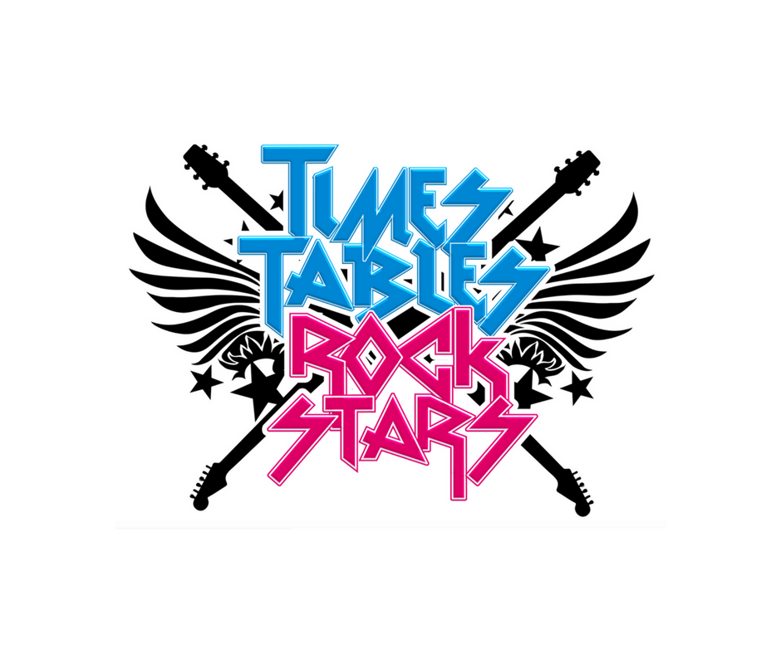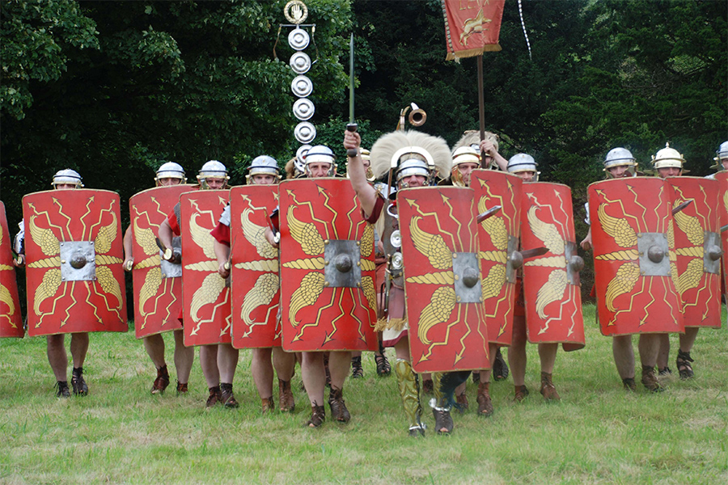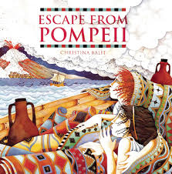

Dear Parents and Year 3 and 4 children:

Welcome to the new academic year in Amethyst. This half term we will be exploring the history topic ‘What did the Romans do for us?

Our challenge questions are:

LC1: Can I describe the legend of Ancient Rome?

LC2: Can I investigate who the Romans were?

LC3: Can I explore the invasion of Roman Britain?

LC4: Can I understand why the Romans decided to invade Britain?

LC5: Can I research who Boudicca was and what she did?

LC6: Can I research the impact of the Roman empire on Britain?

LC7: Can I understand what religious beliefs the Romans had?

What did the Romans do for us?

As artists we will: be developing our skills in design, drawing, craft, painting and art appreciation by making puppets, drawing from observation, and creating our own version of a cartoon drawn by a famous illustrator.

As scientists we will:

be focusing on the topic ‘States of Matter’. We will be exploring solids, liquids and gases and how they change state, and looking at evaporation and the stages of the water cycle.

Wow Days and Trips:

We will be exploring the ruins of Roman Lincoln by taking part in a workshop at Lincoln Castle and following the Roman trail. We will also be developing our science enquiry skills around solids, liquids and gases by visiting the Magna Science centre.

As authors we will: be writing descriptions

linked to our topic

book ‘Escape from

Pompeii’.

We will also be looking at stories from imaginary worlds, particularly from Roald Dahl books, and creating our own imaginary world.

As mathematicians we will:

be focusing on number and place value, addition and subtraction, measurement and statistics.

We will also be climbing the leader board on Times Tables

Rock Stars!

As musicians we will: be focusing on creating Roman music using repeating patterns and performing them.

As readers we will:

be reading ‘The boy at the back of the class’.

We will be

Reading as

a class and

developing our vocabulary.