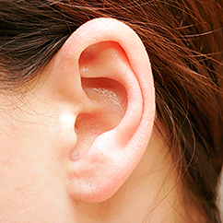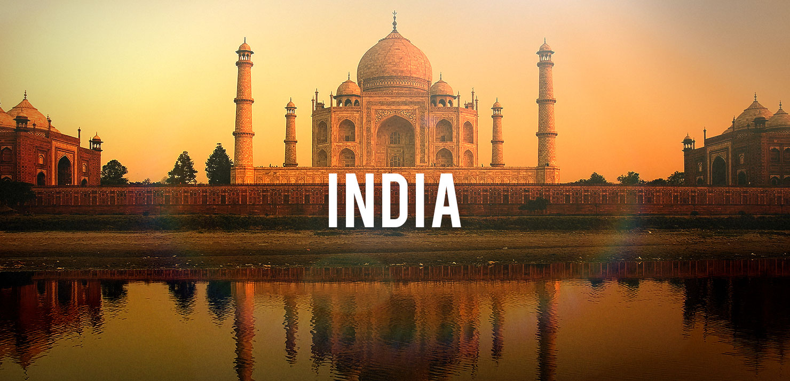 

As programmers we will: be looking at ‘the journey inside a computer’, exploring how a computer works.

Wow day:

We will be having a special visitor in school to hold an Indian experience day!

Dear Parents and Year 3 and 4 children:

In Amethyst this half term we will be exploring the geography topic ‘India’.

Our challenge questions are:

LC1: Can I locate and research India?

LC2: Can I compare life in Chembakoli and Mumbai?

LC3: Can I compare the school day in India to my school day?

LC4: Can I investigate the Indian climate?

LC5: Can I explain the importance of Fairtrade?

LC6: Can I explore the main religions in India?

As scientists we will:

Be continuing to learn all about ‘Sound’. We will be carrying out experiments and looking at how deaf people communicate.

We will also

be learning

some Makaton

signing.

As designers we will: design and sew our own pin cushions using different stitches and then stuffing them

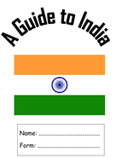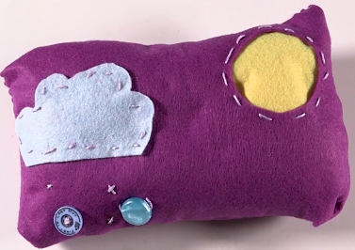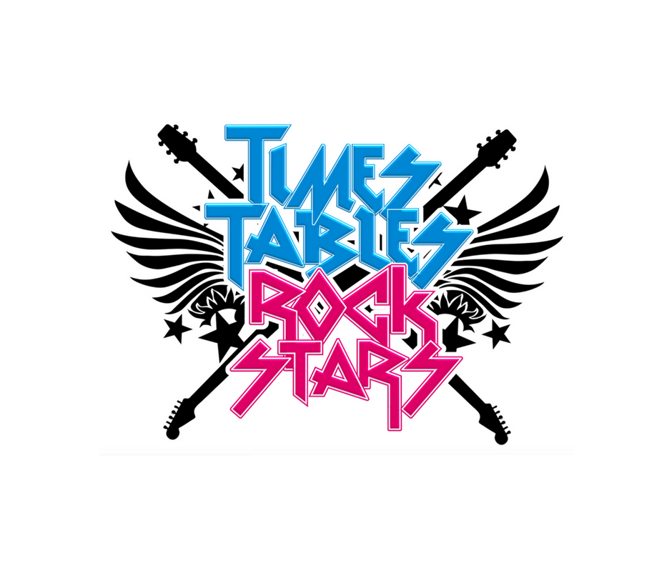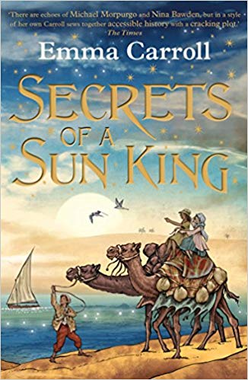

As Musicians we will: be listening to and creating our own traditional Indian music, and then performing as a class! We will also be having some sessions with the music man.

As authors we will:

be creating our own information leaflets all about India, writing letters

and writing

our own

poems.

As mathematicians we will:

be focusing on improving our mental maths. We will also be developing our knowledge of fractions, multiplication and division, telling the time and the properties of shapes.

We will also continue

with Times tables Rock stars!

Would you like to live in India?

As Readers we will:

be continuing to read our book ‘Secrets of a Sun King’, which the children

are

thoroughly

enjoying!