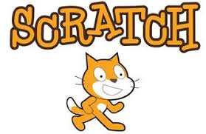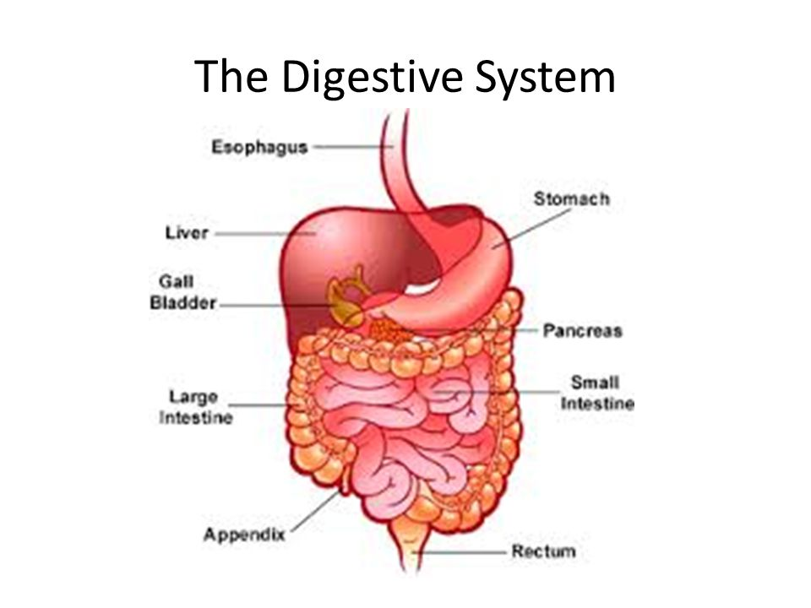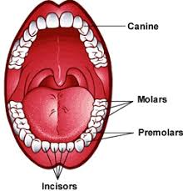 

As programmers we will:

use ‘Scratch’ to explore coding. We will look at

the algorithms behind the program and

create our own animations!

As designers we will:

be adapting recipes to investigate how we can change flavours. We will be baking different biscuits, designing and creating our own packaging and having our own bake off!

Dear Parents and Year 3 and 4 children:

In Amethyst this half term we will be exploring the science topic ‘What happens to the food we eat?’

Our challenge questions are:

L.C1 Why would it not be sensible to eat a burger every day?

L.C2 What happens to that piece of chocolate once you swallow it’?

L.C3 What is the digestive system and why is it important?

L.C4 Why is it important to brush your teeth every day?

L.C5 How do different fluids affect our teeth?

L.C6 Why are sharks teeth different to our teeth?

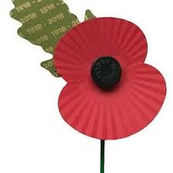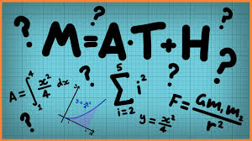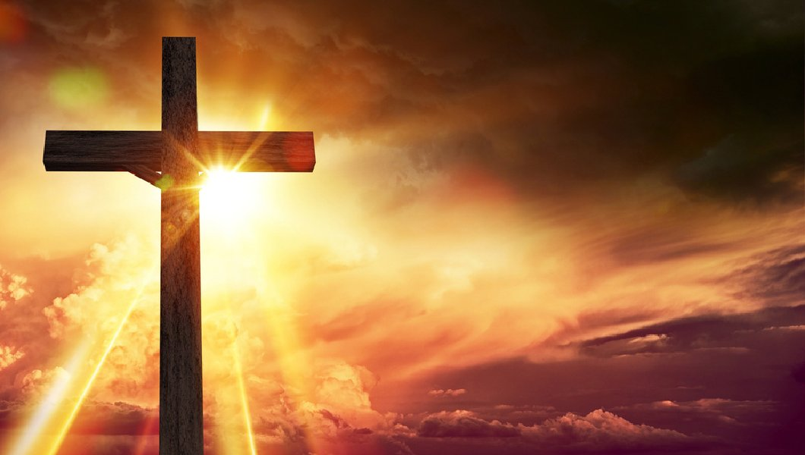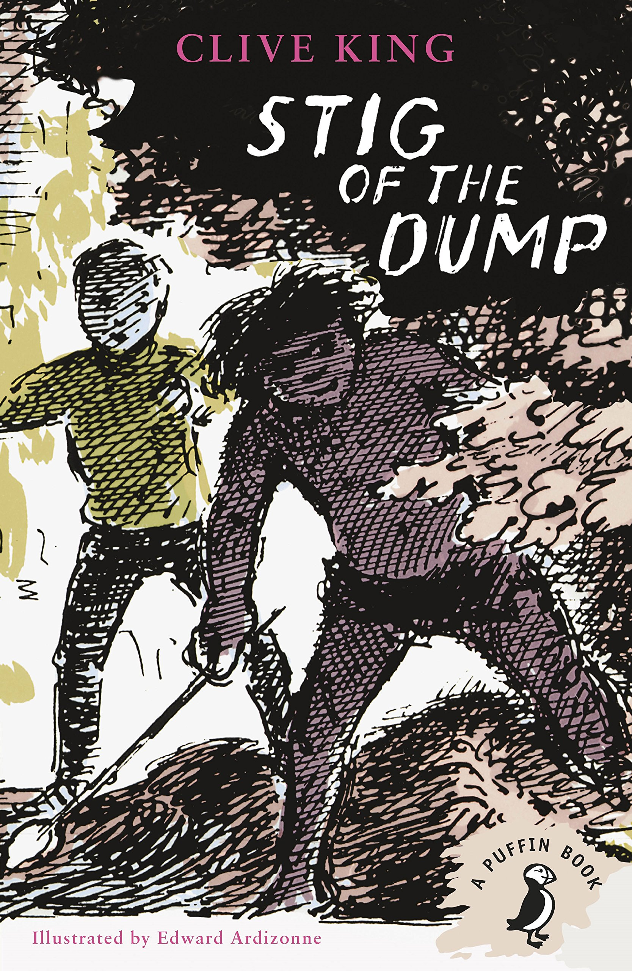

As Authors we will:

be studying different types of poetry, then creating and performing our own. We will also be learning about similes and metaphors to use

them in our writing!

As Readers we will:

be finishing ‘Stig of the Dump’ as our class read. We are all studying a different Michael Morpurgo

book in guided

reading.

As Musicians we will:

be looking at the features of a ballad. We will be writing our own lyrics and working in groups to perform our very own ballads.

As Citizens we will:

discuss our values of peace and forgiveness. We will also be making poppies for Remembrance Day.

As mathematicians we will:

be focusing on multiplication and division, fractions and properties of shapes. We will also continue daily times tables and mental maths.

What happens to the food we eat?

As Believers we will:

Continue to look at the Christian faith

and values, including important festivals.

.