Welbourn Church of England Primary School
‘Believe, Excite, Succeed, Together’
Amethyst Class
Topic: Where does the river take you? (Rivers and mountains)
Subject: Geography
Main rivers of the U.K  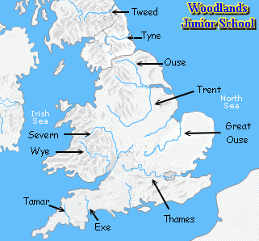 | Highest mountains in the U.K  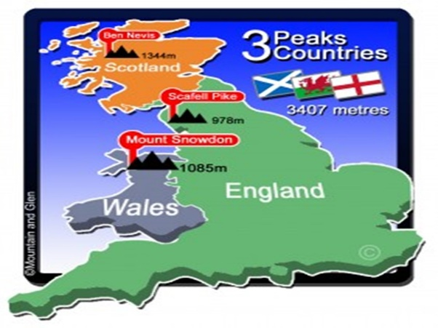
Key facts: Rivers | Key facts: Mountains
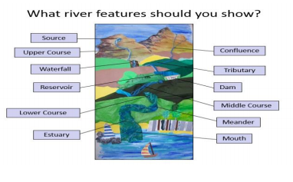 | 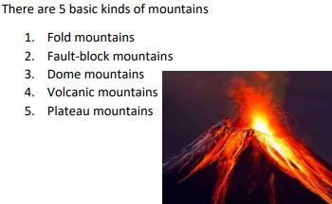
Key Vocabulary
Channel: the path a river takes. | Summit: the highest part of a hill / mountain.
Confluence: the junction at two rivers. | Slope: An angle along the side of a mountain or hill.
Estuary: The large part of a river where it meets the sea. | Valley: A low area of land between hills or mountains.
Meander: The winding bend in the river. | Peak: A pointed top of a ridge or mountain.
Mouth: The endpoint of a river. | Ridge: A line formed along a high part of a mountain.
Source: Where a river begins. | The Rockies: A mountain region in North America.
Tributary: A river or stream that feeds into another river. | The Andes: A mountain region in South America.
Water cycle: The journey of water on the Earth. | The Alpes: A mountain region in Europe.

