Reading Framework Y5 and 6 – Long Term Overview 2022 - 2023
Autumn
Poetry Thursday  Read a minimum of 2 poems from the poetry book of the term each week. | Texts  Guided reading and class books | Explicit Focus Points  Black – NC Objectives  Black and bold – ideas for teaching  Green – Reading Rope Strands  Language Comprehension  Background knowledge, Vocabulary, Language Structure, Verbal reasoning  Literacy Knowledge | Fluency Development  (6 Ps – identify specific focus)  Pitch, Power, Pace  Punctuation, Pause  Passion | Writing Objectives/Cross Curricular links
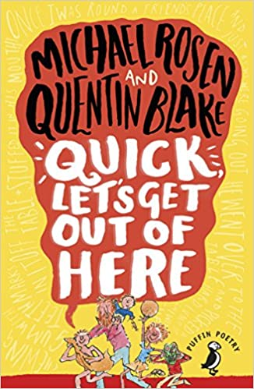  (Funny poems) | Guided reading:  Treason  (Topic link)  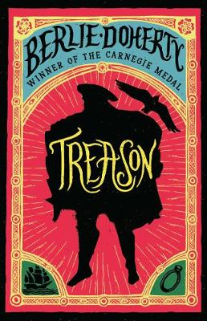  Class book:  The Last Bear  (Contemporary – Children’s book prize 2022 – currently popular)  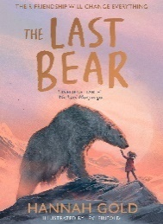 | VOCABULARY  - checking that the text makes sense to them, discussing their understanding and explaining the meaning of words in context  - discussing words and phrases that capture the reader’s interest and imagination  LITERACY KNOWLEDGE  - asking questions to improve their understanding of a text  - listening to and discussing a wide range of fiction, poetry, plays, non-fiction and reference books or textbooks.  VERBAL REASONING  - participate in discussions about books that are read to them and those they can read for themselves, building on their own and others’ ideas and challenging views courteously  - drawing inferences such as inferring characters' feelings, thoughts and motives from their actions, and justifying inferences with evidence  - identifying main ideas drawn from more than 1 paragraph and summarising these  - predicting what might happen from details stated and implied.  - -Be taught how to compare characters, settings, themes and other aspects of what they read.  BACKGROUND KNOWLEDGE  - Basic understanding of The Tudors – develop through the topic. | Pace: The speed and rhythm of what we read.  Punctuation: The adherence to and understanding of the marks an author has placed upon the page
 | Guided reading:  Holes  (Classic – Pie Corbett)  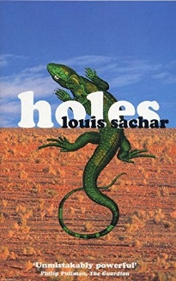  Class book:  Varjak Paw  (Classic – Pie Corbett)  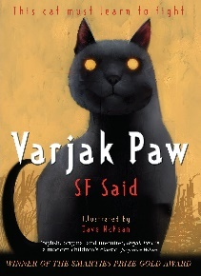 | VOCABULARY  - checking that the text makes sense to them, discussing their understanding and explaining the meaning of words in context  - using dictionaries to check the meaning of words they have read  LITERACY KNOWLEDGE  - asking questions to improve their understanding of a text  VERBAL REASONING  - participate in discussions about books that are read to them and those they can read for themselves, building on their own and others’ ideas and challenging views courteously  - drawing inferences such as inferring characters' feelings, thoughts and motives from their actions, and justifying inferences with evidence  - identifying main ideas drawn from more than 1 paragraph and summarising these  - -Making comparisons within reading, within and across books  LITERACY KNOWLEDGE  - asking questions to improve their understanding of a text  - Identifying themes and conventions in a wide range of books (compare to previous book)  - listening to and discussing a wide range of fiction, poetry, plays, non-fiction and reference books or textbooks.  LANGUAGE STRUCTURE  - identifying how language, structure and presentation contribute to meaning  - Reading books that are structured in different ways and reading for a range of purposes | Pitch: The musicality of the reading voice – including tone and intonation.  Passion: The emotion of the reading – including empathy and sympathy and the development of a reader’s love for the written word.
 | Spring
 | Texts  Anchor and Supplementary | Explicit Focus Points  Black – NC Objectives  Black and bold – ideas for teaching  Green – Reading Rope Strands  Language Comprehension  Background knowledge, Vocabulary, Language Structure, Verbal reasoning  Literacy Knowledge | Fluency Development  (6 Ps – identify specific focus)  Pitch, Power, Pace  Punctuation, Pause  Passion | Writing Objectives/Cross Curricular links
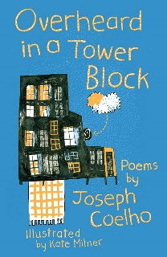  (Poems about bullying, exams, growing up and separated families) | Guided reading:  Freedom – Catherine Johnson  (Topic link and contemporary – children’s book award 2019)  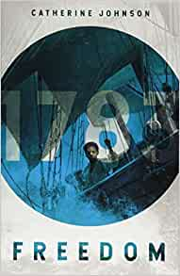  Class book:  All the Things that could go Wrong  (Anti bullying)  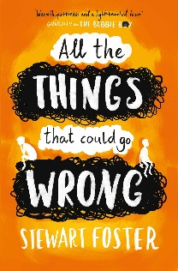 | VOCABULARY  - using dictionaries to check the meaning of words they have read  - discussing words and phrases that capture the reader’s interest and imagination  VERBAL REASONING  - drawing inferences such as inferring characters' feelings, thoughts and motives from their actions, and justifying inferences with evidence  - participate in discussion about both books that are read to them and those they can read for themselves, taking turns and listening to what others say.  identifying main ideas drawn from more than 1 paragraph and summarising these  - predicting what might happen from details stated and implied.  - -Be taught how to compare characters, settings, themes and other aspects of what they read.  LITERACY KNOWLEDGE  - asking questions to improve their understanding of a text  - increasing the familiarity with a wide range of books, including fairy stories, myths and legends, and retelling some of these orally.  LANGUAGE STRUCTURE  Reading books that are structured in different ways and reading for a range of purposes | Passion: The emotion of the reading – including empathy and sympathy and the development of a reader’s love for the written word.  Power: The strength given to the reading voice – including volume and stress.
 | Guided reading:  Romeo and Juliet (A Shakespeare Story) Andrew Matthews and Tony Ross)  (Preparation for Secondary)  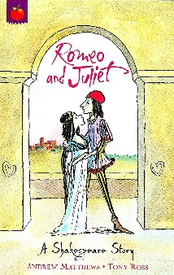  Class book:  Tom’s Midnight Garden  (Pie Corbett – Classic)  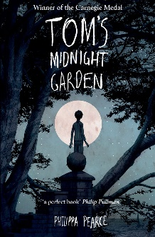 | VOCABULARY  - checking that the text makes sense to them, discussing their understanding and explaining the meaning of words in context  - discussing words and phrases that capture the reader’s interest and imagination  VERBAL REASONING  - drawing inferences such as inferring characters' feelings, thoughts and motives from their actions, and justifying inferences with evidence  - predicting what might happen from details stated and implied  - identifying main ideas drawn from more than 1 paragraph and summarising these  - participate in discussion about both books that are read to them and those they can read for themselves, taking turns and listening to what others say.  LITERACY KNOWLEDGE  - asking questions to improve their understanding of a text  - Identifying themes and conventions in a wide range of books  - increasing the familiarity with a wide range of books, including fairy stories, myths and legends, and retelling some of these orally.  LANGUAGE STRUCTURE  - identifying how language, structure and presentation contribute to meaning | Pause: The knowing of when not to read and for how long  Pitch: The musicality of the reading voice – including tone and intonation  Pace: The speed and rhythm of what we read.
 | Summer
 | Texts  Anchor and Supplementary | Explicit Focus Points  Black – NC Objectives  Black and bold – ideas for teaching  Green – Reading Rope Strands  Language Comprehension  Background knowledge, Vocabulary, Language Structure, Verbal reasoning  Literacy Knowledge | Fluency Development  (6 Ps – identify specific focus)  Pitch, Power, Pace  Punctuation, Pause  Passion | Writing Objectives/Cross Curricular links
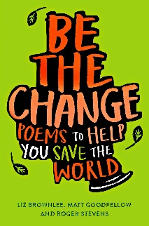  (Taking care of our world poems) | Guided reading:  Escape the Rooms  (Humour and enjoyment)  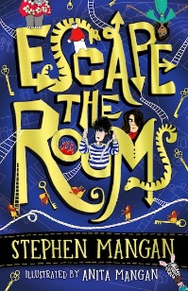  Class book:  Skellig  (Pie Corbett – Classic)  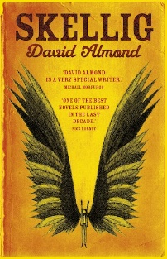 | VOCABULARY  - checking that the text makes sense to them, discussing their understanding and explaining the meaning of words in context  - discussing words and phrases that capture the reader’s interest and imagination  VERBAL REASONING  - drawing inferences such as inferring characters' feelings, thoughts and motives from their actions, and justifying inferences with evidence  - -Be taught how to compare characters, settings, themes and other aspects of what they read.  - -Making comparisons within reading, within and across books  - Ask questions to improve their understanding  - predicting what might happen from details stated and implied.  LITERACY KNOWLEDGE  - asking questions to improve their understanding of a text  - listening to and discussing a wide range of fiction, poetry, plays, non-fiction and reference books or textbooks.  - Identifying themes and conventions in a wide range of books  - increasing the familiarity with a wide range of books, including fairy stories, myths and legends, and retelling some of these orally.  LANGUAGE STRUCTURE  - Reading books that are structured in different ways and reading for a range of purposes | Pause: The knowing of when not to read and for how long  Punctuation: The adherence to and understanding of the marks an author has placed upon the page.  Power: The strength given to the reading voice – including volume and stress.
 | Guided reading:  Clockwork  (Pie Corbett – Classic)  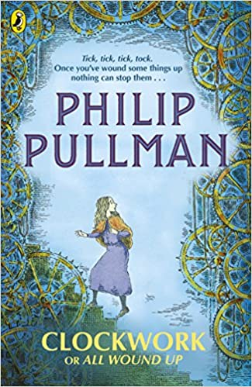  Class book:  Amari and the Night Brothers  (Diversity – BAME)  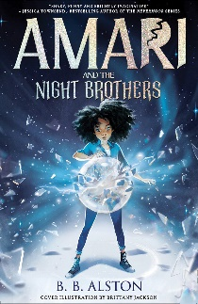 | VOCABULARY  - checking that the text makes sense to them, discussing their understanding and explaining the meaning of words in context  - discussing words and phrases that capture the reader’s interest and imagination  - using dictionaries to check the meaning of words they have read  VERBAL REASONING  - drawing inferences such as inferring characters' feelings, thoughts and motives from their actions, and justifying inferences with evidence  - predicting what might happen from details stated and implied  - participate in discussion about both books that are read to them and those they can read for themselves, taking turns and listening to what others say.  - identifying main ideas drawn from more than 1 paragraph and summarising these  LITERACY KNOWLEDGE  - asking questions to improve their understanding of a text  - increasing the familiarity with a wide range of books, including fairy stories, myths and legends, and retelling some of these orally. | Passion: The emotion of the reading – including empathy and sympathy and the development of a reader’s love for the written word.  Punctuation: The adherence to and understanding of the marks an author has placed upon the page.  Pace: The speed and rhythm of what we read.

- Children’s classics (books, rhymes and poems that we feel all children should know).
- Diversity
- Humour and enjoyment
- Contemporary children’s books (Present)
- Topic linked books
- Books by the same author
- Poetry (Funny poetry, poetry about taking care of our planet and poetry about bullying, exams and growing up)

