Reading Framework Y3 and 4 – Long Term Overview 2022 - 2023
Autumn
Poetry Thursday  Read a minimum of 2 poems from the poetry book of the term each week. | Texts  Anchor and Supplementary | Explicit Focus Points  Black – NC Objectives  Black and bold – ideas for teaching  Green – Reading Rope Strands  Language Comprehension  Background knowledge, Vocabulary, Language Structure, Verbal reasoning  Literacy Knowledge | Fluency Development  (6 Ps – identify specific focus)  Pitch, Power, Pace  Punctuation, Pause  Passion | Writing Objectives/Cross Curricular links
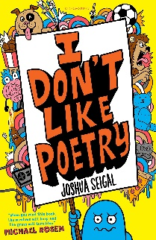  (Funny poems) | Harley Hitch and the Iron Forest  (Enjoyment)  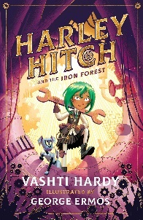  Class book:  James and the Giant Peach (Roald Dahl – Books by the same author)  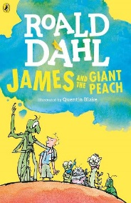 | VOCABULARY  - using dictionaries to check the meaning of words that they have read  - discussing words and phrases that capture the reader’s interest and imagination  VERBAL REASONING  - drawing inferences such as inferring characters’ feelings, thoughts and motives from their actions, and justifying inferences with evidence  - predicting what might happen from details stated and implied  - identifying main ideas drawn from more than 1 paragraph and summarising these  - participate in discussion about both books that are read to them and those they can read for themselves, taking turns and listening to what others say  - asking questions to improve their understanding of a text  LITERACY KNOWLEDGE  - checking that the text makes sense to them, discussing their understanding, and explaining the meaning of words in context  LANGUAGE STRUCTURE  - identifying how language, structure, and presentation contribute to meaning | Pace: The speed and rhythm of what we read.  Punctuation: The adherence to and understanding of the marks an author has placed upon the page.  Pause: The knowing of when not to read and for how long.
 | Charlott’es Web  (Classic – Pie Corbett’s reading spine)  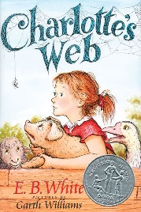  Class book:  The Aboninables  (Classic – Pie Corbett’s reading spine)  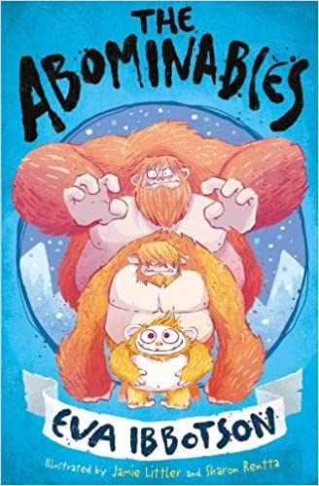 | VOCABULARY  - using dictionaries to check the meaning of words they have read  - discussing words and phrases that capture the reader’s interest and imagination  VERBAL REASONING  - drawing inferences such as inferring characters' feelings, thoughts and motives from their actions, and justifying inferences with evidence  - participate in discussion about both books that are read to them and those they can read for themselves, taking turns and listening to what others say.  LITERACY KNOWLEDGE  - asking questions to improve their understanding of a text  - increasing the familiarity with a wide range of books, including fairy stories, myths and legends, and retelling some of these orally. | Passion: The emotion of the reading – including empathy and sympathy and the development of a reader’s love for the written word.  Power: The strength given to the reading voice – including volume and stress.
Ongoing, independent reading – Pupil choice from home and school books. Group reading challenges provided for differentiated groups where possible to encourage discussion and motivation.

Class Book – Reading spine

Reading display – include a range of book covers and add reviews that children write as we progress through the term. Extreme reading challenge. Reading rewards to be discussed with the children.

Fluency – a small group pupils will be selected to be assessed using the Multi-dimensional Fluency Scale at the start of the term. The group will be split into two, one group that only receives in class support with reading fluency and the other will have weekly practise with reading a range of poems, songs, short stories, extracts and etc. After 5-6 weeks, both groups will be re-assessed using the Multi-dimensional Fluency Scale. The results will be analysed and good practise will be shared with the rest of the classes, adapting and adopting new practise where appropriate.

 | Spring
 | Texts  Anchor and Supplementary | Explicit Focus Points  Black – NC Objectives  Black and bold – ideas for teaching  Green – Reading Rope Strands  Language Comprehension  Background knowledge, Vocabulary, Language Structure, Verbal reasoning  Literacy Knowledge | Fluency Development  (6 Ps – identify specific focus)  Pitch, Power, Pace  Punctuation, Pause  Passion | Writing Objectives/Cross Curricular links
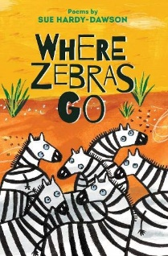  (Range of topics covered including protecting the environment and animals) | Planet Omar  (Diversity - BAME)  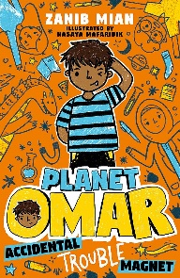  Class book:  Usbourne Illustrated Arabian Nights  (Topic link)  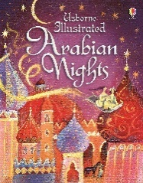 | Background knowledge  - what diversity is and how it might feel to be different  Vocabulary  - using dictionaries to check the meaning of words that they have read  Language Structure  - identifying how language, structure, and presentation contribute to meaning  Verbal reasoning  - discussing words and phrases that capture the reader’s interest and imagination  - participate in discussion about both books that are read to them and those they can read for themselves, taking turns and listening to what others say  - checking that the text makes sense to them, discussing their understanding, and explaining the meaning of words in context  - asking questions to improve their understanding of a text  - drawing inferences such as inferring characters’ feelings, thoughts and motives from their actions, and justifying inferences with evidence  - identifying main ideas drawn from more than 1 paragraph and summarising these  Literacy Knowledge  - listening to and discussing a wide range of fiction, poetry, plays, non-fiction and reference books or textbooks  - reading books that are structured in different ways and reading for a range of purposes  - identifying main ideas drawn from more than 1 paragraph and summarising these | Pace: The speed and rhythm of what we read.  Punctuation: The adherence to and understanding of the marks an author has placed upon the page.  Passion: The emotion of the reading – including empathy and sympathy and the development of a reader’s love for the written word.
 | The Lion, The Witch and the Wardrobe  (Classic – Pie Corbett)  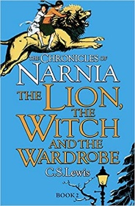  Class book:  The Girl Who Stole an Elephant  (Contemporary – currently popular)  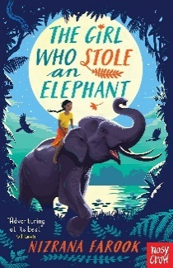 | Vocabulary  - using dictionaries to check the meaning of words that they have read  - discussing words and phrases that capture the reader’s interest and imagination  - checking that the text makes sense to them, discussing their understanding, and explaining the meaning of words in context  Verbal reasoning  - asking questions to improve their understanding of a text  - drawing inferences such as inferring characters’ feelings, thoughts and motives from their actions, and justifying inferences with evidence  - predicting what might happen from details stated and implied  - identifying main ideas drawn from more than 1 paragraph and summarising these  - participate in discussion about both books that are read to them and those they can read for themselves, taking turns and listening to what others say  Literacy Knowledge  - identifying themes and conventions in a wide range of books | Pitch: The musicality of the reading voice – including tone and intonation.  Power: The strength given to the reading voice – including volume and stress.  Pace: The speed and rhythm of what we read.  Punctuation: The adherence to and understanding of the marks an author has placed upon the page.  Pause: The knowing of when not to read and for how long.  Passion: The emotion of the reading – including empathy and sympathy and the development of a reader’s love for the written word.
 | Summer
 | Texts  Anchor and Supplementary | Explicit Focus Points  Black – NC Objectives  Black and bold – ideas for teaching  Green – Reading Rope Strands  Language Comprehension  Background knowledge, Vocabulary, Language Structure, Verbal reasoning  Literacy Knowledge | Fluency Development  (6 Ps – identify specific focus)  Pitch, Power, Pace  Punctuation, Pause  Passion | Writing Objectives/Cross Curricular links
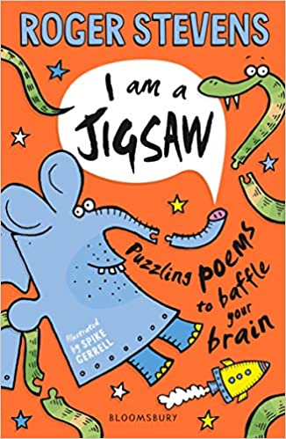  (Puzzles) | Nothing to see here hotel  (Humour and enjoyment)  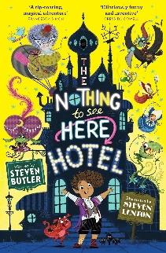  Class text:  Ellie and the Cat  (Diversity – BAME)  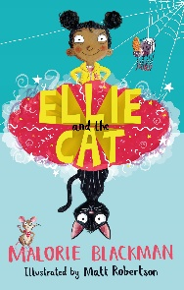 | Vocabulary  - using dictionaries to check the meaning of words that they have read  - discussing words and phrases that capture the reader’s interest and imagination  Language Structure  - identifying how language, structure, and presentation contribute to meaning  Verbal reasoning  - checking that the text makes sense to them, discussing their understanding, and explaining the meaning of words in context  - asking questions to improve their understanding of a text  - drawing inferences such as inferring characters’ feelings, thoughts and motives from their actions, and justifying inferences with evidence  - predicting what might happen from details stated and implied  - identifying main ideas drawn from more than 1 paragraph and summarising these  - participate in discussion about both books that are read to them and those they can read for themselves, taking turns and listening to what others say  - retrieve and record information from non-fiction  Literacy Knowledge  - listening to and discussing a wide range of fiction, poetry, plays, non-fiction and reference books or textbooks  - identifying themes and conventions in a wide range of books | Pitch: The musicality of the reading voice – including tone and intonation.  Power: The strength given to the reading voice – including volume and stress.  Pace: The speed and rhythm of what we read.  Punctuation: The adherence to and understanding of the marks an author has placed upon the page.  Pause: The knowing of when not to read and for how long.  Passion: The emotion of the reading – including empathy and sympathy and the development of a reader’s love for the written word.
 | Matilda  (Humour and enjoyment – children’s interest)  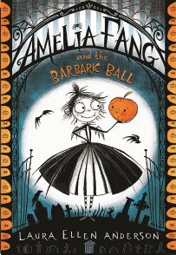  Class text: Bill’s New Frock  (Classic – Pie Corbett)  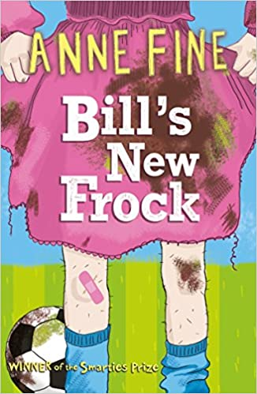 | VOCABULARY  - discussing words and phrases that capture the reader’s interest and imagination  - using dictionaries to check the meaning of words they have read  LITERACY KNOWLEDGE  - listening to and discussing a wide range of fiction, poetry, plays, non-fiction and reference books or textbooks.  - asking questions to improve their understanding of a text  - retrieve and record information from non-fiction  - Identifying themes and conventions in a wide range of books  VERBAL REASONING  - participate in discussions about books that are read to them and those they can read for themselves, building on their own and others’ ideas and challenging views courteously  - drawing inferences such as inferring characters' feelings, thoughts and motives from their actions, and justifying inferences with evidence  - identifying main ideas drawn from more than 1 paragraph and summarising these | Passion: The emotion of the reading – including empathy and sympathy and the development of a reader’s love for the written word.  Pitch: The musicality of the reading voice – including tone and intonation

- Children’s classics (books, rhymes and poems that we feel all children should know).
- Diversity
- Humour and enjoyment
- Contemporary children’s books (Present)
- Topic linked books
- Books by the same author (Roald Dahl)
- Poetry

