‘Believe, Excite, Succeed, Together’
Reading Framework Reception, Y1 and Y2 – Long Term Overview 2022 - 2023
R/ Y1 |  |  | Y2
- Children’s classics  - PSHE emotions and relationships  - Diversity  - Humour and enjoyment  - Contemporary children’s picture books (currently popular)  - Environment (books about the world, looking after the world, animals and plants).  - Books by the same author (Julia Donaldson) |  |  | As in R / Y1 plus - Extended texts to be read aloud.
Key texts to share with Reception
Term 1 | Term 2 | Term 3 | Term 4 | Term 5 | Term 6
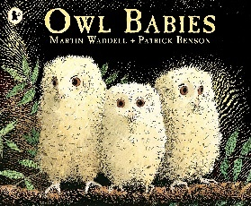  (Pie Corbett - Classic)  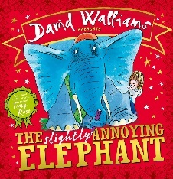  (Contemporary children’s picture book) | 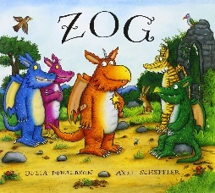  (Books by the same author)  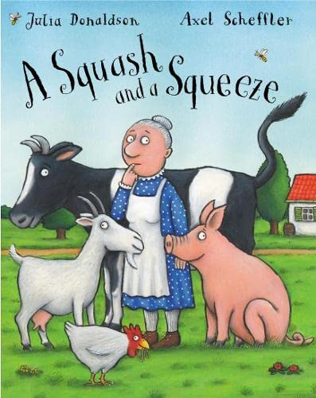  (Humour and enjoyment) | 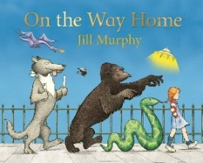  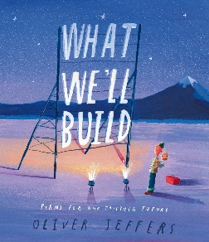  (Pie Corbett – Classic)  (Environment) | 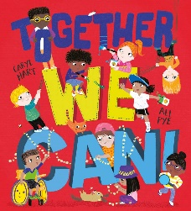  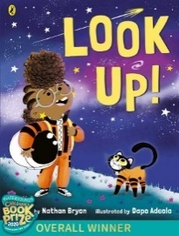  (PSHE)  (Diversity – BAME) | 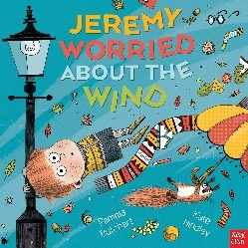  (PSHE)  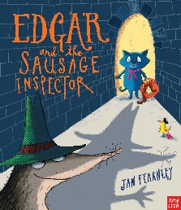  (Humour and enjoyment) | 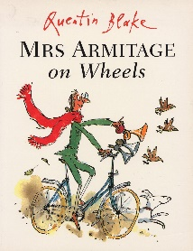  (Pie Corbett – Classic)  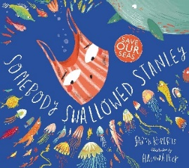  (Environment)
Focus | Focus | Focus | Focus | Focus | Focus
Anticipate (where appropriate) key events in stories.  Make comments about what they have heard and ask questions to clarify their understanding. | Demonstrate understanding of what has been read to them by retelling stories and narratives using their own words and recently introduced vocabulary | Demonstrate understanding of what has been read to them by retelling stories and narratives using their own words and recently introduced vocabulary. | Anticipate (where appropriate) key events in stories.  Offer explanations for why things might happen, making use of recently introduced vocabulary from stories, non-fiction, rhymes and poems when appropriate. | Use and understand recently introduced vocabulary during discussions about stories, non-fiction, rhymes and poems and during role play. | Listen attentively and respond to what they hear with relevant questions, comments and actions when being read to and during whole class discussions and small group interactions.  • Make comments about what they have heard

Key texts to share with Year 1
Term 1 | Term 2 | Term 3 | Term 4 | Term 5 | Term 6
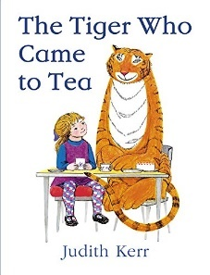  (Pie corbett – classic)  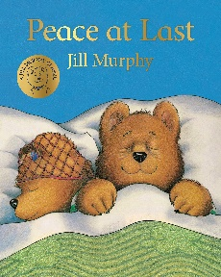  (Pie corbett – classic) | 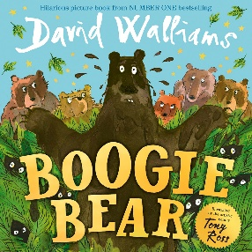  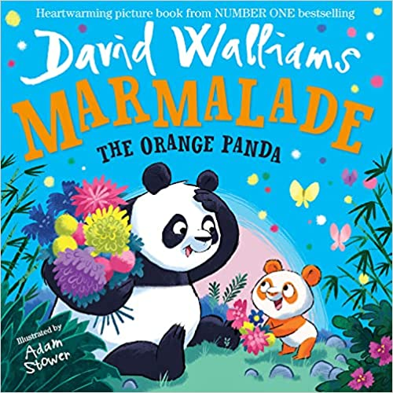  (Humour and enjoyment)  (Books by the same author) | 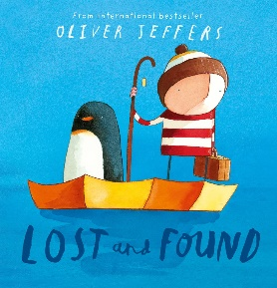  (Pie corbett – classic)  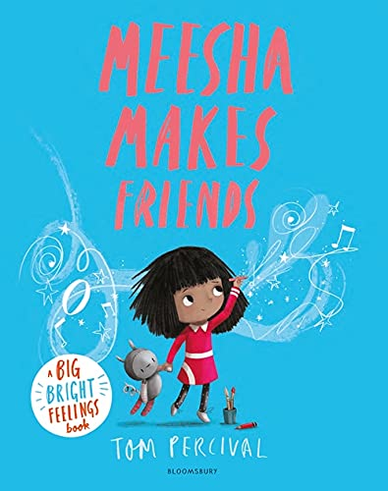  (Diversity) | 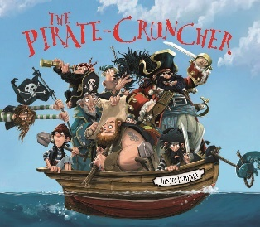  (Humour and enjoyment)  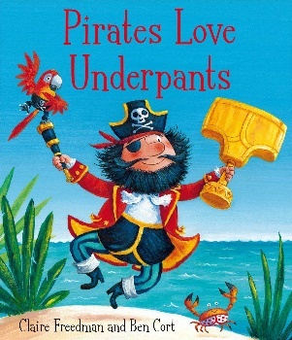  (Humour and enjoyment) | 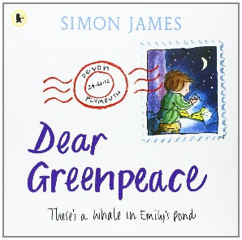  (Environment)  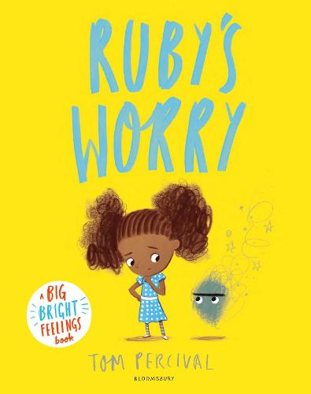  (PSHE) | 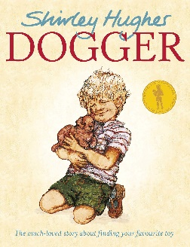  (Pie corbett – classic)  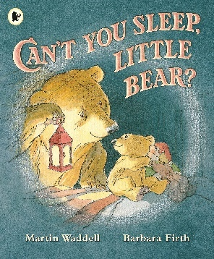  (Pie corbett – classic)
Focus | Focus | Focus | Focus | Focus | Focus
To make simple reasonable inferences from  pictures and text linked to own knowledge and  experiences  To use what has been read to predict what might  happen next | To participate in discussion about what is read to them  and listens to what others have to say | To retell or explain information read and link to other  parts of text e.g. pictures | To identify new and unfamiliar words  To locate information and use  textual cues to answer simple literal questions | To identify some key features of a text; including title and  main events  To know that texts can be structures in a certain  order  To know some language features used within the texts; including predictable phrases and rhyme | To locate information and use  textual cues to answer simple literal questions.

Autumn
Texts  Anchor and Supplementary | Explicit Focus Points  Black – NC Objectives  Black and bold – ideas for teaching  Green – Reading Rope Strands Language Comprehension  Background knowledge, Vocabulary, Language Structure, Verbal reasoning  Literacy Knowledge | Fluency Development  (6 Ps – identify specific focus)  Pitch, Power, Pace  Punctuation, Pause  Passion | Writing Objectives/Cross Curricular links
Term 1  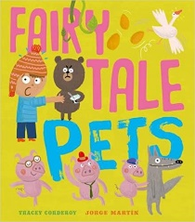  Humour and enjoyment | Read Write Inc sessions  Key texts to share:  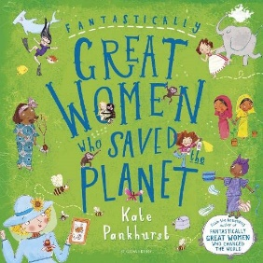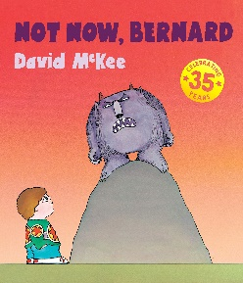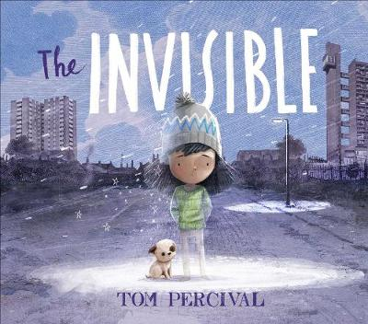
Term 2  Non-fiction texts – including  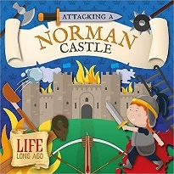  Topic link | LITERACY KNOWLEDGE (Y2)  - Listening to, discussing and expressing views about a wide range of stories and non-fiction at a level beyond that at which they can read independently.  - Being introduced to non-fiction books that are structured in different ways.  VERBAL REASONING  - Basic recognition of simple themes across a range of texts  - Deduce and infer single points from specific parts of text and explain opinions  - Make reasonable predictions from details in the text  BACKGROUND KNOWLEDGE (Y2)  - drawing on what they already know or on background information and vocabulary provided by the teacher | Echo reading – Phrasing and power in voice  Choral reading – ensure children use power | Writing  - Information booklet about castles

Spring
Texts  Anchor and Supplementary | Explicit Focus Points  Black – NC Objectives  Black and bold – ideas for teaching  Green – Reading Rope Strands  Language Comprehension  Background knowledge, Vocabulary, Language Structure, Verbal reasoning  Literacy Knowledge | Fluency Development  (6 Ps – identify specific focus)  Pitch, Power, Pace  Punctuation, Pause  Passion | Writing Objectives/Cross Curricular links
Term 3  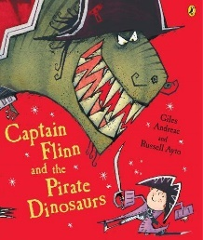  Humour and enjoyment | Reading Strategies – Using Prior Knowledge/Previewing, Questioning, Making Inferences, Summarising.  Year 2  VOCABULARY  - Recognising simple recurring literary language in stories and poetry  discussing and clarifying the meanings of words, linking new meanings to known vocabulary.  - Discussing their favourite words and phrases.  VERBAL REASONING  - Making inferences on the basis of what is being said and done answering and asking questions.  - Predicting what might happen on the basis of what has been read so far.  - Participate in discussion about books, poems and other works that are read to them and those that they can read for themselves, taking turns and listening to what others say.  - Explain and discuss their understanding of books, poems and other material, both those that they listen to and those that they read for themselves.  LITERACY KNOWLEDGE  - Listening to, discussing and expressing views about a wide range of contemporary and classic poetry, stories and non-fiction at a level beyond that at which they can read independently.  - Being introduced to non-fiction books that are structured in different ways.  LANGUAGE STRUCTURE  - Read words containing common suffixes.  - Read further common exception words, noting unusual correspondences between spelling and sound and where these occur in the word.  BACKGROUND KNOWLEDGE  - Understand both the books that they can already read accurately and fluently and those that they listen to by: drawing on what they already know or on background information and vocabulary provided by the teacher.  - Checking that the text makes sense to them as they read and correcting inaccurate reading. | Echo reading – Phrasing and power in voice  Choral reading – ensure children use power  Pitch: The musicality of the reading voice – including tone and intonation.  Power: The strength given to the reading voice – including volume and stress.
Term 4  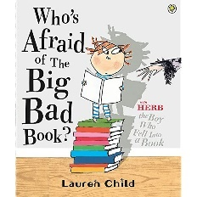  Children’s classics | Reading Strategies – Using Prior Knowledge/Previewing, Questioning, Making Inferences, Summarising.  Background knowledge  - drawing on what they already know or on background information and vocabulary provided by the teacher  Vocabulary  - discussing and clarifying the meanings of words, linking new meanings to known vocabulary  Verbal reasoning  - Basic recognition of simple themes across a range of texts  - Deduce and infer single points from specific parts of text and explain opinions  - Predicting what might happen on the basis of what has been read so far.  - Participate in discussion about books, poems and other works that are read to them and those that they can read for themselves, taking turns and listening to what others say.  Literacy Knowledge  - Being introduced to fiction / non-fiction books that are structured in different ways. | Punctuation: The adherence to and understanding of the marks an author has placed upon the page.  Pause
Ongoing, independent reading – children have independent reading book linked to 95-98% accuracy

Class Book – selected age appropriate texts – linked to anchor text where appropriate-

Reading display – 6 p’s, vocabulary displayed with context and meaning

Fluency – MDFS – use for children who are just off RWI every 2 weeks and half termly

Summer
Texts  Anchor and Supplementary | Explicit Focus Points  Black – NC Objectives  Black and bold – ideas for teaching  Green – Reading Rope Strands  Language Comprehension  Background knowledge, Vocabulary, Language Structure, Verbal reasoning  Literacy Knowledge | Fluency Development  (6 Ps – identify specific focus)  Pitch, Power, Pace  Punctuation, Pause  Passion | Writing Objectives/Cross Curricular links
Term 5  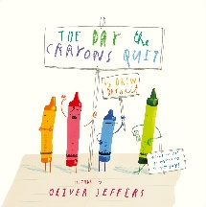  Books by the same author  PSHE | Reading Strategies – Using Prior Knowledge/Previewing, Questioning, Making Inferences, Summarising.  Year 2  VOCABULARY  - discussing and clarifying the meanings of words, linking new meanings to known vocabulary  VERBAL REASONING  - explain and discuss their understanding of books, poems and other material, both those that they listen to and those that they read for themselves  - participate in discussion about books, poems and other works that are read to them and those that they can read for themselves, taking turns and listening to what others say  - checking that the text makes sense to them as they read, and correcting inaccurate reading  - answering and asking questions  LITERACY KNOWLEDGE  - listening to, discussing and expressing views about a wide range of contemporary and classic poetry, stories and non-fiction at a level beyond that at which they can read independently | Pause: The knowing of when not to read and for how long.  Punctuation: The adherence to and understanding of the marks an author has placed upon the page. | Poetry
Term 6  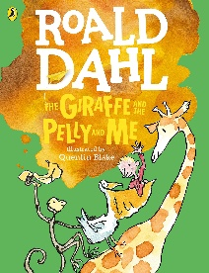  Books by the same author | Reading Strategies – Using Prior Knowledge/Previewing, Questioning, Making Inferences, Summarising.  Background knowledge  - drawing on what they already know or on background information and vocabulary provided by the teacher  Vocabulary  - discussing and clarifying the meanings of words, linking new meanings to known vocabulary  - recognising simple recurring literary language in stories and poetry (same author- different texts)  Verbal reasoning  - checking that the text makes sense to them as they read, and correcting inaccurate reading  - making inferences on the basis of what is being said and done  - answering and asking questions  - predicting what might happen on the basis of what has been read so far  Literacy Knowledge  - becoming increasingly familiar with and retelling a wider range of stories, fairy stories and traditional tales  - listening to, discussing and expressing views about a wide range of contemporary and classic poetry, stories and non-fiction at a level beyond that at which they can read independently | Pitch: The musicality of the reading voice – including tone and intonation.  Power: The strength given to the reading voice – including volume and stress. | Narrative / Author study  Jill Tomlinson
Ongoing, independent reading – children have independent reading book linked to 95-98% accuracy

Class Book – selected age appropriate texts – linked to anchor text where appropriate-

Reading display – 6 p’s, vocabulary displayed with context and meaning

Fluency – MDFS – use for children who are just off RWI every 2 weeks and half termly

