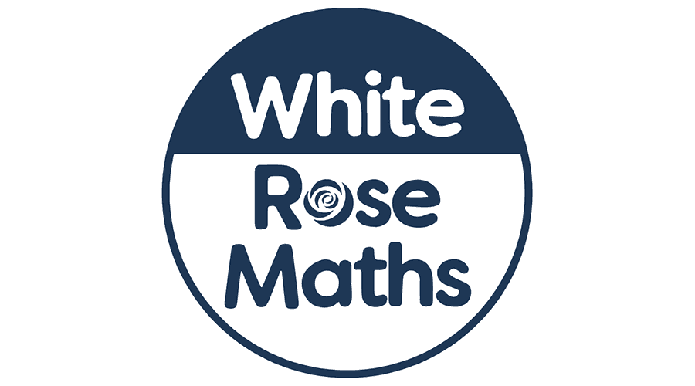

**As artists we will be:**. exploring prehistoric art and begin this by looking at cave paintings. We will create our own pictures using charcoal and other natural materials.

**As musicians we will:** be performing, reading and manipulating simple graphic scores.

**As historians we will:** be learning about dinosaurs and how fossils are formed. We will make our own fossils out of salt dough and then “excavate” them. We will also be exploring the life of Mary Anning.

**As mathematicians we will:** be exploring and completing investigations with money. Children will use their knowledge from place value and addition and subtraction to find the total value of a set of coins, less than £1. We will also be working with multiplication and division, recognising and making equal groups. In Year 2, we will continue to use Times Tables Rockstars.



Why is Mary Anning remembered?

KS1

**In PSHE we will**: be continuing to follow our program 1decision which uses a unique blend of videos, techniques and resources to approach different topics.

**As authors we will:** continue to follow our Read, Write, Inc program, learning, writing our set 2 and 3 sounds and applying them to our spellings.

Year 2 children are completing the English Hub Fluency Programme which will involve reading a variety of texts linked to Traditional Tales.

**As athletes we will:**.be continuing to develop our ball skills and applying these to football in our PE sessions with coach Harry. We will be focussing on passing a ball to another player as well as using our kicking skills in different team games.

**As scientists we will:** be recapping over (from previous learning) the 5 different animal groups that scientists use to classify animals. We will also learn to identify the group an animal belongs to by its features including humans. Finally we will look at our five senses and how important they are.

**In Computing we will:** continue toexplore robots using individual commands, both with other learners and as part of a computer program.

**In R.E we will:** be discussing what we mean by sacred texts and thinking about how these stories and books are treated.