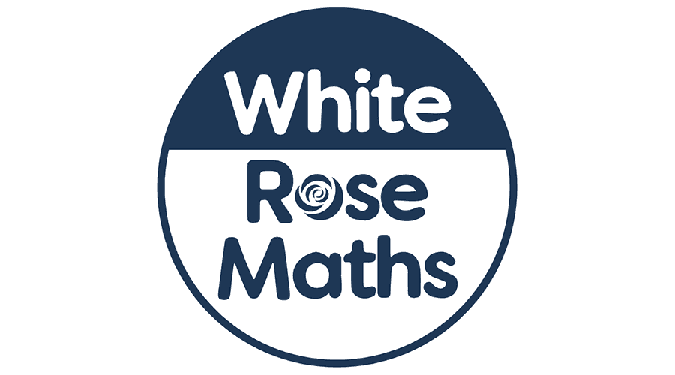

**As geographers we will:**be using maps and atlases to locate places and landmarks in our local area. We will use the book The Jolly Postman as a starting point and create our own journeys plotting the landmarks and places we will see on the way.

**As musicians we will:** be performing, reading and manipulating simple graphic scores.

**As designers we will be:**. planning, designing and evaluating Christmas Stocking decorations.

**As mathematicians we will:** be continuing work on addition and subtraction. We will solve simple word problems applying our increasing knowledge of mental and written methods. We will also be working on multiplication and division and counting in patterns for Year 1. In Year 2, we will continue to use Times Tables Rockstars.



What happens to the letters we post?

KS1

**In PSHE we will**: be continuing to follow our program 1decision which uses a unique blend of videos, techniques and resources to approach different topics.

**In Computing we will:** explore robots using individual commands, both with other learners and as part of a computer program.

**In R.E we will:** be exploring what makes a place or object sacred and what this means for different people and their beliefs.

**As authors we will:** continue to follow our Read, Write, Inc program, learning, writing our set 1 and 2 sounds and applying them to our spellings. They will learn that ‘and’ can join words, phrases and clauses and begin to know the four different sentence types and that they have different functions.

**As scientists we will:** be observing and describing how seeds and bulbs grow into mature plants.

**As athletes we will:**.be learning to create a sequence of movements in Dance and in Gymnastics we will be learning to jump and roll into different shapes, and put contrasting movements together.