As Citizens we will:

Explore rules for and ways of keeping physically and emotionally safe including responsible ICT use and online safety.

As Musicians we will:

Listen with concentration to a range of music linked to the Great Fire of London and build up to performing a song.

As Designers we will:

Taste a variety of different breads and plan, bake and evaluate our own bread.

Was the Great Fire of London really a disaster?

As Believers we will:

Explore how Christians see God.

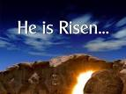

As Geographers we will:

Name, locate and identify characteristics of London whilst learning how to use atlases and globes.

As Readers we will:

Read a selection of fiction and non-fiction books linked to The Great Fire of London.

As Authors we will:

Explore how to write a newspaper report about a historical event.

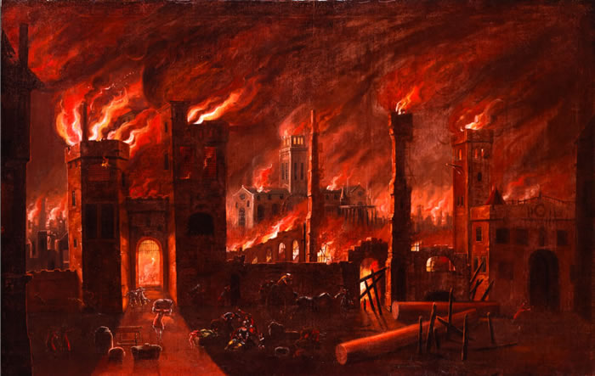will:

As Historians we will explore:

LC1: How did the fire spread and how did people react?

LC2: How was the fire stopped?

LC3: How did people save their belongings?

LC4: Why did the fire stop?

LC5: Who was to blame?

As Scientists we will:

Distinguish between an object and the materials it’s made from.

Identify and name a range of everyday materials. Describe the properties of some materials and use vocabulary such as flexible and transparent. We will also compare and classify materials.

Dear Parents of Emerald children:

Here is our topic for this half term. If you have any questions, then please do not hesitate to ask!