Long Term Curriculum Overview Year 1/2 2018 - 2019
Our Vision: At Welbourn we aim to promote and develop Christian attitudes throughout the school, enabling children to make informed decisions and become aware and be tolerant of other cultures and religions. Our school mission statement, “trying our best to be our best,” provides a framework whereby we put children at the centre of all that we do and value aspirations, resilience and independent learning. It has at its heart our Christian focus and our desire to see children grow and develop their God given potential as part of a loving school community: Believe, Excite, Succeed, Together
Year group
 | Autumn 1 | Autumn 2 | Spring 1 | Spring 2 | Summer 1 |  | Summer 2
Key Question  ( Topic name) | Was the Great Fire of London really a disaster? | What happens to the letters we post? | Would you rather live in Kenya or Welbourn? | How are toys different to a long time ago? | How does your garden grow? | Would you like to be an explorer?  Space
Driver | History | English | Geography | History | Science | History
Key events, experiences, trips | Fire engine visit  Baking bread | Visit to the post office to post a letter  Carol singing at Welbourn Manor | Yorkshire Wildlife Park  Making a fruit salad | Visit to Welbourn Manor to share toys  Visit to the Mosque in Lincoln | Gardening at Welbourn Manor  Belton trip | Space centre, Leicester
Parental engagement opportunities | Parental involvement morning | Nativity | Parental involvement morning  Carousel of activities linked to Africa | Parental involvement morning  Sewing with parent helpers  Sharing favourite toys at Welbourn Manor | Parental involvement morning | Parental involvement morning  Sports day
English units and rich texts | Newspaper report  Poetry  Stories | The Jolly Postman  Letters and postcards  Instructions | Handa’s Surprise  Mama Panya’s Pancakes  Stories  Information text | Pinocchio – traditional tales  Poetry | Life cycle of a plant – explanation text  Descriptive writing – The Little Gardener |  | The Way Back Home – Oliver Jeffers  Stories  Space poetry
Maths links and opportunities | Grouping materials in tables  Venn diagram for sorting materials | Post office – money  Weighing parcels | Tables – classifying animals  Compass directions – position and direction of a safari | Statistics – most common minibeast. Pictogram  Sorting – venn diagrams. Old and new toys | Temperature – Geography link to weather  Sorting plants – venn diagrams. |  | Shape and measures linked to planets
Science topic | Materials | Materials | Animals | Animals | Plants and trees |  | Plants and trees
SC1 skills opportunities | Sorting materials  Grouping materials | Carry out simple tests  Use observations and ideas to suggest answers and suggestions  Observing closely | Classifying animals | Observing changes – tadpoles  Answering and asking Qs | Planting seeds  Asking and answering Qs |  | Observing changes
Geography |  | Use simple compass directions  Use aerial photographs  Devise a simple map  Use and construct basic symbols in a key | Place knowledge. Geographical skills and fieldwork – Kenya and Welbourn study. |  | Human and physical geography – seasonal and daily weather patterns.
History | Events beyond living memory - The Great Fire of London |  |  | Changes within living memory - Toys old and new |  |  | The lives of significant individuals – Neil Armstrong
Art | Great Fire of London scene.  Skills covered: drawing, shape, line, colour, painting. | Designing and making wrapping paper for a Christmas present.  Skills covered: using a range of materials, drawing, pattern, texture, shape. |  |  | Van Gogh artist study (sunflowers and snail).  Skills covered: drawing, collage, form, space, making links to artists and their own work, describing similarities and differences.
DT | Taste and review different breads.  Design and bake bread. Review bread.  Baking stromboli with Darren from Roots to Food.  Skills covered: Choose right ingredients for a product  Use equipment safely  Make sure product looks attractive  To be hygienic when working with food |  | Design, make and evaluate fruit salad. Linked to the story Handa’s surprise.  Skills covered:  Explain what a healthy diet is  Use equipment safely | Design, make and evaluate finger puppets. Textiles and sewing.  Linked to Pinocchio.  Skills covered: Measure textiles  Join textiles together in different ways  Cut textiles  Choose textiles for both appearance and quality
Music |  | Nativity songs | Call and response – African drumming | Musical me – making music for puppet | Tradtional stories – Kapow |  | Spae - Kapow
PE | Jumping  Athletics | Throwing  Athletics | Running  Gymnastics | Sending and receiving  Gymnastics | Rounders  Dance |  | Attacking and defending  Dance
Computing | Research | Programming – Beebot | Introduction to data | Digital imagery | Word processing |  | Rocket to the moon - kapow
RE | Christianity – What do Christian’s believe God is like? | Christianity - Who do Christians believe made the world? | Islam – Why is the Qu’ran important to Muslims? | Islam – What do Muslims celebrate? | Christianity plus other religions.  Where do people worship? |  | Christianity plus other religions.  Where do people worship?
Church school values | Justice | Peace and Forgiveness | Love and Compassion | Generosity and Thankfulness | Service and Stewardship |  | Equality
British values | Democracy  -class rules  -School Council elections | Mutual respect | Individual liberty | The rule of law | Tolerance |  | The best of being British
Global learning links/ international days | 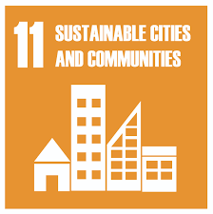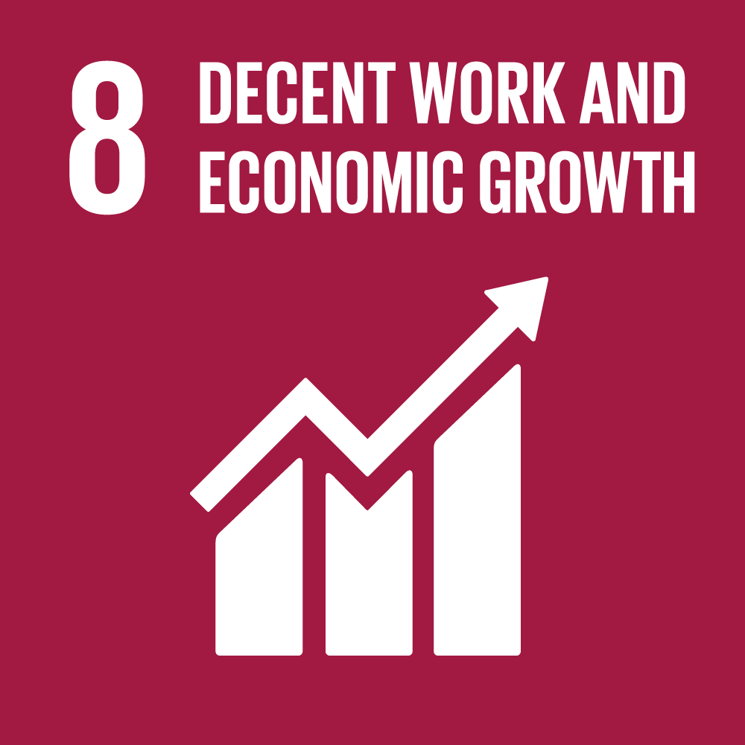 | 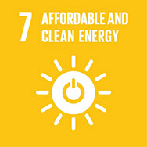 | 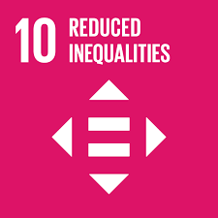 | 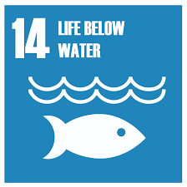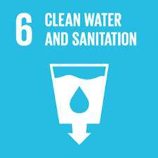 | 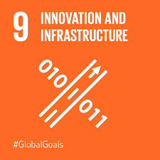
SMSC opportunities | Morals – recognising right and wrong through school council elections. | Social – visit to local post office to post letters to Santa. | Cultural diversity between Kenya and Welbourn. | Spiritual opportunities – visiting Lincoln Mosque and respecting the faith of others. | Social opportunities – visits to Welbourn Manor Nursing Home planting seeds and sketching wild flowers with the residents. |  | Social opportunities – choral worship with Welbourn Manor Nursing Home.
PSHE/ P4C | Routines in new classroom. Class rules. | Wellbeing – My world  Kapow | Wellbeing – My world  Kapow | Wellbeing – Looking out  Kapow | Wellbeing – Looking out  Kapow |  | Transition.
Themed weeks | Well being week / transition / new starts  Routes to Food workshop | Anti Bullying Week  World Hello Day | Chinese new year  Art week - Africa |  | KS1 & KS2 SATs weeks |  | Sports day  Move up morning

