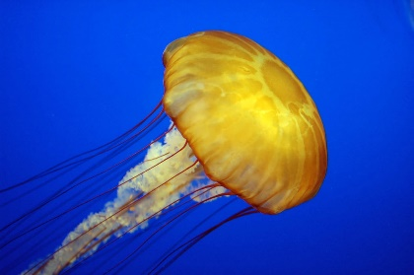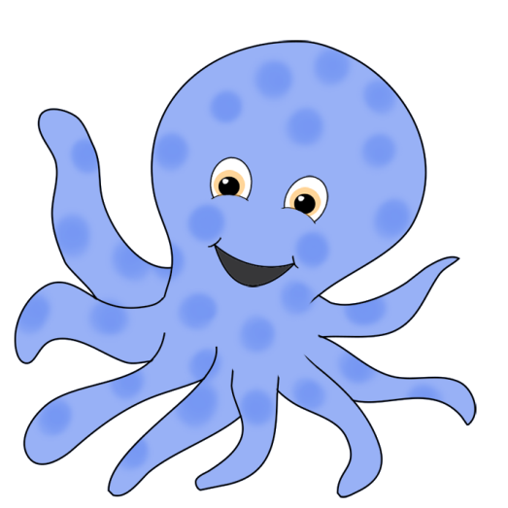

**Emerald**

**What’s causing the commotion in the ocean?**

In **RE** we will be thinking about the Muslim faith and how the Qur’an is used.

Our **Science** topic this term is all about ocean animals. We will be exploring their bodies, what they eat and how we could group them! We will also explore how ocean animals grow from babies to adults.

In **Geography** we will locate the world’s oceans and seasides and look at their features.

For **Art** we will be practising our drawing skills and drawing self-portraits.

In **Music** we will be using our senses and responding to music from by the sea.

In **Computing** we will be practising our word processing skills!

This half term in **Maths** we will be looking at place value, addition, subtraction and measures. We will be using lots of resources to help us! We will also be working on our times tables, specifically 2x, 5x and 10x.

In **English** this term our key text will be ‘Commotion in the Ocean’. We will practise writing super sentences through describing characters and settings and eventually writing our own story including a sea creature. We will also study non-fiction and create our own information text about penguins.

In **PE** we will practising our running and jumping skills. We will also be doing gymnastics. Please have PE kit in school all week.